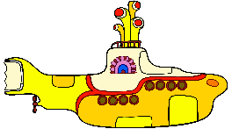
The Yellow Submarine Demo
Purpose: To collect evidence that determines what happens to atoms when substances react.
Table 1. Observations
 | BEFORE POUR |  | AFTER POUR
Chemical | - Lead Nitrate | - Potassium Iodide | ????
Observations
Making Sense of the Yellow Submarine
Below is the equation for the chemical reaction you observed and, in Table 2, the models for some of the substances. Complete the table by constructing models for the remaining substances present in the reaction.
Pb(NO₃)_{2(aq)} + 2KI_{(aq)} --> PbI_{2(s)} + 2KNO_{3(aq)}
Table 2. Models
 | BEFORE |  | AFTER
Chemical Name and Formula | Lead Nitrate  Pb(NO₃)₂ | Potassium Iodide  2KI | Lead Iodide  PbI₂ | Potassium Nitrate  2KNO₃
Molecular Model | 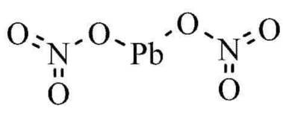 |  |  | 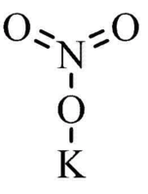  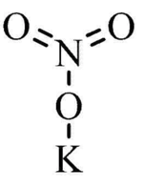
Number of Atoms

- How do the models above support your observations from Table 1?

- Use evidence from this activity to defend the following claims about chemical reactions:
CLAIM | EVIDENCE
During a chemical reaction, new substances form.
During a chemical reaction, atoms rearrange.
During a chemical reaction, matter is not created.
During a chemical reaction, matter is not destroyed.

