LESSON 7 – PRECIPITATION
LESSON 6 RECAP:
- What three things are needed for a cloud to form?

- Where does the water needed for a cloud come from?
BACKGROUND:
Water is one of the key ingredients to life on Earth. About 75% of our planet is covered by water or ice. The oceans hold about 97% of the water on Earth. About 1.7% of water is stored in polar ice caps and glaciers; and another 1.7% is held in rivers, lakes, and soil. A tiny fraction of water exists in Earth’s atmosphere as water vapor.
In the last lesson we focused on clouds. Clouds are an important part of the water cycle. The water cycle is the movement of water cycled through the atmosphere (air), hydrosphere (oceans and other water bodies), geosphere (land), and biosphere (living things). Energy from the sun helps to power this process, and Earth’s gravity keeps water in the atmosphere from leaving the planet.
During the water cycle, the sun heats water on the surface of the Earth, and causes it to evaporate. Evaporation is the process when water moves from being a liquid to being vapor. Water vapor is made up of tiny water droplets in the air. Water can also move into the air through transpiration. Transpiration is the movement of water out of plants. During photosynthesis, plants make oxygen and water. Water then moves out of tiny holes on the leaves and into the air. The water vapor rises up into the atmosphere, and as it cools, it condenses. During condensation the water vapor condenses on solid particles found in the air called cloud condensation nuclei (CCNs) and form clouds. Precipitation happens when so much water vapor condenses that the air cannot hold it anymore. The clouds get so heavy that some of the water must fall back down to Earth as rain, snow, sleet or hail. Most of this water ends up as storage in oceans or infiltrates the ground to become groundwater. Precipitation that doesn’t get stored in these places becomes run-off and flows over the land as surface water.
Fill in the blanks below using words from the word bank provided:
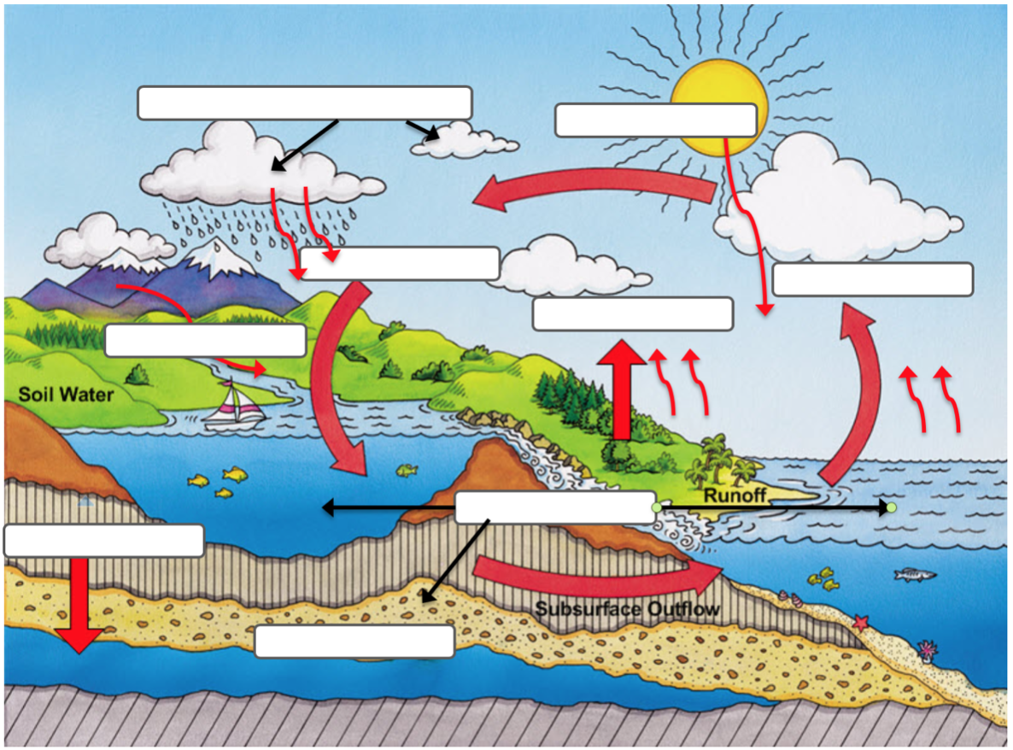
Word Bank:
Radiation
Evaporation
Transpiration
Condensation
Precipitation
Storage
Groundwater
Infiltration
Run-off

- Which parts of the water cycle require energy from the sun?
- Which parts of the water cycle require the water molecules to give away heat energy (cool down)?
- Which parts of the water cycle are caused by the force of gravity?
PART 1-INVESTIGATION QUESTION: __________________________________________________________________________________________________
__________________________________________________________________________________________________
TYPES OF PRECIPITATION
Precipitation GIF
Notice | Wonder/Question
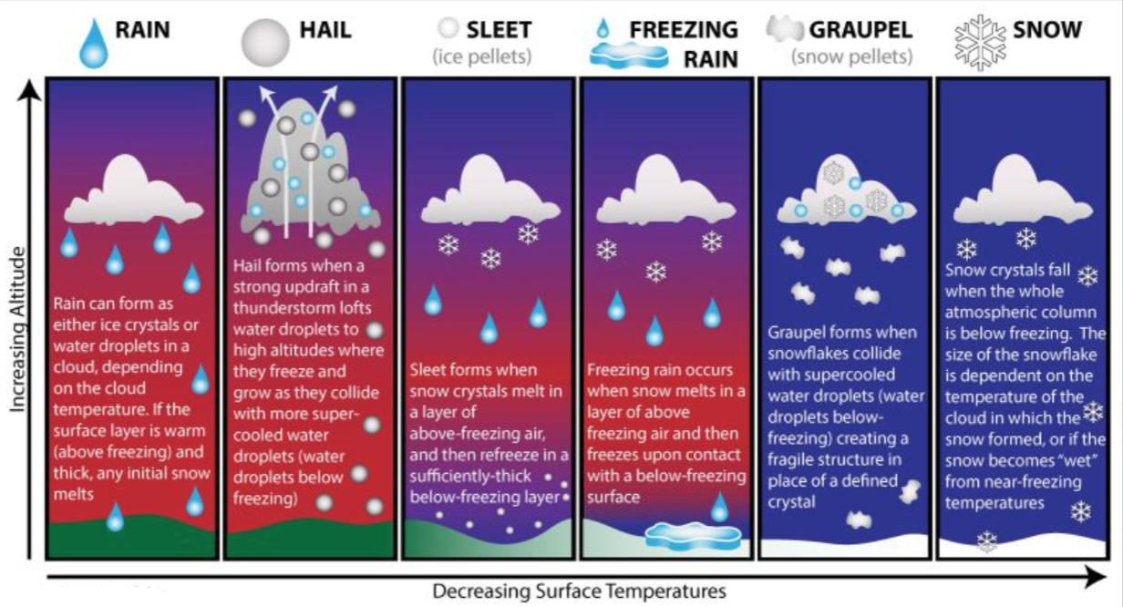

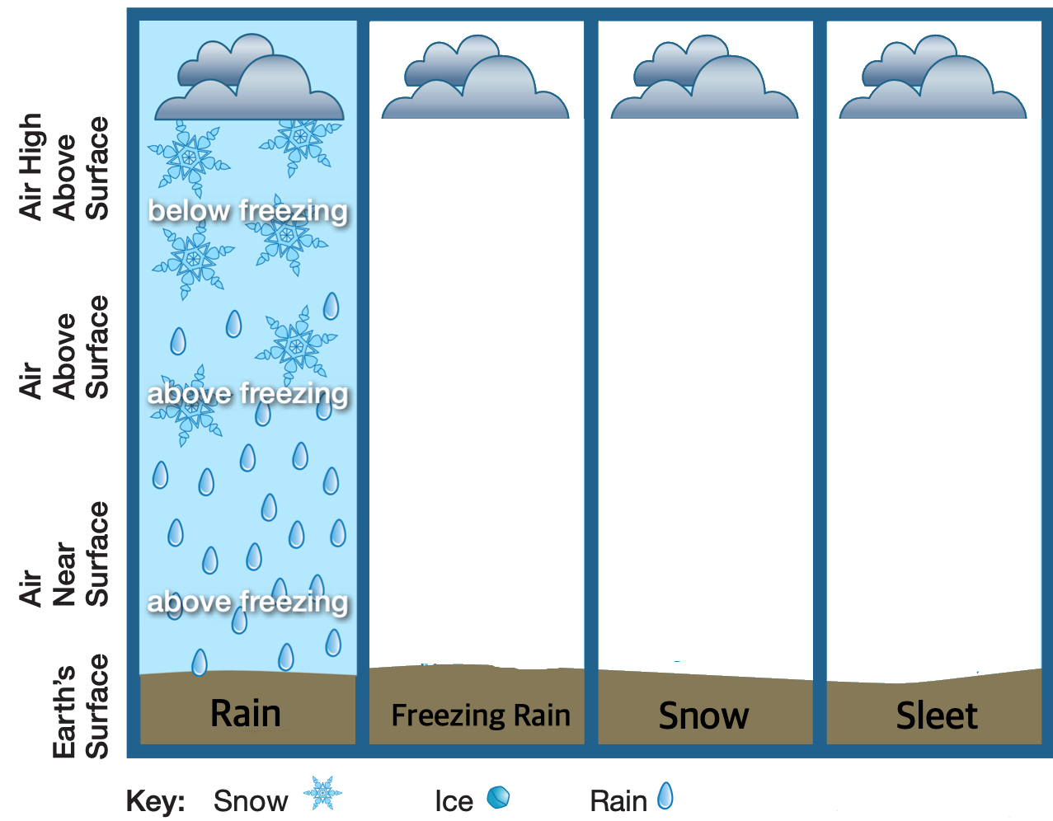
PRECIPITATION MODELS
Based on the diagram and the gif about types of precipitation, draw models to show how each type of precipitation is formed. Rain is done as an example.

PART 2-INVESTIGATION QUESTION: __________________________________________________________________________________________________
__________________________________________________________________________________________________
Clouds, floating at various altitudes, are all made of gases and much larger water droplets or ice crystals suspended in those gases. As a result, we naturally begin to wonder why precipitation isn’t falling from the sky all the time. What do you predict keeps water droplets or ice crystals floating in the air? What are some related experiences you have had when you saw air keeping something aloft or floating suspended in air?

PRECIPITATION DEMONSTRATIONS:
In the following demonstrations, record observations, including any measurements discussed.
Condition | Observations | What does this tell us?
Ping Pong Ball is like

Air blown from hair dryer close to balance is like

Air blown from hair dryer far away from balance is like

Ping-pong ball 6-inches above hair dryer is like

Ping-pong ball 1-inch above hair dryer is like

Ping-pong ball 12-inches above hair dryer is like

MAKING SENSE
Key | Force of Gravity | Lift Force (from Updraft) | Movement
Models | When Forces are Equal | When Updraft Forces  are Stronger | When Updraft Forces  are Weaker

- What outside conditions at the surface might cause updraft forces:
  - To be equal to gravity?

  - To be stronger?

  - To be weaker?

- What form of precipitation would you expect if updraft forces:
  - Were equal to gravity?

  - Were stronger?

  - Were weaker?

