LESSON 6 – WATER IN THE AIR
PART 1-INVESTIGATION QUESTION: __________________________________________________________________________________________
__________________________________________________________________________________________
LESSON 5 RECAP:
- What type of cloud tends to produce hail?

- What type of movement happens inside these clouds? What type of heat transfer causes this movement?

- What three things are needed for a cloud to form?

- What are cloud condensation nucleation sites?

- What are the two categories of clouds? How are they different?

ENVIRONMENTS
Environments of the World | Beach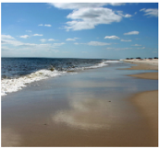 | Desert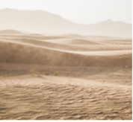 | Lawn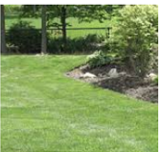 | Snow 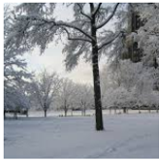 | Rocky  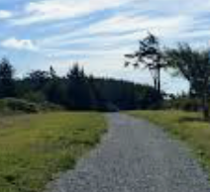 | Puddle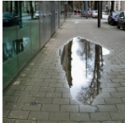 | Soil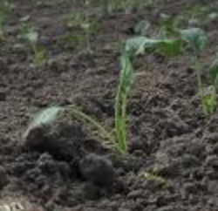
Is this a place that could contribute water to the atmosphere?
PREDICTIONS:

ENVIRONMENTAL SCENARIO
1 | 2 | 3 | 4 | 5 | 6 | 7 | 8
Control Group | Building a Sandcastle on a Miami Beach | Trapped in Death Valley | Playing Tag in Your Backyard on a Summer Day | Sledding at Hawk Island on a Sunny, Winter Day | Taking a Walk on the rocky part of the River Trail on a Spring Day | Avoiding Puddles on the River Trail | Working in Your Garden on a Summer Day
PLANNING OUR INVESTIGATION
Procedure:
- You will have 3 minutes to prepare your assigned scenario according to the provided directions.
- When directed, send one person (a different person each time) to check the humidity of the container and to record the data. This person will share the measurement with the remainder of the table group.
Observations:
Time Passed | Humidity of Container (%)
0-minutes
2-minutes
4-minutes
6-minutes
8-minutes

Identify the following for this investigation:
Hypothesis: ________________________________________________________________________________________
__________________________________________________________________________________________________
Independent variable: _____________________________ Dependent variable:_________________________________
Constants:___________________________________________________________________________________________________________________________________________________________________________________________
Control Group: ________________________________
OBSERVATIONS:
ENVIRONMENTAL SCENARIO
Group # | 1 | 2 | 3 | 4 | 5 | 6 | 7 | 8
Set-up | Control Group | Building a Sandcastle on a Miami Beach | Trapped in Death Valley | Playing Tag in Your Backyard on a Summer Day | Sledding at Hawk Island on a Sunny, Winter Day | Taking a Walk on the rocky part of the River Trail on a Spring Day | Avoiding Puddles on the River Trail | Working in Your Garden on a Summer Day
Relative Humidity
ANALYSIS:
- Based on the data you obtained, does your environment contribute water to the atmosphere?

CLAIM | EVIDENCE
Circle:  YES  -or-  NO | What did you observe in your investigation to support your claim?

- Review the characteristics of the common world environments below. CIRCLE the environment(s) that best match your investigation scenario.
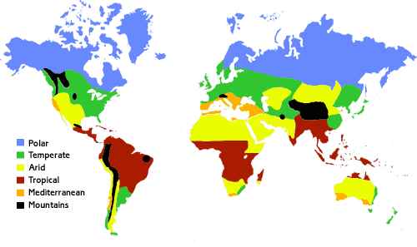
 | Tropical | Subtropics | Temperate | Polar
Locations | The Caribbean  Central America  South Florida | Sahara Desert  The Mediterranean  South Africa | Michigan  Europe  Russia | Northern Canada  Alaska  South Pole
Average Temperature | 70 to 90ºF | 68ºF or more | 20 to 75ºF | -56 to 32ºF
Daylight Hours | 10 to 13.5 | 9 to 15 | 6 to 12 | 0 to 24
MAKING SENSE
- Which containers provided evidence that water went into the air? What does this tell us about where the water in the air outside could be coming from?

- Think back to the setup you made to simulate sunlight and a surface with water in it. Based on the ideas we have developed so far about how light interacts with matter, how would you explain how some of that water gets into the air?

- Based on the class data, how would you describe the amount of water vapor in the environments listed below?
 | Tropical  (Central America) | Subtropics  (Sahara Desert) | Temperate  (Michigan) | Polar  (North Pole)
Humid
-or-
Dry?
Evidence
PART 2-INVESTIGATION QUESTION: __________________________________________________________________________________________
__________________________________________________________________________________________

MAKING A CLOUD LAB
During this lab you will test conditions that may lead to the formation of a cloud. If a cloud forms, the atmosphere (bottle) will appear foggy.
Procedure Test #1:  - Place a Petri dish of hot water under your bottle.  - Place an ice pack on the opposite side of the bottle.  - Draw your initial observations, including the placement of materials.  - Record initial humidity measurement.  - Wait 2-minutes and record any new observations, including a humidity measurement.  - Wait 3 more minutes and record any new observations, including humidity.  - Return your bottle to the light stand to dry. You may reuse the bottle when humidity is at or below 30%.  - Complete the data table on page 6. | Observations:  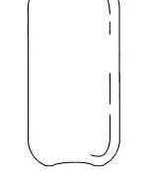
 |  | Humidity
 |  | Initial
 |  | 2-min
 |  | 5-min
Procedure Test #2:  - Place a Petri dish of hot water under your bottle.  - Place an ice pack on the opposite side of the bottle.  - Draw your initial observations, including the placement of materials.  - Record initial humidity measurement.  - Light a match.  - Lift your bottle slightly and place burning match underneath.  - Blow out the match, and quickly and gently drop bottle, so that most of the smoke is trapped within.  - Wait 2-minutes and record any new observations, including a humidity measurement.  - Wait 3 more minutes and record any new observations, including humidity.  - Return your bottle to the light stand to dry. You may reuse the bottle when humidity is at or below 30%.  - Complete the data table on page 6. | Observations:
 |  | Humidity
 |  | Initial
 |  | 2-min
 |  | 5-min
Procedure Test #3:  - Place a Petri dish of snow/ice under your bottle.  - Place a hand warmer on the opposite side of the bottle.  - Draw your initial observations, including the placement of materials.  - Record initial humidity measurement.  - Wait 2-minutes and record any new observations, including a humidity measurement.  - Wait 3 more minutes and record any new observations, including humidity.  - Return your bottle to the light stand to dry. You may reuse the bottle when humidity is at or below 30%.  - Complete the data table on page 6. | Observations:
 |  | Humidity
 |  | Initial
 |  | 2-min
 |  | 5-min
Procedure Test #4:  - Place a Petri dish of snow under your bottle.  - Place a hand warmer on the opposite side of the bottle.  - Draw your initial observations, including the placement of materials.  - Record initial humidity measurement.  - Light a match.  - Lift your bottle slightly and place burning match underneath.  - Blow out the match, and quickly and gently drop bottle, so that most of the smoke is trapped within.  - Wait 2-minutes and record any new observations, including a humidity measurement.  - Wait 3 more minutes and record any new observations, including humidity.  - Return your bottle to the light stand to dry. You may reuse the bottle when humidity is at or below 30%.  - Complete the data table on page 6. | Observations:
 |  | Humidity
 |  | Initial
 |  | 2-min
 |  | 5-min

Data Table
Test | Humidity Range (Low % High %) | CCN* | Cloud
1 |  | Y / N | Y / N
2 |  | Y / N | Y / N
3 |  | Y / N | Y / N
4 |  | Y / N | Y / N
*Cloud Condensation Nuclei (CCNs): a solid surface on which water vapor condenses (i.e. ash, pollen, pollutants)
Analysis:
- What patterns do you notice in your data and observations?

- What impact does the addition of the match smoke have on the formation of a cloud?

- In what way must temperature of water vapor change in order for a cloud to form?

- How can you explain why clouds formed at some times, but not others? Use the observations from your tests as evidence for your claim.
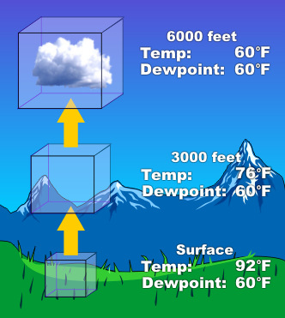
MAKING SENSE
- _________ ________________ is the atmospheric temperature needed for water vapor to condense into water droplets. This will vary due to pressure and humidity.

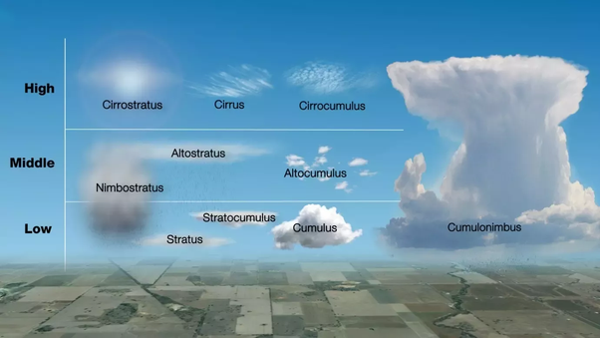
- Examine the image to the right:
a. Explain what must be happening to water vapor in order for some clouds to form at some heights and not at
others.

- Describe how dew point impacts the height at which a cloud forms.

- What do you predict causes a cumulonimbus cloud to grow to such extreme heights compared to other types of clouds?

- Construct a model showing how a cloud forms. Then, write an explanation describing the reasons why a cloud forms.

____________________________________________________________________________________________________________________________________________________________________________________________________________________________________________________________________________________________________________________________________________________________________________________________________________________________________________________________________________________________________________________________________________________________________________________________________________

