Weather- Snow Day Science
Lesson 5- Clouds
INVESTIGATION QUESTION: __________________________________________________________________________________________
__________________________________________________________________________________________
LESSON 4 RECAP :
- What will happen to air (air molecules) when it is in contact with a warmer surface? Be specific.

- Label the diagram below with the correct type of heat transfer occurring at each number.
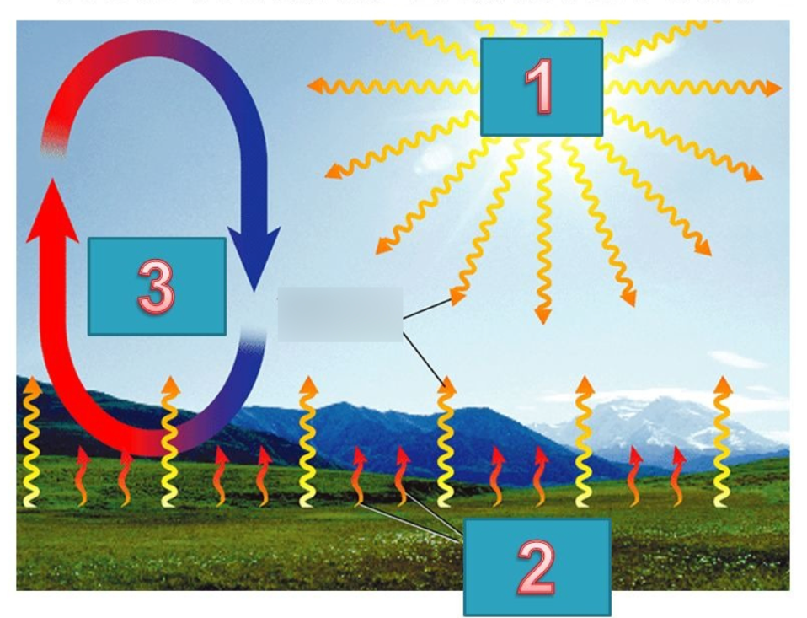

- Watch the video clip ‘How the Sun Heats the Earth’ and fill in the blanks.
- The sun must create the energy we call sunlight through a process called ___________________.

- During fusion, the atoms of hydrogen in the sun are combined to form ____________________.

- It takes a little over __________ minutes for sunlight to reach the earth after it leaves the sun.

- Most of the wavelengths of sunlight travel through the ________________ to get absorbed and to heat the _________________________.

- This helps explain why it gets _________________ the higher you go in the atmosphere. The Earth’s atmosphere is mostly heated from the __________________________.

- Natural greenhouse effect keeps the earth’s average temperature around _____________.
CLOUDS THAT TEND TO PRODUCE HAIL
The type of clouds that produces hail tends to develop into a structure similar to the one shown in the photo below (taken from an airplane). The top of such clouds is often over 20,000 feet high and can be several miles wide. This type of cloud is called cumulonimbus. They can form alone, in clusters, or along lines but aren’t always visible from the ground if there is a lower layer of clouds blocking this view from up high.
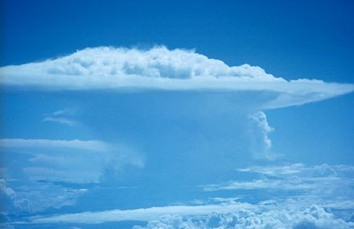
- What else do you notice about the structure of this cloud?

- If you could observe the motion of the air in the clouds above the ground on a day when it hails, what do you predict you might see happening?

AIR MOVEMENT IN THE FORMATION OF A CUMULONIMBUS CLOUD
Follow the prompts below to annotate the pictures and then work with a partner to answer the questions that follow.
- Use upward-pointing arrows to label spots in the cloud where you see air moving upward.
- Use an “x” to label any spots in the cloud where you see air that had been rising stop moving upward.
- Use downward-pointing arrows to label any spots where you see air moving downward.
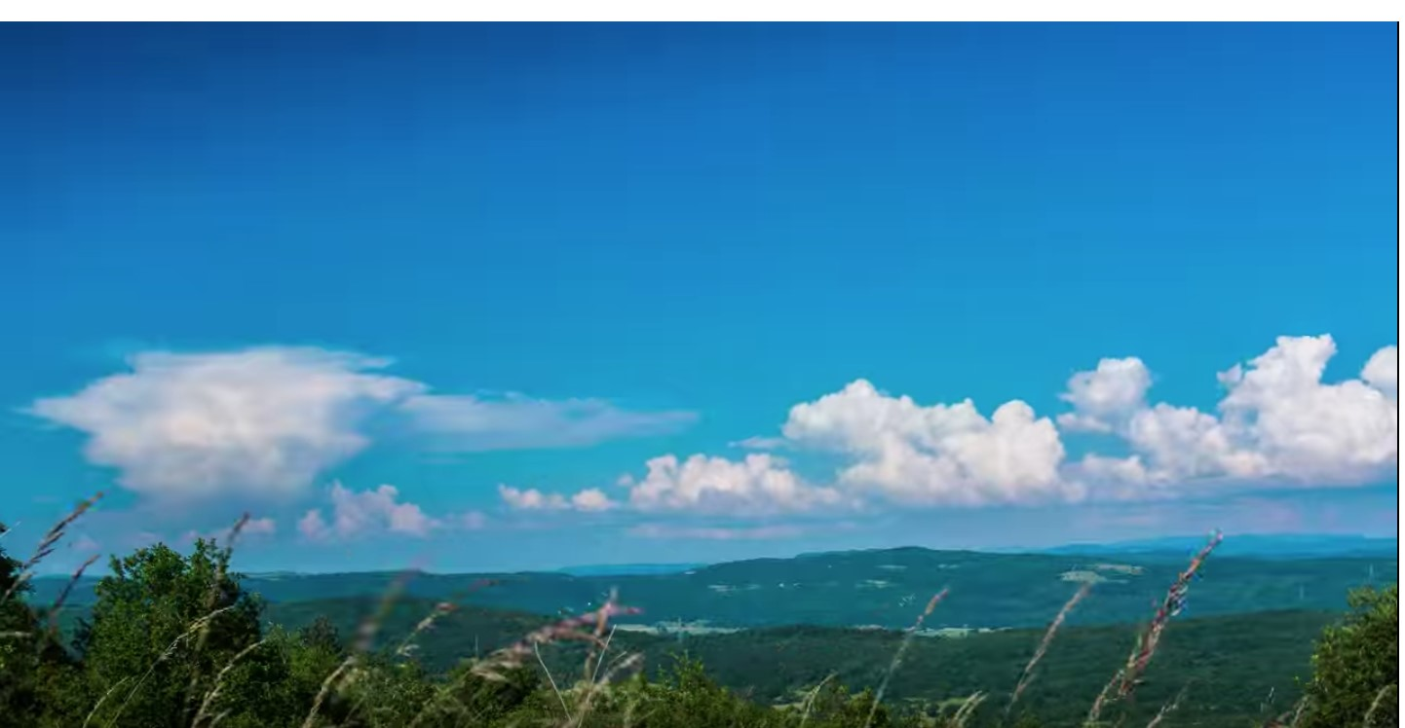  0:20 timelapse | 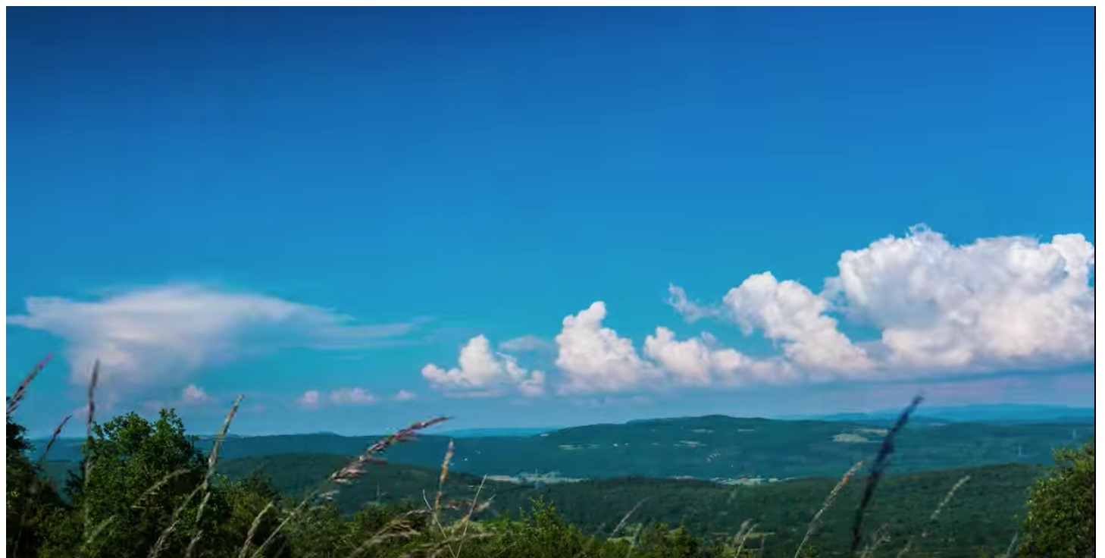  0:32 timelapse
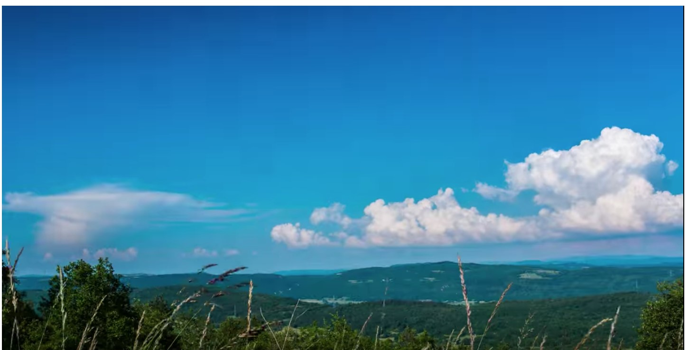  0:36 timelapse | 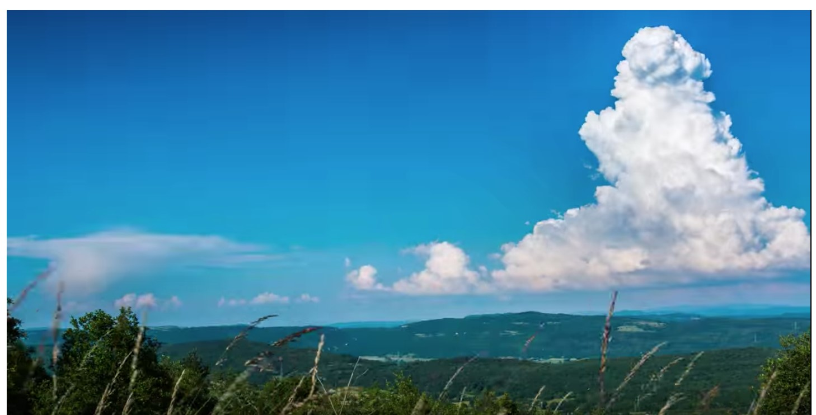  0:41 timelapse
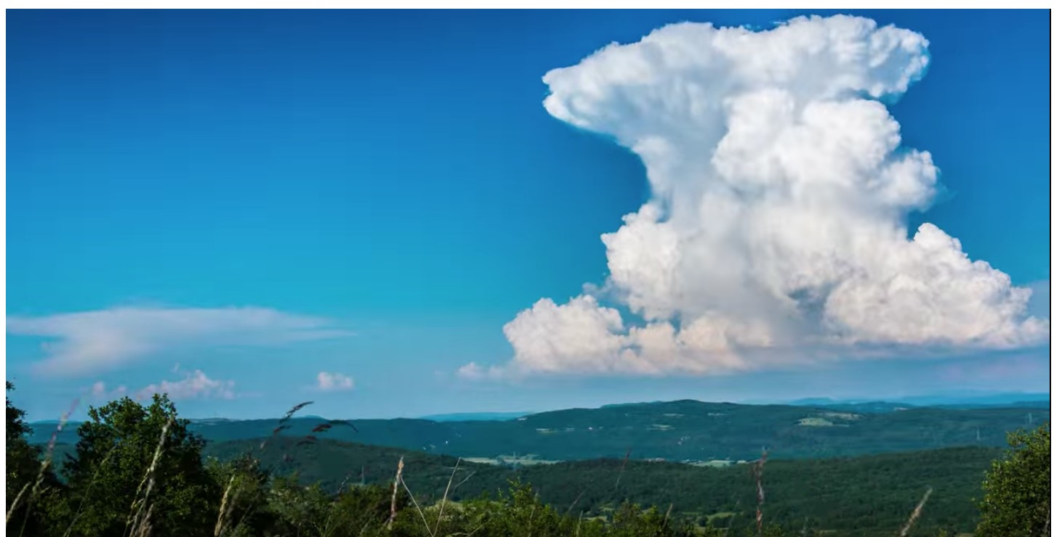  0:48 timelapse | 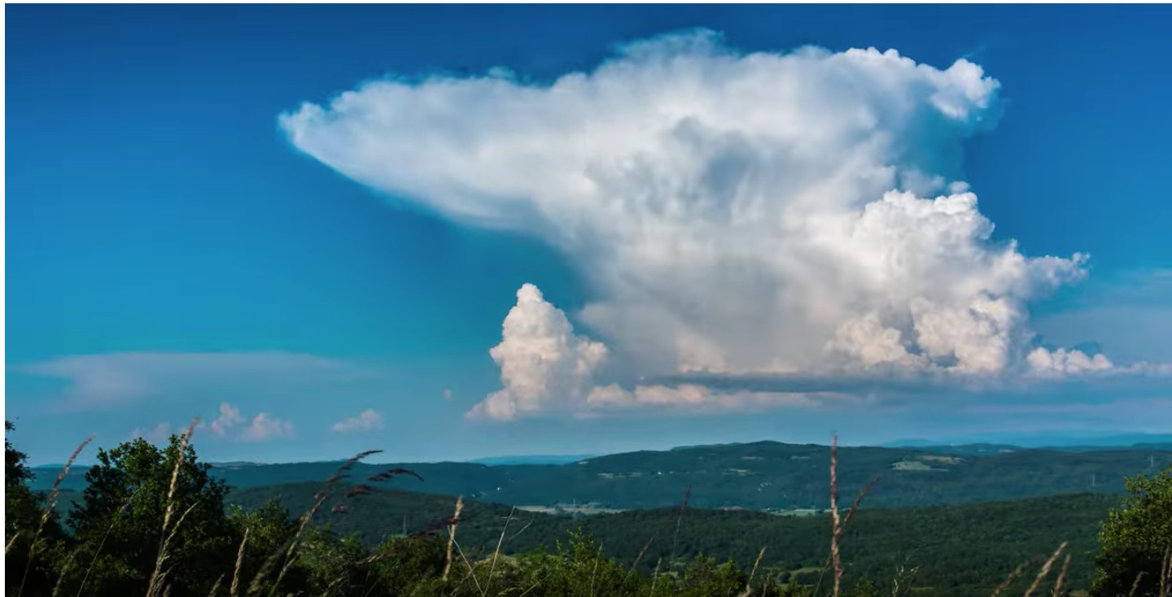  0:58 timelapse

- How can you use the fact that it happened on a mostly sunny day to explain what caused this movement?

- What is causing this upward movement of air in the cloud?

- Why did the rising air in the cloud eventually stop rising (or start falling)?

WHAT IS AIR? WHAT ARE CLOUDS?
Annotate the following text to answer the questions below-
- What is air?
- What are the two most abundant gases found in air?
- What is humidity? How can we measure it?
- What is meant by 100% relative humidity?
- What two things are clouds made of?
- Why can we see clouds?
- What are the conditions for a cloud to form?
- What is it called when a gas is cooled into a liquid?
- What else is needed in addition cooling humid air for condensation to form?
- What is cloud seeding?
The air around us is a mixture of different types of gases. The molecules that make up those gases are too small for us to see. Most of the gas in the air is either oxygen or nitrogen. A smaller amount of it is carbon dioxide, water, and argon. Water in gas form is called water vapor. The amount of water vapor in the air is referred to as humidity.
The amount of each type of gas found in the air is shown in the table below. The amount of water vapor in the air varies greatly with location, temperature, and time. In deserts and at low temperatures, the content of water vapor can be less than 0.1 percent by volume. In warm, humid zones, the air may contain a little over 6 percent water vapor by volume.
Substance | Gas by volume
Nitrogen | Around 78%
Oxygen | Around 21%
Argon | About 1%
Carbon dioxide | Less than 1%
Water | From 0% to 6%
Other substances | Less than 1%
Humidity probes can help us measure changes in the amount of water vapor in the air. They report the amount of water vapor in the air as something called relative humidity. Relative humidity is reported as a percentage from 0 to 100 percent. A relative humidity reading of 100 percent means the air has reached the maximum amount of water vapor it can hold. It doesn’t mean that the air is only made of water vapor molecules. A relative humidity measure of 50 percent means that the water vapor in the air is halfway between the minimum and maximum amounts possible for a specific temperature.
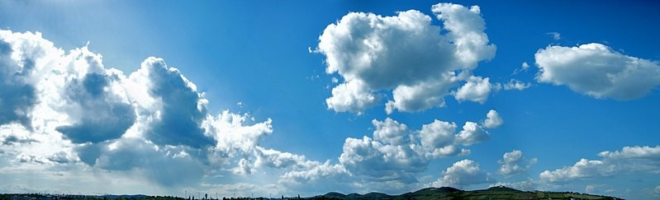
When there is humidity in the air, we can’t see the water vapor in the air. Why not? We can't see the water vapor in the air because it is a gas. In a gas, the molecules are too small and too spread apart for us to see them. So what is it we are seeing when we see a cloud in the sky? Clouds are visible, which tells us they must be made of something large enough for us to see.
Clouds in the sky are made of two things. They are made of gases, and they are made of much larger water droplets or ice crystals suspended in those gases. We can see clouds because those water droplets or crystals are big enough to reflect a noticeable amount of light. That is also what makes them appear white. But the more water droplets or crystals in the cloud or the bigger they are, the more sunlight they absorb. Depending on the direction the sunlight is coming from, this can result in less sunlight reaching parts of the cloud. This will make parts of the cloud appear darker.
Water has to turn from gas into liquid or solid form in order for a cloud to start forming. This can only happen when the air is at a relative humidity of 100 percent and the air is cooled down. When cooling a substance turns it from a gas into a liquid, it is referred to as condensation. When cooling a substance turns it from a gas to a solid, it is referred to as deposition.
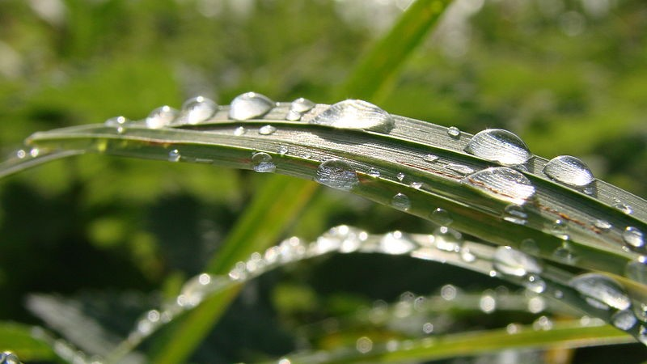
But cooling really humid air alone is not enough to start either of these processes. Something else is needed. The missing ingredient is a solid surface for the water to start sticking to. When you are outside, the surface can be the ground. You might find water condensed out of the air to form dew on the grass in the morning. If it gets even colder, you might find it had deposited out of the air as frost. But if water vapor needs a solid surface to do this, how does this help explain cloud formation?
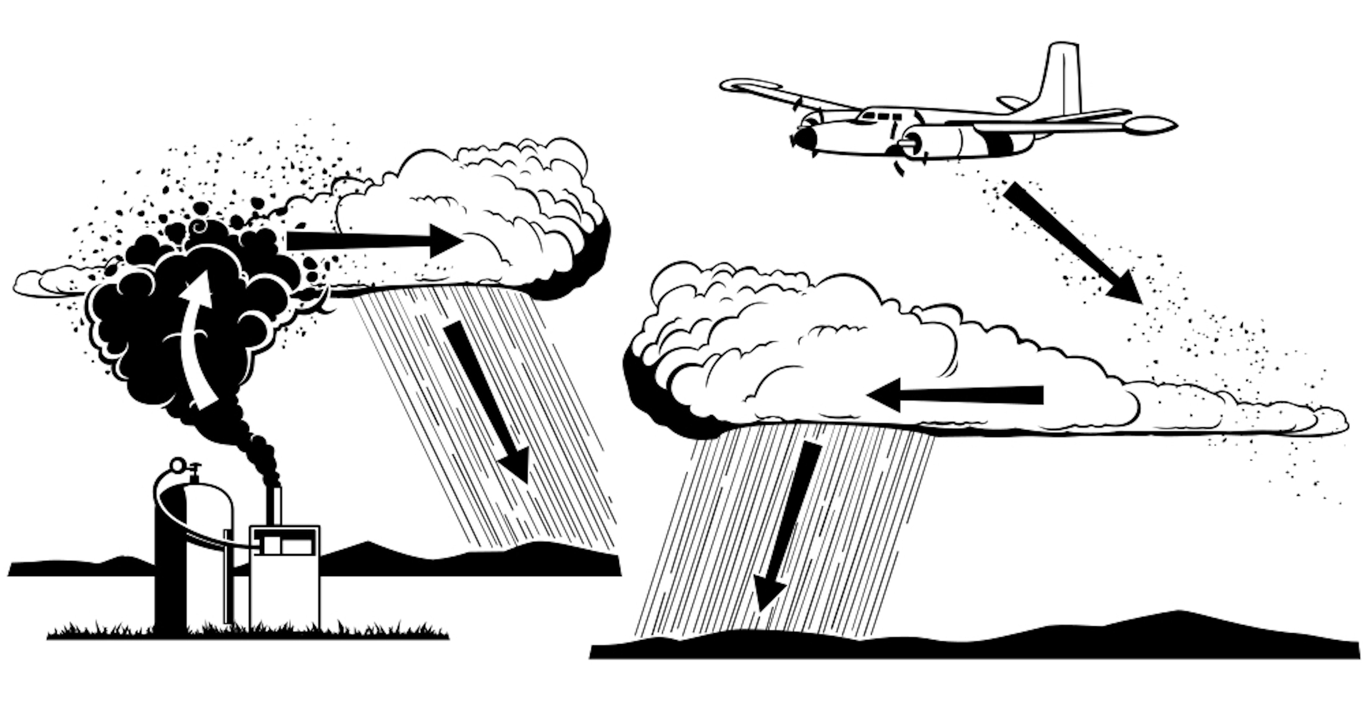
The air outside also contains small pieces of solids, such as dust, ash, pollen, and pollutants. These are the solid surfaces that droplets or ice crystals start forming on when clouds form. Any type of solid particle that water vapor sticks to as it cools down is referred to as cloud condensation nuclei (CCNs) or cloud seeds. When there aren’t enough CCNs in the air, droplets or crystals won’t form and no cloud will form.
Scientists and engineers have tested ways to add additional CCNs into the air to try to increase the amount of cloud formation and the amount of precipitation. These types of processes are called cloud seeding. CCNs used in cloud seeding can be dumped into the air from aircraft. They can also be launched into the air from the ground from generators or canisters fired from guns or rockets. All these techniques have been tested, but there isn’t consensus among experts on whether these attempts produced a significant increase in precipitation at locations where they have been tried.
CLOUD TYPES & ASSOCIATED WEATHER
As you watch the film, draw pictures to show the variations of clouds that can be observed. Also, when asked, take notes about similarities in how the variations form and the types of expected weather for a given type of cloud.
Cumulus
Description | Clouds that grow upward by accumulating in one spot and swelling. They are common where humidity and heat are high, and where the motion of the air is vertical (convection). As the rising air cools, water vapor will condense to form these “bubbly” clouds.
Modeling the Variations | - Cumulus humilis |  | - Cumulus mediocres |  | - Cumulus congestus
 | Model: |  | Model: |  | Model:
 | Weather: |  | Weather: |  | Weather:
 | - Cumulonimbus |  | - Alto |  | - Cirro
 | Model: |  | Model: |  | Model:
 | Weather: |  | Weather: |  | Weather:
 | - Pileus |  | Similarities in how they form:
 | Model:
 | Weather:
Stratus
Description | Clouds that are stretched out. They are wider than they are tall. The motion of air is horizontal rather than vertical. This horizontal motion is called advection. Types of status can block sunlight, causing overcast skies. At night, stratus clouds are like a blanket in the atmosphere, causing night temperatures to be warmer than expected.
Modeling the Variations | - Cirrostratus | - Cirrus |  | - Alto
 | Model: | Model: |  | Model:
 | Weather: | Weather: |  | Weather:
 | - Nimbo | - Stratocumulus |  | Similarities in how they form:
 | Model: | Model:
 | Weather: | Weather:

- What type of a cloud is fog, and why does it develop so close to the ground?

- How does satellite technology change our observations of clouds? You may draw models to help your explanation.

- Why does a cloud “bubble downward?”

- Clouds we see and those that impact our weather are found in which layer of the atmosphere?

  - Troposphere
  - Stratosphere
  - Mesosphere
  - Thermosphere

