Weather- Snow Day Science
Lesson 9-Air Masses, Wind, and Fronts
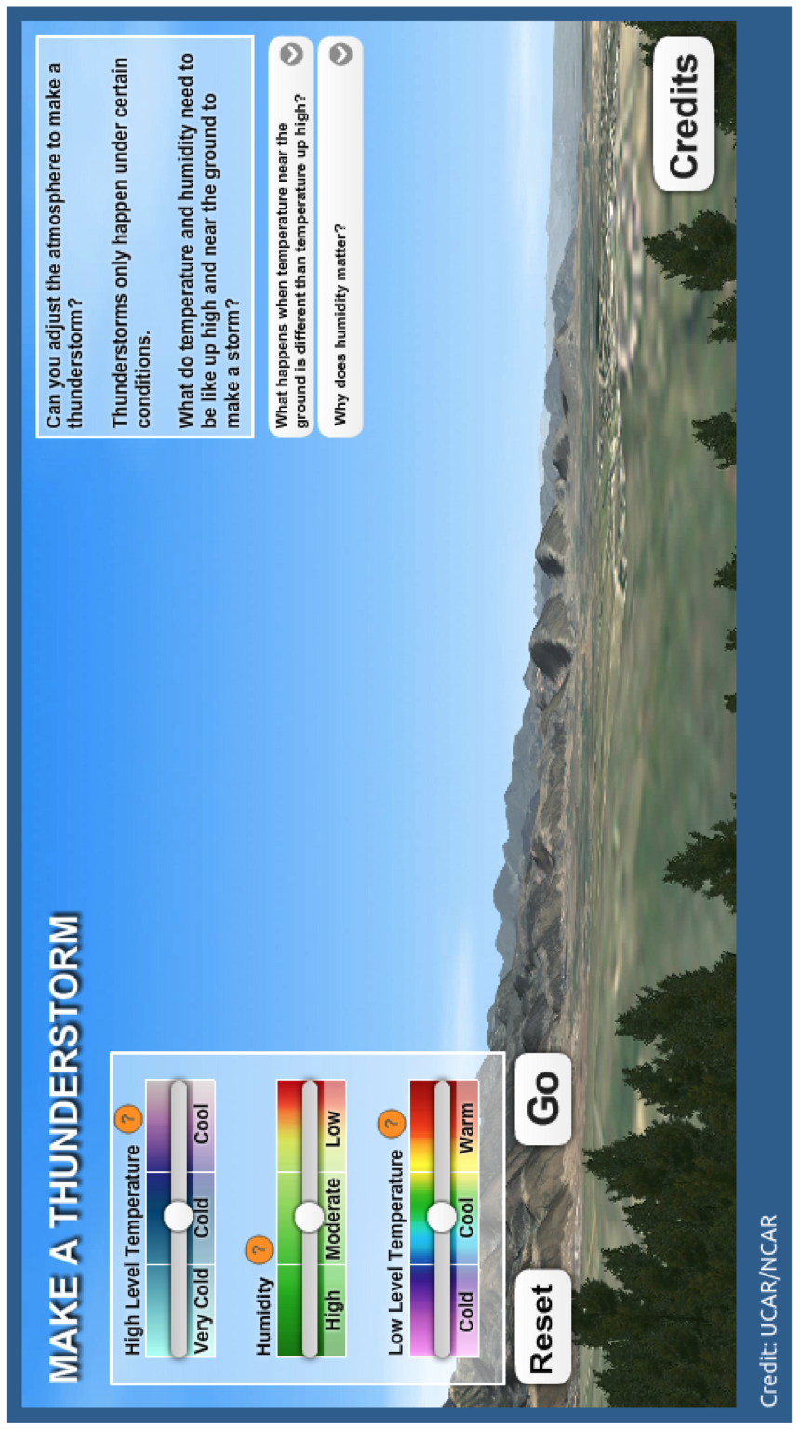
LESSON 8 RECAP:
Background: Hail forms when water droplets in a cloud get very, very cold (supercooled) and collide with other supercooled water droplets. This happens in thunderstorms when the clouds grow so tall they lift the water droplets into very cold parts of the atmosphere. Hail can grow very large if it is forming inside a storm that has strong updrafts pushing those droplets into this part of the atmosphere.
Watch the demo using the ‘Make Thunderstorm’ simulation to test out your ideas about what causes a storm to form.

- On the diagram above,
  - Put a star on each condition slider where you would form the biggest thunderstorm.
  - Model the force of gravity and lift (updraft) that would have to occur for hail to form.

- Why do thunderstorms/hailstorms happen most often in spring according to this model?

INVESTIGATION QUESTION: __________________________________________________________________________________________________
__________________________________________________________________________________________________
AIR MASSES
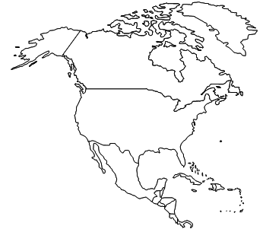
Directions: On the map below, name the air mass, briefly describe the air, and show the direction it moves.

Connections:
- Which air mass(es) may influence the production of hail? Why?

- Which air mass(es) may influence the call of a snow day? Why?

- What about the geography in this area may also help contribute to hail?

WIND, AIR PRESSURE AND CORIOLIS EFFECT
Wind: the movement of air caused by differences in ________________________ and the ________________________________
  - Wind moves from areas of ___________ pressure to areas of _______ pressure
  - Coriolis Effect: causes global wind to ________________ because of the ________________________
  - Air Pressure: the result of the __________________________________ pushing down on an area.
    - Measured with a ___________________________ (psi, atm, mmHg, millibars)
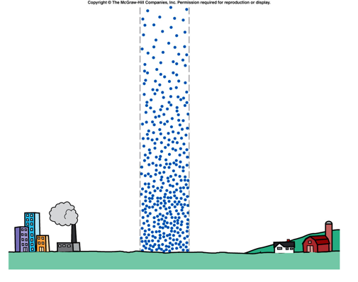
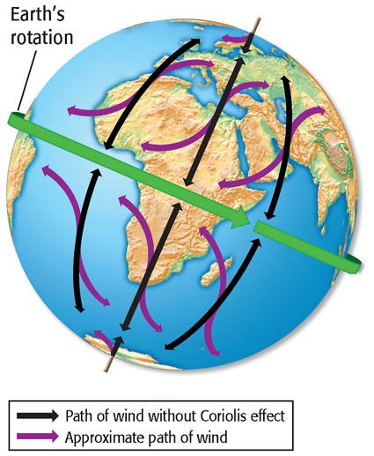
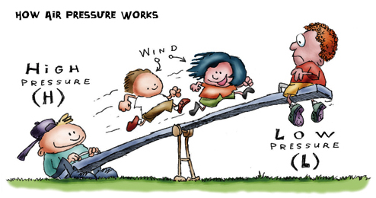

AIR PRESSURE DEMOS
Demo | Predict | Observe | Explain
1
2
3
4
FACTORS THAT EFFECT AIR PRESSURE
FACTOR | EFFECT | PICTURE
Altitude |  | 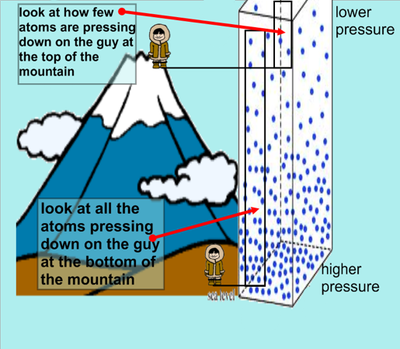
Temperature |  | H  L
Humidity |  | 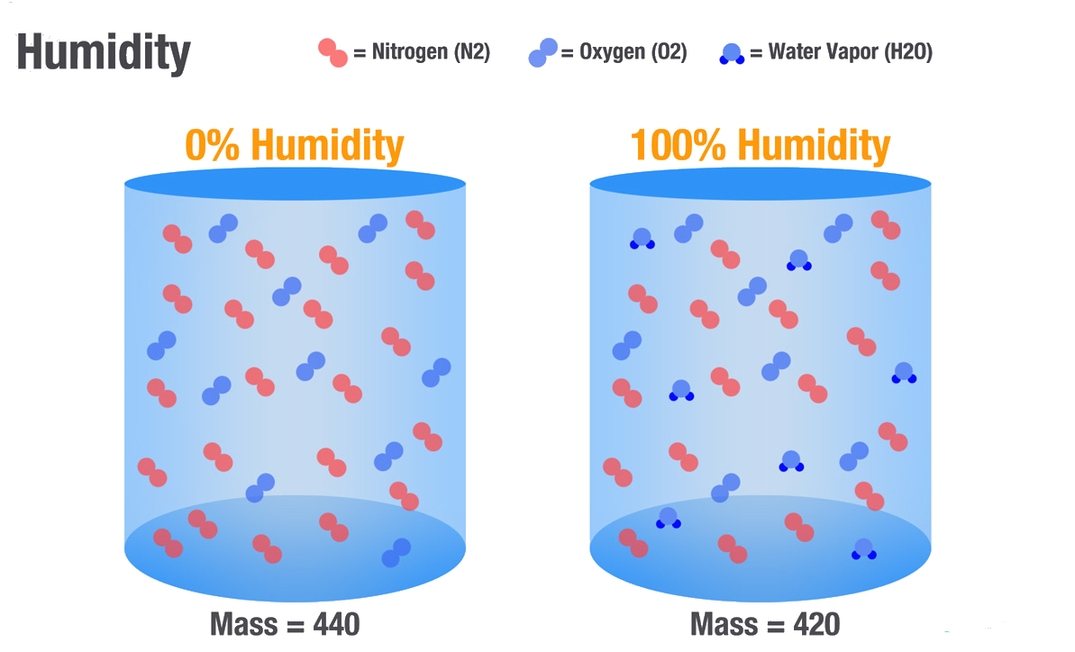  L  H

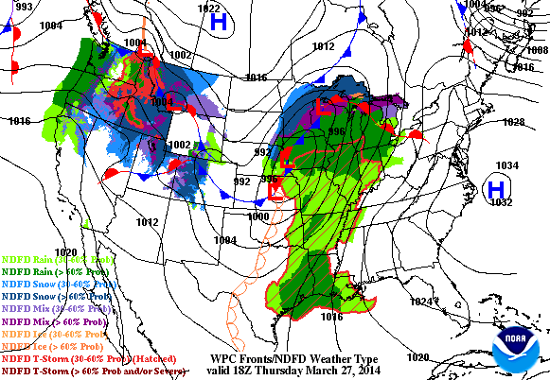
AIR PRESSURE AND WEATHER
- What type of pressure systems brings
stormy weather according to the weather
maps above? Why?

FRONTS-WHEN AIR MASSES MEET
DEMO: Watch the simulation of a hot and cold “air mass” meeting.
- Make a prediction of what you think will happen when the hot and cold ”air masses” meet.

- Draw what happens over time.

Directions: Record any observations you believe are necessary to help you understand the differences between fronts, and draw a model showing how air masses interact with one another to form the front.
FRONT & DESCRIPTION | MODEL
Cold Front
Warm Front
Stationary Front
Occluded Front

ANALYSIS:
What type of front (cold, warm, stationary, or occluded) do you think is more likely responsible for:
  - Fog? Why?

  - the rain out (2 days of rain) earlier this year? Why?

  - 1967 blizzard in Lansing? Why?

  - A hail storm? Why?

