Weather- Snow Day Science
Lesson 8-Why Hail
LESSON 7 RECAP:
Last time, we reviewed the water cycle and investigated what conditions are needed for different types of precipitation and why it doesn’t precipitate all the time.

- Fill-in the diagram with the parts of the water cycle.
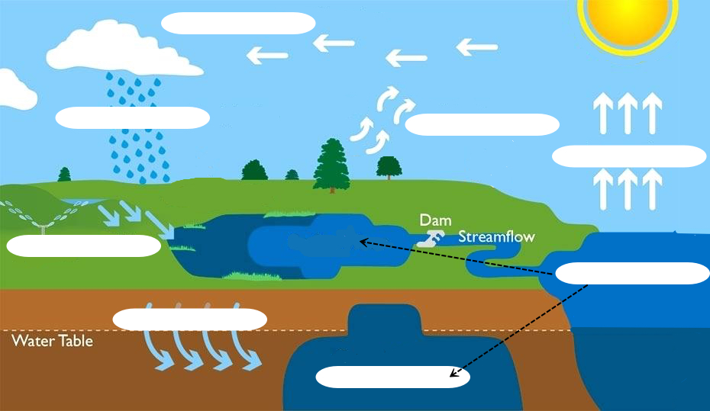
Word Bank:
Evaporation
Transpiration
Condensation
Precipitation
Storage
Groundwater
Infiltration
Run-off

- What two “forces” drive the water cycle? (Without them the water cycle would not exist).

- Based on the diagram below and our last lesson, why do we get different types of precipitation? Label what type of precipitation each of these results in.
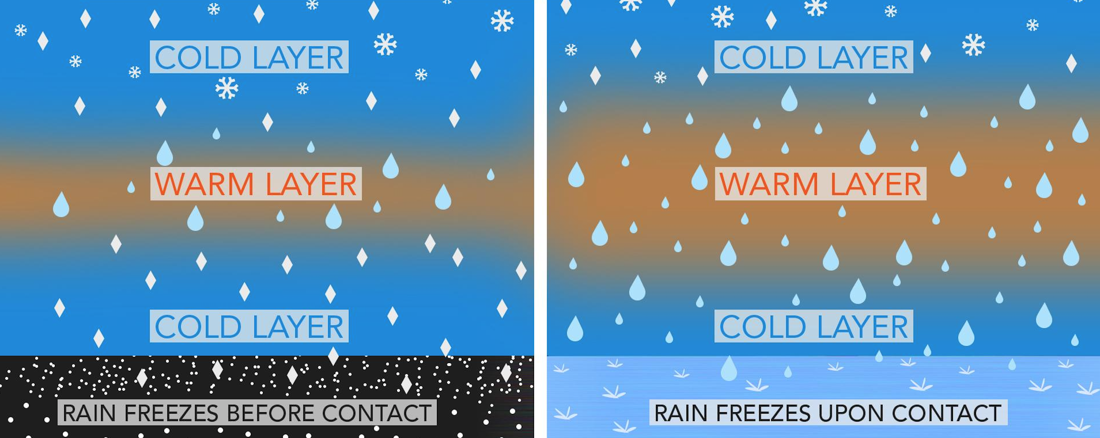

- Draw the movement of and the lift force acting on the precipitation based on the key and scenario given.
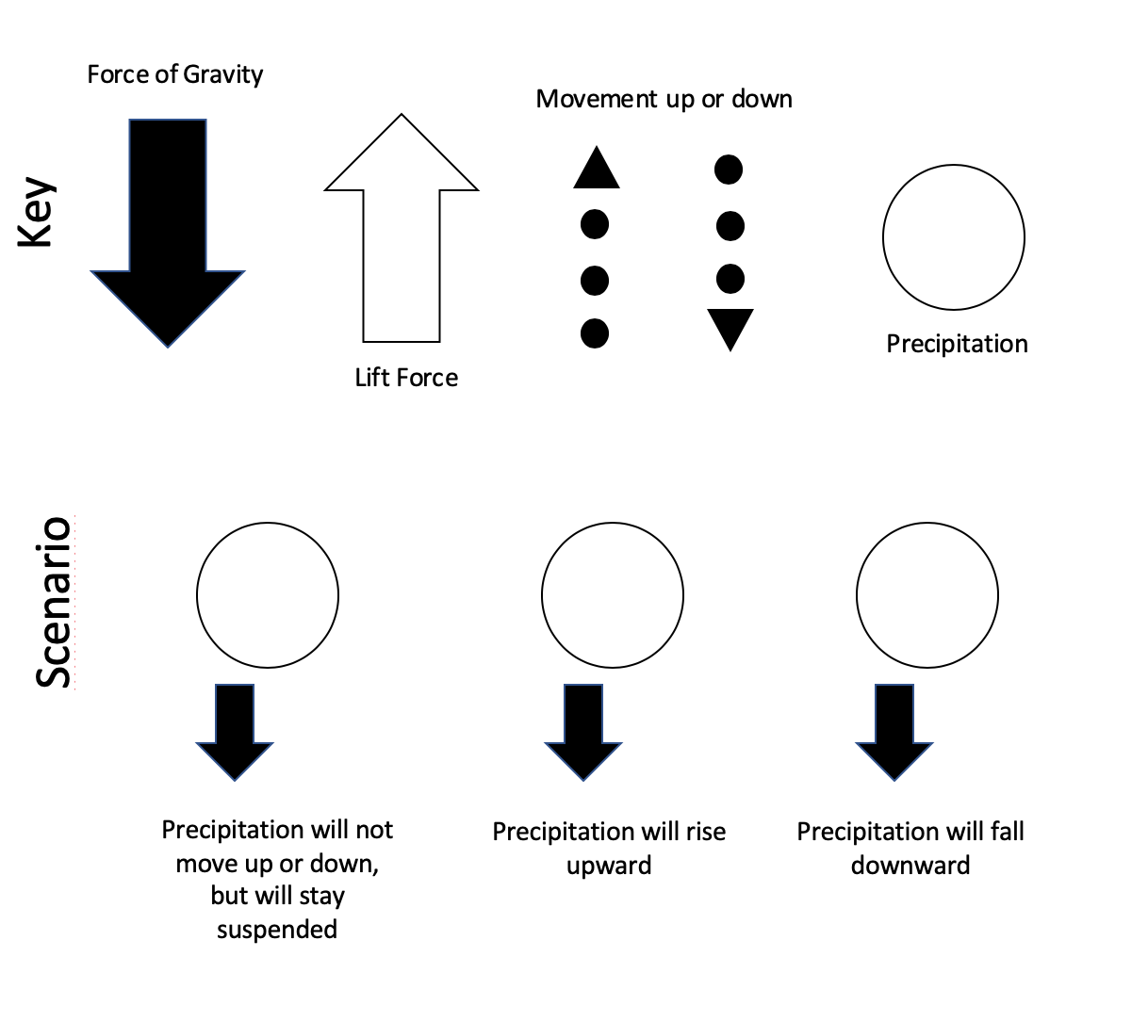

- Use the model to explain why it doesn’t precipitate as soon as water condenses.

INVESTIGATION QUESTION: __________________________________________________________________________________________________
__________________________________________________________________________________________________
BACKGROUND: HOW DOES HAIL FORM?
Watch the ‘Formation of Hail’ video and answer the following questions:
- What, in some thunderstorms, pushes rain and ice pellets high into a thunderstorm keeping them suspended within a storm to form hail?

- What are temperatures like in this area?

- What happens when ice pellets comes into contact with a water droplets? If this happens slowly what does the ice look like? What happens if it happens quickly?

- The longer a strong updraft is present the _________________ the hail stone can become.

- Pea size hail can be formed with updrafts of ___________. Softball size hail needs updrafts of ____________.

PLANNING OUR INVESTIGATION-
Question- What causes more lift in one cloud versus another?
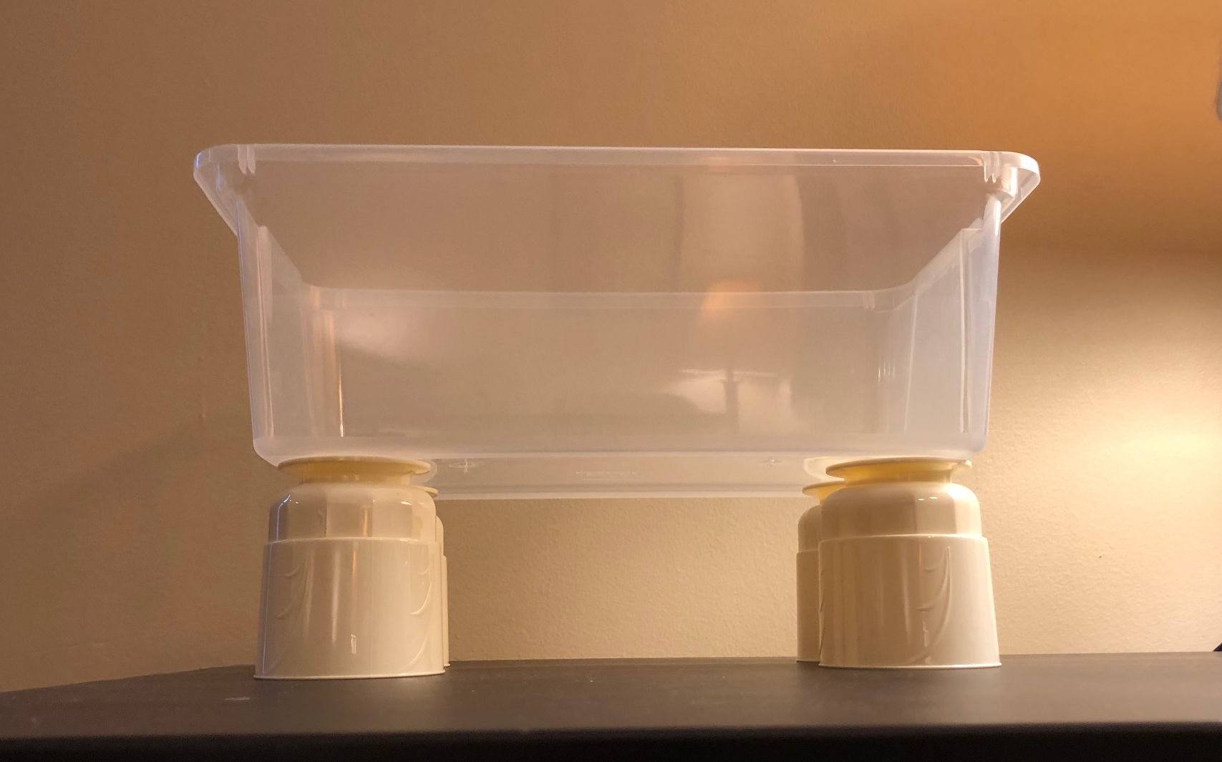
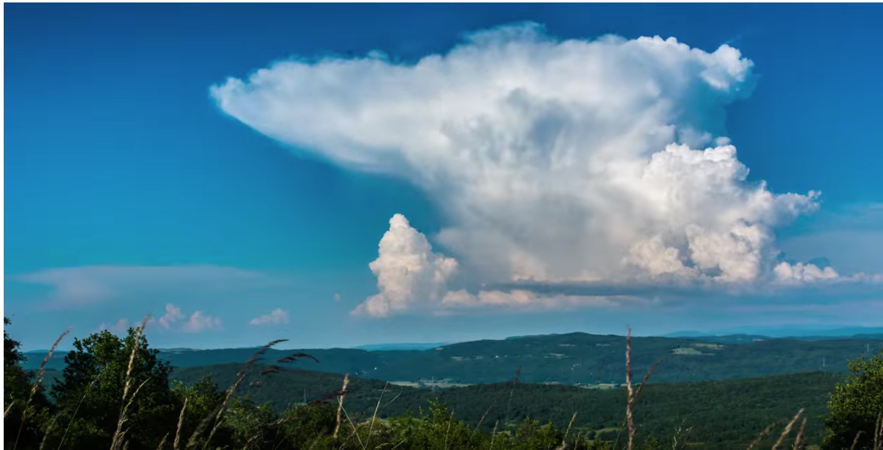
Observe set-up of demonstration and fill in the following:
B
B
A
A

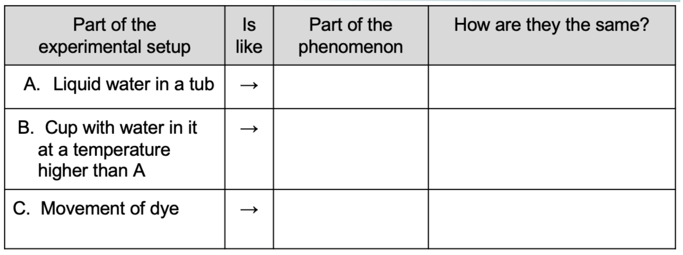
- Describe the movement of the dye after it was added to the water and draw what you observed.

- How does the movement of the dye over the warm cup relate to what is happening with the air in the atmosphere over warm ground?

- Identify the following for this investigation:
Hypothesis: ________________________________________________________________________________________
__________________________________________________________________________________________________
Independent variable: _____________________________ Dependent variable:_________________________________
Constants:___________________________________________________________________________________________________________________________________________________________________________________________
OBSERVATIONS:
Relative Temperature at “B” | Observations
Hot
Cold

Question
A group of scientists measures the temperature of the ground and the air above that surface at three locations. Which location would you expect to have the strongest updrafts?

CLAIM:
Circle one
  - an area where the surface temperature is much greater than the air above it
  - an area where the surface temperature is colder than the air above it
  - an area where the surface temperature is the same as the air above it
EVIDENCE:

REASONING:

ANALYSIS:

CONCLUSION- PUTTING IT ALL TOGETHER
- What claims can we make about what causes different strength or size of updrafts?

- Where is the thermal energy coming from that causes the updrafts? Where did this energy originally come from?

- What is happening to the air molecules in an updraft? (Speed, arrangement, density???)

- What did we call that movement for air? For water?

- Why would higher temperature differences between the surface and the air above make for stronger convection and evaporation?

- What types of surfaces can absorb more radiant energy and cause a higher temperature difference?

NEXT STEPS:
What about other movement? What did we notice happening in the water and dye investigation at the surface and at the bottom of the tub? What do you think this might be simulating?

