Weather- Snow Day Science
Lesson 4-Effects of Temperature
INVESTIGATION QUESTION: __________________________________________________________________________________________
__________________________________________________________________________________________
LESSON 3 RECAP:
In the last lesson, we collected data from a virtual weather balloon and noticed a pattern in air temperatures between the ground and higher up.

- What did we notice about the temperature taken by the weather balloon at different altitudes?

- What happens to the kinetic (motion) energy of molecules as their temperature increases?

- Draw a picture of air molecules that are at a higher altitude vs a lower altitude
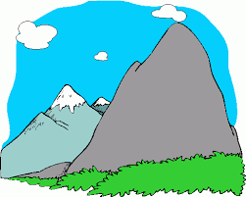

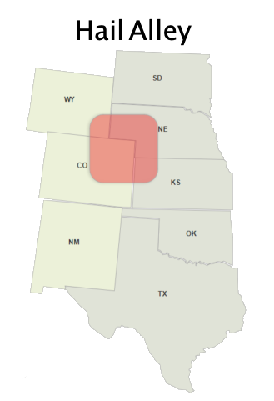

Reminder: Freezing level is the minimum altitude (height above Earth) that the temperature reaches 0°C (32°F) or the freezing point of water.

- Hailstorms happen frequently in an area of the US referred to as hail alley (see map). What did we predict was probably true about the average freezing level in this area?
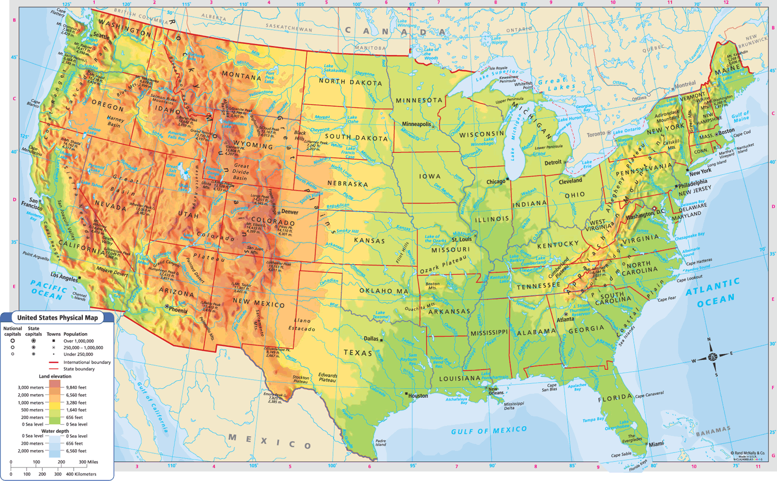

5. Based on the elevation map, why do you
think your answer to #4 is true?

Part 1: Temperature and Sunlight Investigation
PREDICTION:
If we gathered data by moving closer to the ground, what do you expect we would see happen to the air temperature?

PLANNING OUR INVESTIGATION:
Question: How does the air near the ground compare to the air right above it?
Record your ideas below about the following:
- How should we test this?
- What data should we collect? How should we measure it?
- Would it matter what part of the grounds we took these measurements from? Why?
- What other evidence/data do we need to look for and record?

Data source: Describe the surface | Incoming light  (to the surface)  (lux) | Reflected light  (from the surface)  (lux) | Temperature of that surface  (1 in. above)  (℉) | Temperature of air above that surface  (4 ft. above)  (℉)

ANALYZING THE DATA:
What do you notice about the temperature data?
- Is the ground temperature and the air temperature the same at the each site?
- Which surfaces have the warmest temperatures?
- Which surfaces have the coolest temperatures?
What do you notice about the sunlight data:
- Are all surfaces the same? Why or why not?
- Which surfaces reflected the most light?
- What does difference between incoming sunlight and reflected sunlight mean? Where does that difference go?
MAKING SENSE:
Draw (model) and write what you think is happening in this case: There are two different surfaces. Both surfaces receive the same incoming sunlight, but one surface is dark and the other is light. In your model, try to answer the following questions:
- What type of heat transfer (conduction, convection, or radiation) is occurring as sunlight is coming to each surface?
- How much light is coming in and reflected at each surface?
- Where does the other sunlight go (that isn’t reflected)?
- What type of heat transfer (conduction, convection, or radiation) is occurring as sunlight heats up each surface and that heat is transferred to the air right above the surfaces?
- What is the temperature of each surface?
- Why do you think different surfaces may produce different results?

Part 2: Soap Bubble and Bottle Investigation
. PREDICTIONS:
- What will happen to air when it is in contact with a warmer surface?

- What will happen air when it is in contact with a colder surface?

TESTING OUR IDEAS:
Soap Bubble and Bottle Investigation
 | Cold Water Bath | Warm Water Bath
Trial 1
Trial 2
Trail 3

MODELING OUR OBSERVATIONS:
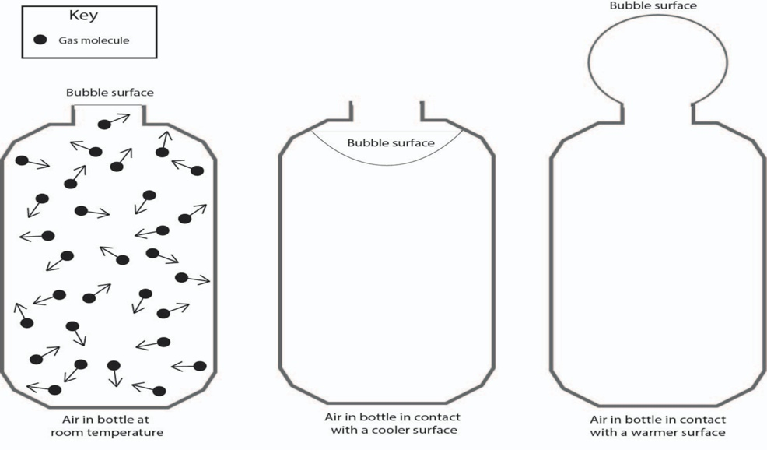

ANALYZING THE DATA:
- Is this an open or closed system?

- As the temperature decreases, what does your model predict will happen:
  - To the spacing between the air molecules:

  - To the speed of the air molecules:

- As the temperature increases, what does your model predict will happen:
  - To the spacing between the air molecules:

  - To the speed of the air molecules:

Part 3: Heated Balloon Investigation
OBSERVATIONS:
As you watch the demo, write down or draw a picture of your observations.

ANALYZING THE DATA:
1. If both the number and size of the gas molecules didn’t increase in the balloon after we heated it, then what happened to them that caused the balloon to increase in volume? Draw and label what is happening to the gas molecules that can explain this.
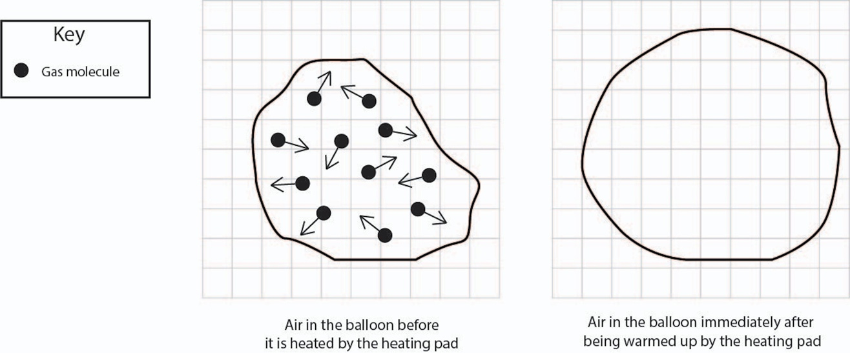
- In which case are the air particles more densely packed together?
- How is the temperature of the air molecules in the balloon changing right before it starts to fall back down?
- How is the density of the air molecules in the balloon changing right before it starts to fall back down?
Problem/Question
Why does the balloon rise or fall in the surrounding air?
Claims | Evidence

MAKING SENSE
Thinking about all that you have discovered, use the space below to construct a model showing what happens to air that comes into contact with Earth’s surface. Answer the following questions as part of your model.
- What type of heat transfer (conduction, convection, or radiation) is occurring as heat from the surface comes into contact with the air ?
- How are temperature, density, and motion of molecules playing a role in what we observe?
- What type of heat transfer (conduction, convection, or radiation) is occurring as the balloon is rising into the air?

CONCLUSIONS
Activity: Effects of Temperature | Problem/Question:  How does the temperature of the ground affect the air right above it?
 | Claim(s): | Evidence:
 | Connections – How do our discoveries explain why it might precipitate a lot at some times, but not at others?
 | Future Steps -- I am now wondering:

