Weather- Snow Day Science
Lesson 3-The Air Up There
INVESTIGATION QUESTION: __________________________________________________________________________________________________
__________________________________________________________________________________________________

BACKGROUND INFORMATION: WHAT IS IN THE AIR?
Annotate the following text to answer the questions below-
- What is an atmosphere? What is its purpose?
- How many layers does the Earth’s atmosphere have?
- In what layer of the atmosphere does weather occur?
- What are the two major atmospheric gases?
- What is the role of the ozone layer?
- What is the role of greenhouse gases?
Earth’s Atmosphere-
An atmosphere is the blanket of gases surrounding a planet. Earth is the only planet in the solar system with an atmosphere that can sustain life. The blanket of gases not only contains the air that we breathe but also protects us from the blasts of heat and radiation coming from the sun. It warms the planet by day and cools it at night.
Earth's atmosphere is about 300 miles (480 kilometers) thick, but most of it is within 10 miles (16 km) the surface. Earth's atmosphere is divided into five main layers: the exosphere, the thermosphere, the mesosphere, the stratosphere and the troposphere.
The troposphere is the layer closest to Earth's surface. It is 4 to 12 miles (7 to 20 km) thick and contains half of Earth's atmosphere. Weather happens in this layer of the atmosphere.
Just What is Air? -
The atmosphere surrounding Earth is full of air! Air is easy to forget about. We usually can’t see it, taste it, or smell it. We can only feel it when it moves. But air is actually made of molecules of many different gases. It also contains tiny particles of solid matter.

Gases in the Air-
The figure below shows the main gases in air. Nitrogen makes up approximately 78% of air, and oxygen makes up approximately 21% of air. Trace gases, which include argon, carbon dioxide, neon, helium, methane, krypton, and hydrogen, make up approximately 1% of air. These percentages are the same just about everywhere in the atmosphere. The atmosphere is the envelope of gases that surrounds Earth.
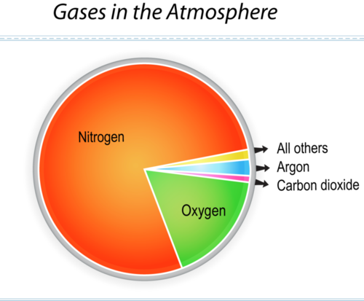

This graph identifies the most common gases in air.

Air also includes water vapor. The amount of water vapor varies from place to place. That’s why water vapor isn’t included in the figure above. It can make up as much as 4% of the air.
There is a special layer of air molecules high in the stratosphere layer of Earth’s atmosphere, called the ozone layer. The composition of the atmosphere is different in the ozone layer. There are more ozone molecules than anywhere else. Ozone molecules help block some of the Sun’s strongest rays. Currently, scientists are monitoring this layer. It has recently become so thin at the South Pole where the molecules are being destroyed that we call it a “hole”.
Greenhouse Gases
Greenhouse gases trap heat in the atmosphere. This is essential so that Earth has a more moderate temperature. Without greenhouse gases, nighttime temperatures would be frigid. Natural greenhouse gases include carbon dioxide, methane, water vapor, and ozone. CFCs and some other man-made compounds are also greenhouse gases. Human activities may increase the amount of greenhouse gases, like carbon dioxide, in the atmosphere.

Modified from Desonie, Dana Ph.D, “Composition of the Atmosphere.” 05 Jan. 2013, modified 20 November 2019, https://www.ck12.org/earth-science/composition/lesson/Composition-of-the-Atmosphere-MS-ES/ Accessed 08 Feb. 2020. and Sharp, Tim,“Earth's Atmosphere: Composition, Climate & Weather.” Space.com. 13 Oct. 2017, Accessed 08 Feb. 2020.
BILL NYE-ATMOSPHERE
As you watch the video, fill in the following:

- The ozone layer blocks out _____________________ light.
- We live in an ____________________ of air.
- The atmosphere acts as a _________________ to keep the Earth warm.
- The lowest and thickest layer of the atmosphere is the ____________________________.
- The lower the pressure, the higher the ____________________.
- Water boils ___________________ in the mountain.
- Name the layers of the atmosphere from upper most layer to the bottom layer:

- Why is it colder in the mountains than in lower elevations?

- The rate of cooling as you increase in elevation is called the ___________________________________.
- This rate of cooling is about ________ ̊ per kilometer.
11. When an atmosphere keeps a planet warm, it’s called the ____________________________________.
12. Sunlight and chemicals create _______________________ smog.
13. The _________________ in coal can cause acid rain when the coal is burned.
14. The troposphere is the part of the atmosphere where we have ___________________________.

LESSON 2 RECAP:
What was the air outside like on a day when it hailed?
Precipitation Event | Temperature | Humidity | Wind | Time of Year | Time of Day
Hail

PREDICTIONS:
- How do we get ice during conditions like these (in table above and in the video of the beach)?

- If you could explore the air high above the ground, how do you think it would compare to the air near the surface?

- What are some ways that we could put devices that record such measurements up in the air?

WEATHER BALLOONS:
As you watch the videos, listen for and record what kind of data the weather balloon measures.

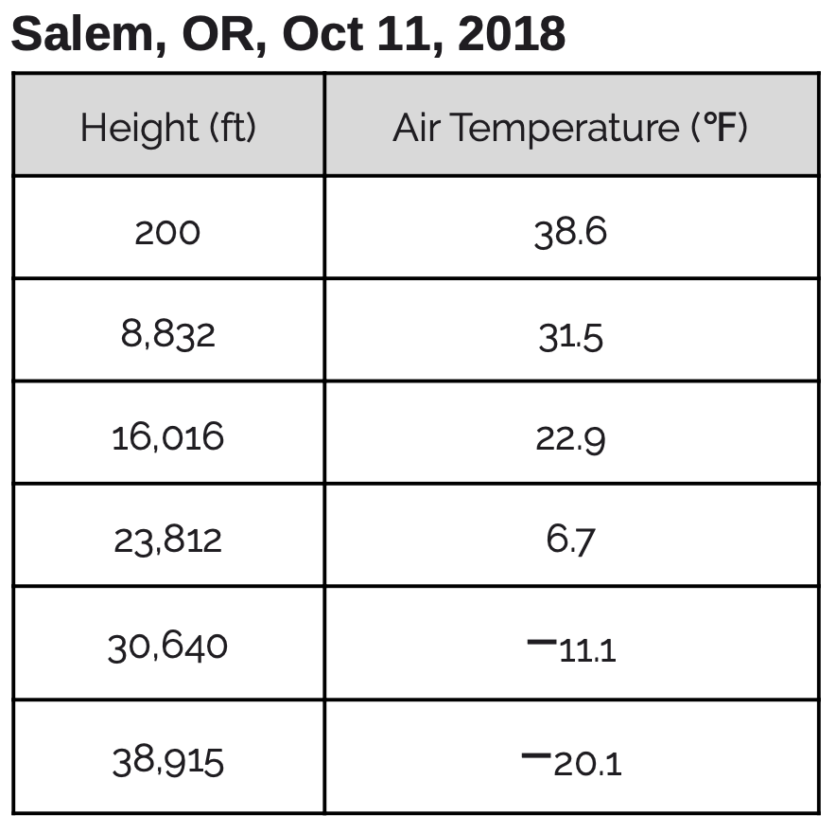
WEATHER BALLOON DATA:
Below you will find air temperature for cities across the US at varying altitudes and times of the year. Annotate the tables with your observations and your wonderings/questions.
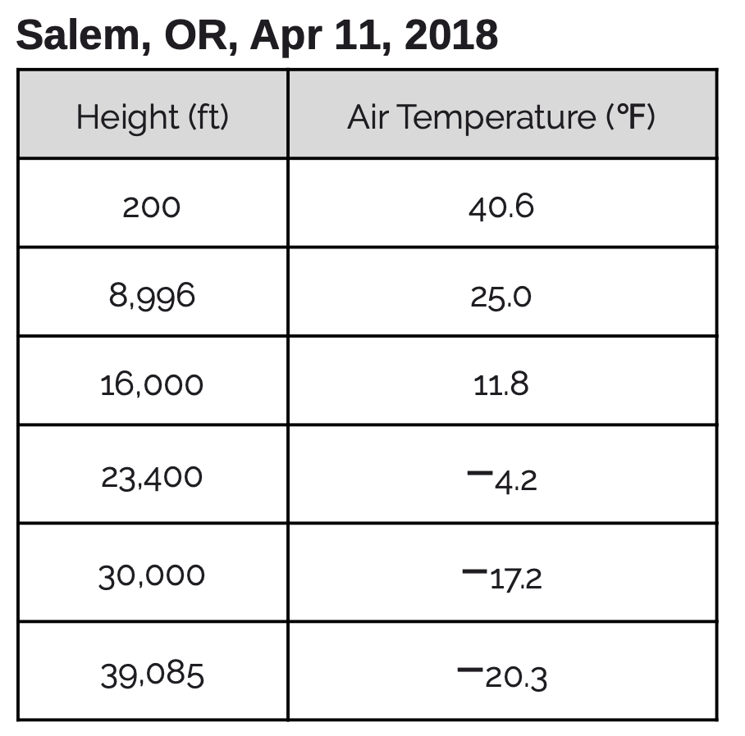
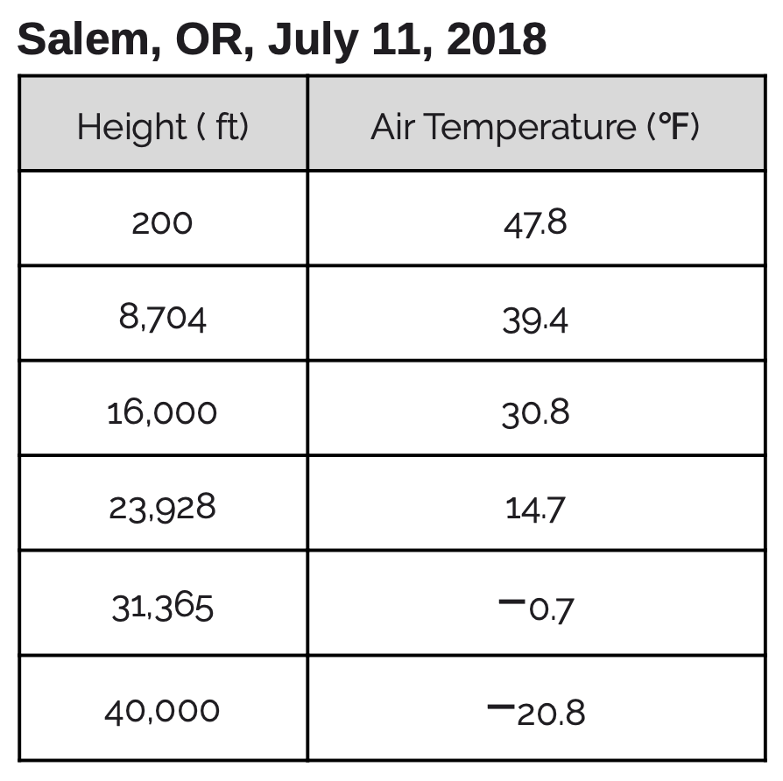

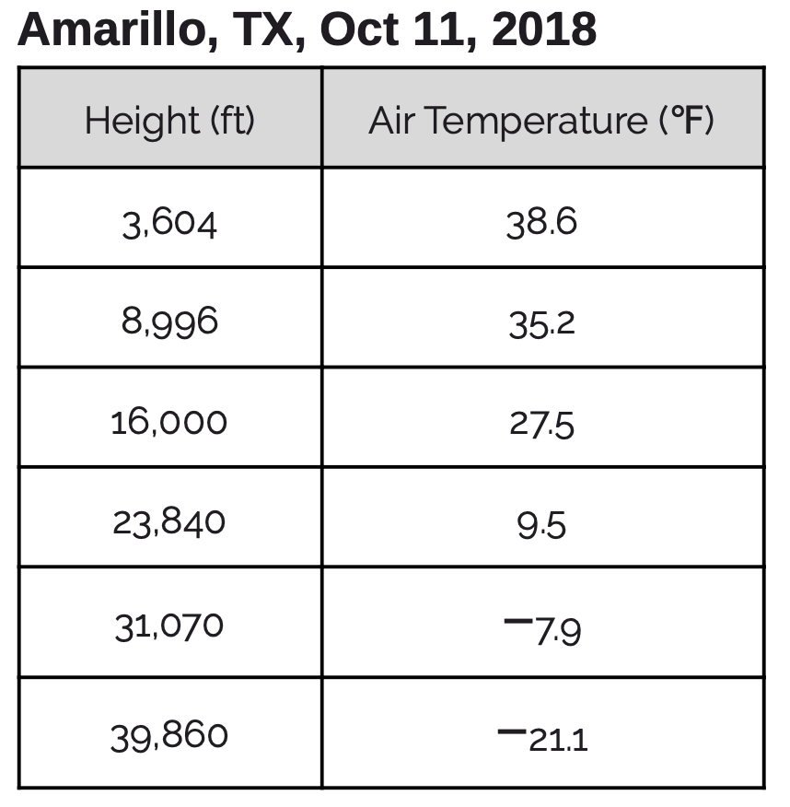
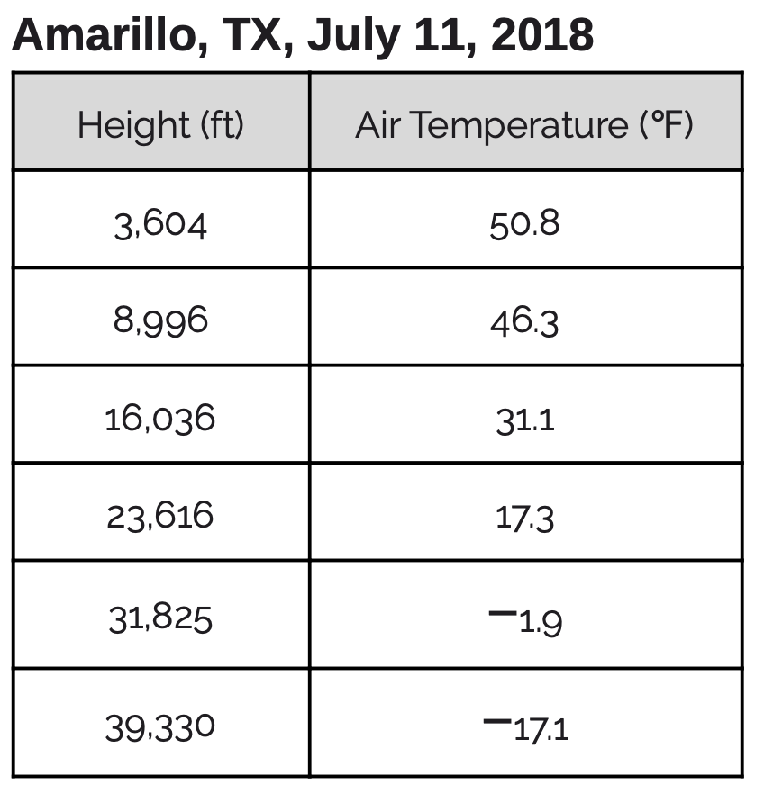
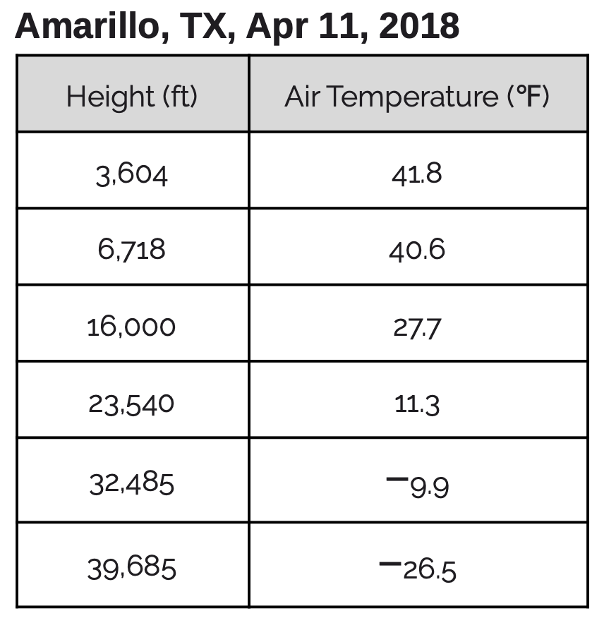

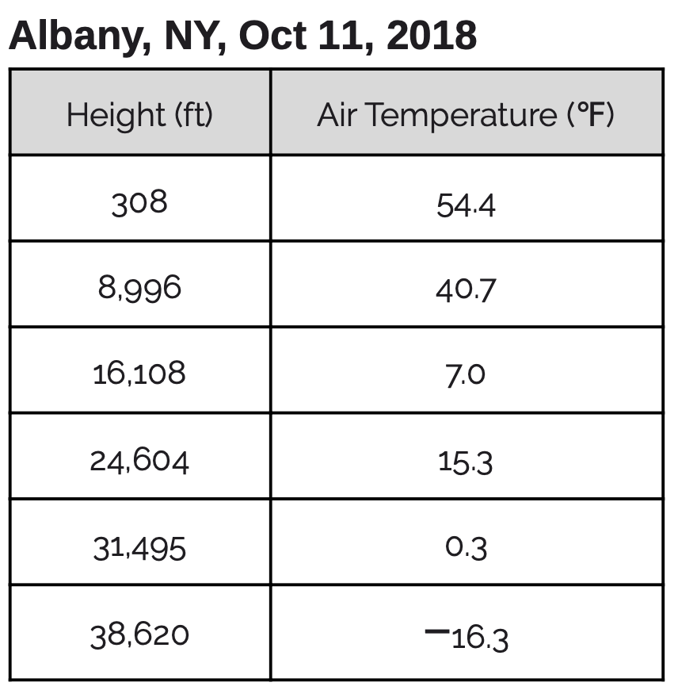
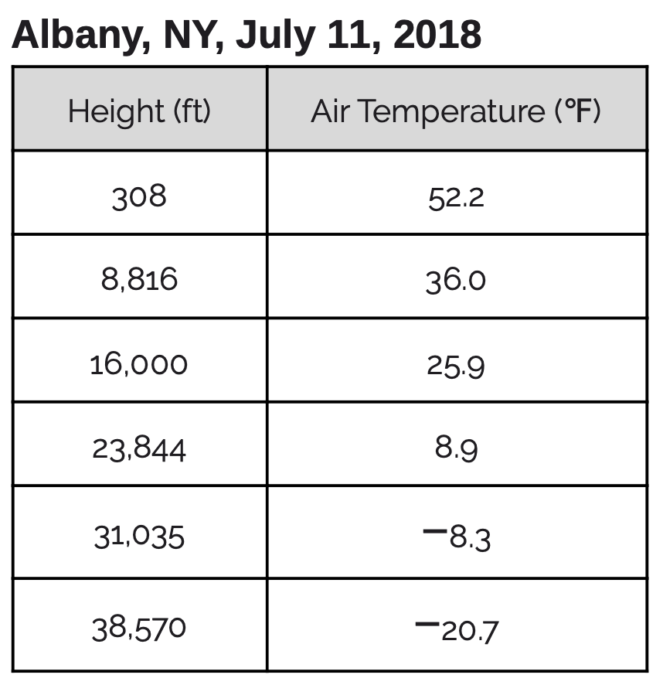
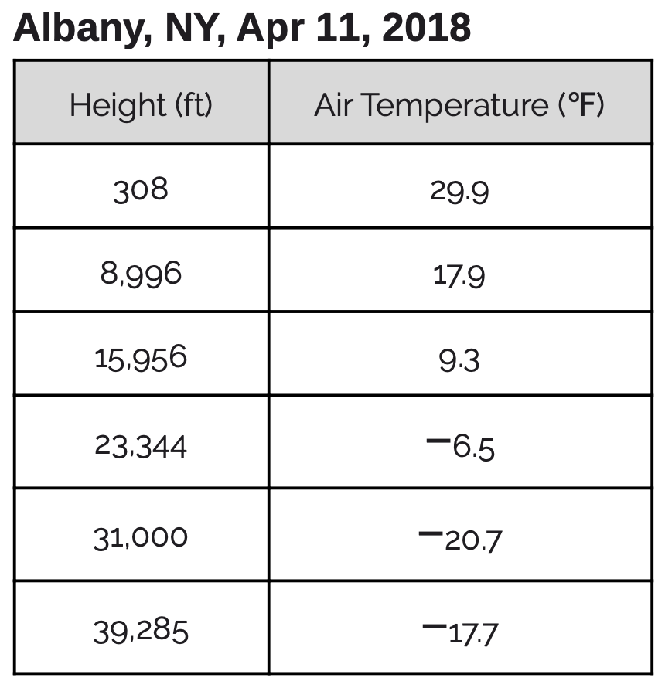

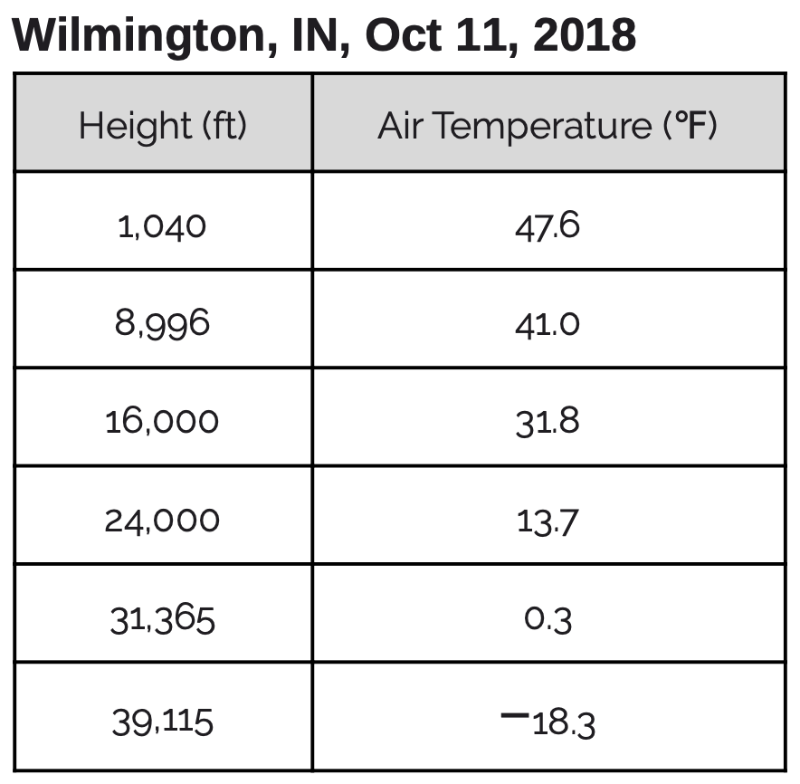
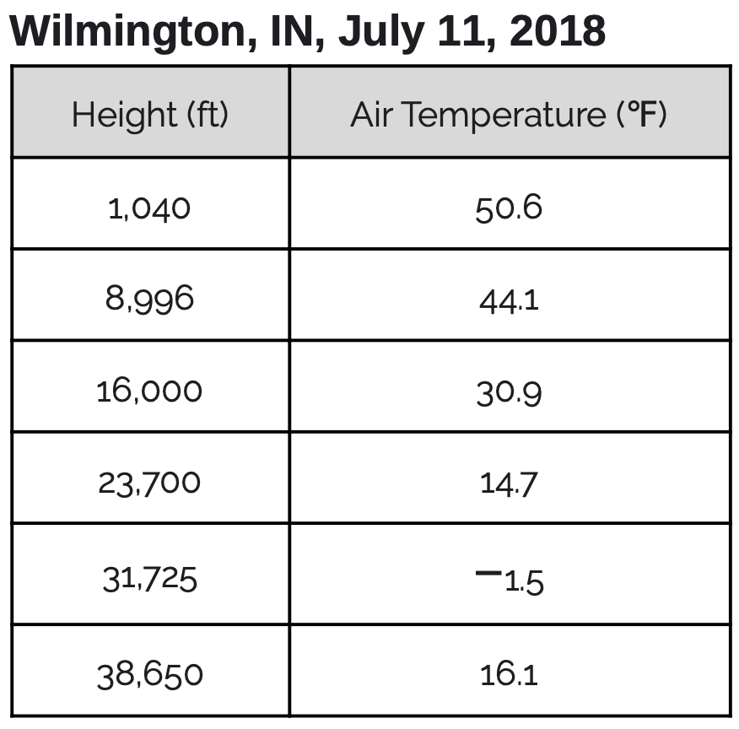
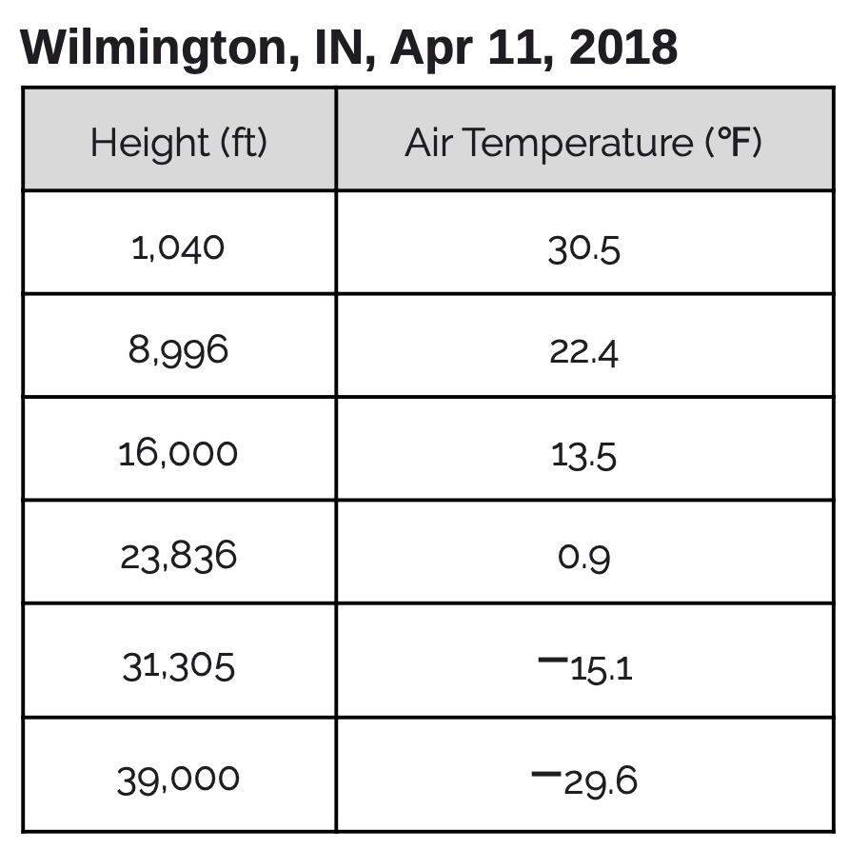

MAKING SENSE:
What patterns do you notice for the weather balloon data?
- What happens to the air temperature as the altitude (height above Earth) increases?

- What effect does time of year have on this trend?

ARGUING FROM EVIDENCE:

Problem/Question
How will the temperature of the air higher up compare to the temperature of the air closer to the ground?”
Claims | Evidence
Below is a picture of Mt. Everest and its base camp. Support the claim with evidence and reasoning.
Claims | Evidence and Reasoning
If it were raining at base camp, then it would be snowing at the peak of Mt. Everest.

MAKING CONNECTIONS:
Freezing Level-
Freezing level is the minimum altitude (height above Earth) that the temperature reaches 0°C (32°F) or the freezing point of water.

One of the hailstorms that we watched, happened in Phoenix, Arizona (* on the maps) on a day where the temperatures were in the 80s. Annotate the maps below regarding the freezing level (feet above the ground) over the course of a couple of days. (The hailstorm happened on October 5th)
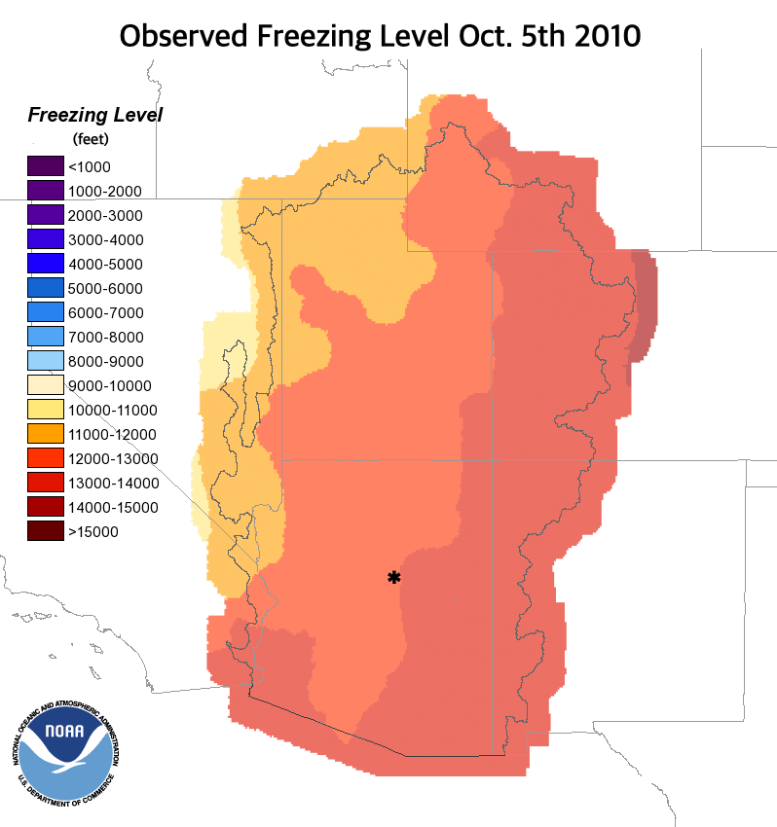
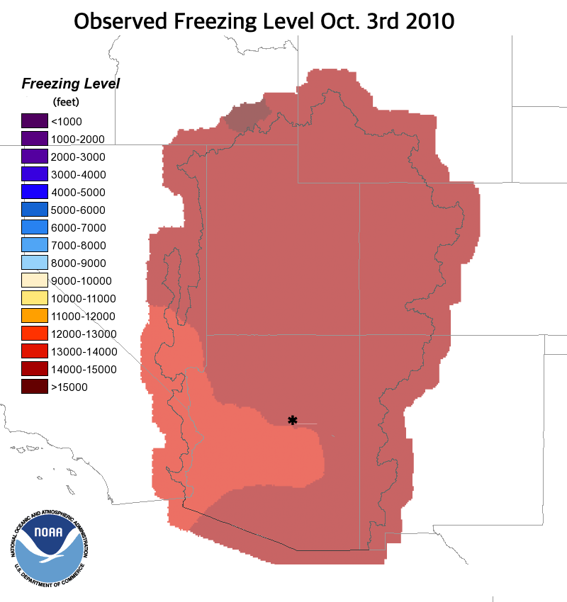

- What happened to the freezing level in Phoenix from October 3rd to October 5th?

- How do you think this contributed to the likelihood of the hailstorm?

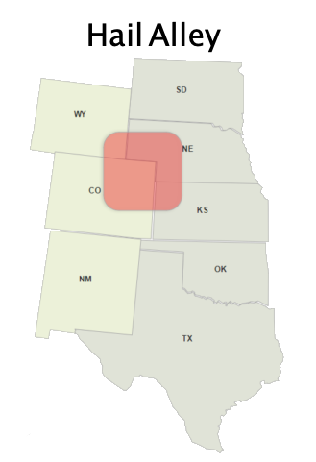

- What do you think is true about the average freezing level in Hail Alley, where hailstorms happen the most frequently?

MOLECULES, HEAT, AND TEMPERATURE
As you watch the video, fill in the blanks.
- You can see what energy ____________, but you cannot _____________ it directly.
- Potential energy is energy _____________________________________________________.
- Kinetic energy is the energy of ___________________________.
- The _______________ kinetic energy a group of molecules has, the _____________________ the temperature.
- How could we represent the temperature differences between the air molecules up high in the atmosphere and the air molecules closer to the ground? Draw a model of air molecules at each different altitudes.
Air molecules at high altitude

Air molecules at low altitude

PREDICTIONS

- Why would it be colder in the mountains? It’s closer to the sun and we’ve always heard that heat rises. Make a prediction of what you think causes it to be colder at higher altitudes.

- If we went outside, do you think we would also find a difference in the temperature of the air a few feet above the ground compared to the temperature of the air right next to the ground?

