Weather- Snow Day Science
Lesson 2-Clues from Weather Data
INVESTIGATION QUESTION: ________________________________________________________________________
__________________________________________________________________________________________________
Last time, we observed some interesting videos of hail (ice) falling from the sky and thought about other weather events where there was a lot of precipitation.
If you were at a spot where you knew a hailstorm was going to occur, what are some observations you would make to figure out what caused the hailstorm to happen?
________________________________________________________________________________________________________________________________________________________________________________________________________________________________________________________________________________________________________________________________________________________________________________________________________

Below you will see a radar image of hailstorm that took place near Fort Scott, Kansas. Annotate the image by recording your observations and wonderings/questions.
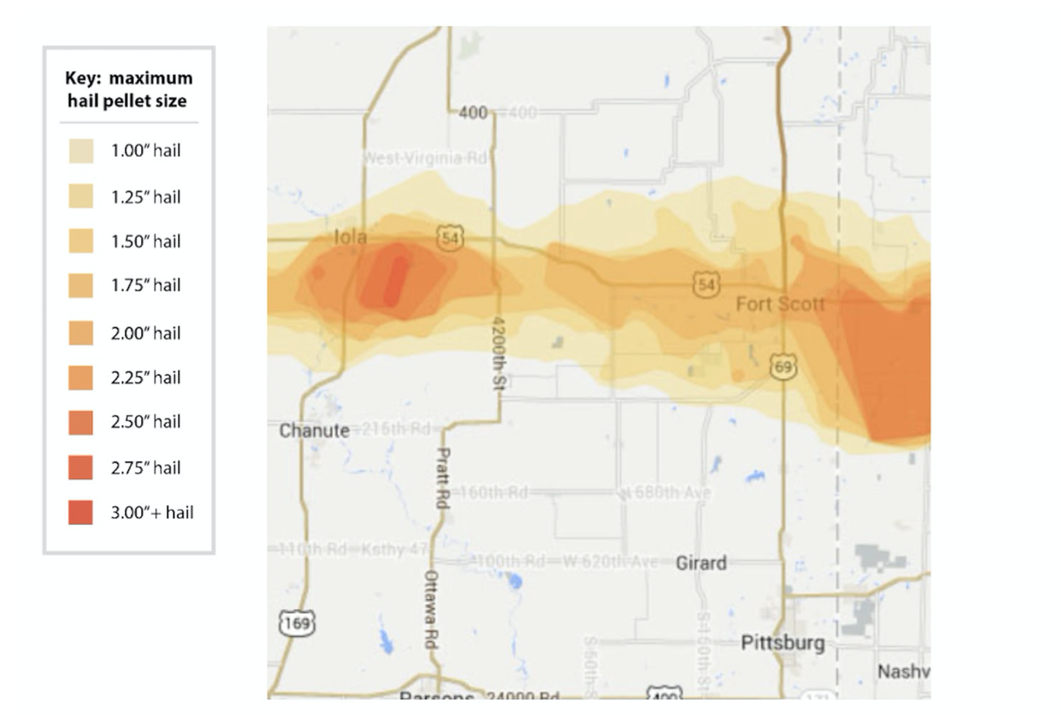

ANALYZING PRECIPITATION EVENTS
KANSAS HAILSTORM
- Below you will find weather data from the nearest weather station about a hailstorm that took place at 4:25 p.m. in Fort Scott, Kansas. Some of the hailstones from this storm measured 3.00+ inches in diameter. Annotate the table with your observations and your wonderings/questions. Pay attention to the following:

- Overall temperature
- Temperature changes
- Overall humidity
- Humidity changes
- Changes in wind
- Time of day
- Time of year

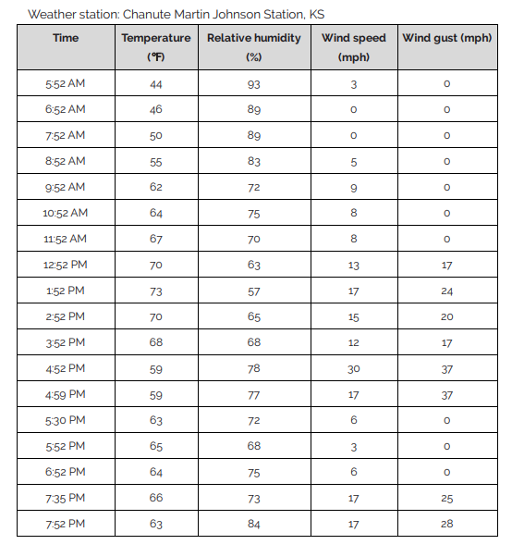
On the other case files provided for the other 7 sites, annotate the data tables with your observations and your wonderings/questions.

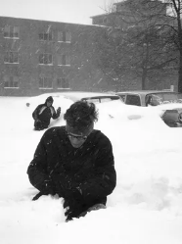
BLIZZARD OF 1967
Below you will weather data from the nearest weather station to Lansing, Michigan on the days surrounding a historic, “paralyzing” blizzard. A record amount of snow, 24 inches, fell January 26-27, 1967. Annotate the tables with your observations and your wonderings/questions.
January 25, 1967
Time | Temperature | Humidity | Wind | Wind Speed | Wind Gust | Pressure
1:00 AM | 57 F | 83 % | SW | 23 mph | 0 mph | 28.79 in
4:00 AM | 54 F | 75 % | SSW | 20 mph | 0 mph | 28.78 in
7:00 AM | 43 F | 86 % | WSW | 28 mph | 0 mph | 28.93 in
10:00 AM | 37 F | 86 % | WSW | 20 mph | 0 mph | 29.03 in
1:00 PM | 35 F | 85 % | WSW | 20 mph | 0 mph | 29.08 in
4:00 PM | 34 F | 82 % | W | 18 mph | 0 mph | 29.14 in
7:00 PM | 0 F | 85 % | W | 12 mph | 0 mph | 29.22 in
10:00 PM | 0 F | 82 % | W | 15 mph | 0 mph | 29.22 in
January 26, 1967 – Approximately 15 inches of snow fell
Time | Temperature | Humidity | Wind | Wind Speed | Wind Gust | Pressure
1:00 AM | 31 F | 82 % | NW | 7 mph | 0 mph | 29.27 in
4:00 AM | 30 F | 82 % | N | 13 mph | 0 mph | 29.29 in
7:00 AM | 28 F | 85 % | NNE | 15 mph | 0 mph | 29.30 in
10:00 AM | 24 F | 88 % | ENE | 17 mph | 0 mph | 29.30 in
1:00 PM | 24 F | 88 % | NE | 13 mph | 0 mph | 29.23 in
4:00 PM | 25 F | 92 % | ENE | 14 mph | 0 mph | 29.15 in
7:00 PM | 25 F | 92 % | NE | 15 mph | 0 mph | 29.13 in
10:00 PM | 25 F | 92 % | NE | 18 mph | 0 mph | 29.02 in
January 27, 1967 – Approximately 9 inches of snow fell
Time | Temperature | Humidity | Wind | Wind Speed | Wind Gust | Pressure
1:00 AM | 25 F | 96 % | NE | 20 mph | 0 mph | 28.85 in
4:00 AM | 26 F | 92 % | NNE | 23 mph | 0 mph | 28.72 in
7:00 AM | 25 F | 96 % | NNE | 26 mph | 0 mph | 28.60 in
10:00 AM | 26 F | 92 % | NNE | 23 mph | 0 mph | 28.56 in
1:00 PM | 24 F | 91 % | N | 21 mph | 0 mph | 28.54 in
4:00 PM | 22 F | 92 % | NNW | 18 mph | 0 mph | 28.59 in
7:00 PM | 22 F | 92 % | NNW | 20 mph | 0 mph | 28.67 in
10:00 PM | 21 F | 92 % | NNW | 17 mph | 0 mph | 28.69 in
January 28, 1967
Time | Temperature | Humidity | Wind | Wind Speed | Wind Gust | Pressure
1:00 AM | 23 F | 85 % | WNW | 21 mph | 0 mph | 28.69 in
4:00 AM | 25 F | 78 % | WNW | 16 mph | 0 mph | 28.72 in
7:00 AM | 27 F | 78 % | WNW | 21 mph | 0 mph | 28.77 in
10:00 AM | 24 F | 84 % | WNW | 21 mph | 0 mph | 28.82 in
1:00 PM | 28 F | 72 % | WNW | 21 mph | 0 mph | 28.86 in
4:00 PM | 29 F | 72 % | W | 18 mph | 0 mph | 28.88 in
7:00 PM | 28 F | 75 % | WNW | 14 mph | 0 mph | 28.96 in
10:00 PM | 27 F | 78 % | NNW | 12 mph | 0 mph | 29.01 in

RAINED OUT
Below you will weather data from the nearest weather station to Lansing, Michigan on the days of rain that prevented seventh grade MacDonald Middle Students from participating in a field trip. Annotate the tables with your observations and your wonderings/questions.
Time | Temperature | Dew Point | Humidity | Wind | Wind Speed | Wind Gust | Pressure | Condition
11:36 PM | 71 F | 65 F | 81 % | N | 20 mph | 29 mph | 29.00 in | Thunder in the Vicinity
11:49 PM | 70 F | 66 F | 88 % | N | 13 mph | 23 mph | 29.01 in | Heavy T-Storm
11:53 PM | 69 F | 66 F | 90 % | N | 8 mph | 20 mph | 29.00 in | Heavy T-Storm
October 2, 2019
12:01 AM | 68 F | 67 F | 96 % | N | 5 mph | 0 mph | 28.99 in | Light Rain
12:09 AM | 69 F | 67 F | 93 % | SE | 3 mph | 0 mph | 28.98 in | Light Rain
12:53 AM | 69 F | 67 F | 93 % | CALM | 0 mph | 0 mph | 28.98 in | Cloudy
1:15 AM | 69 F | 67 F | 93 % | NNW | 6 mph | 0 mph | 28.99 in | Cloudy
1:21 AM | 69 F | 67 F | 93 % | N | 10 mph | 0 mph | 29.00 in | Light Rain with Thunder
1:28 AM | 68 F | 66 F | 93 % | NW | 9 mph | 24 mph | 29.02 in | Heavy T-Storm
1:31 AM | 68 F | 66 F | 93 % | NNW | 9 mph | 24 mph | 29.02 in | Heavy T-Storm
1:42 AM | 68 F | 66 F | 93 % | NE | 6 mph | 0 mph | 29.01 in | Heavy Rain
1:45 AM | 68 F | 66 F | 93 % | VAR | 5 mph | 0 mph | 29.01 in | Heavy Rain
1:53 AM | 68 F | 65 F | 90 % | ESE | 3 mph | 0 mph | 29.01 in | Light Rain
2:53 AM | 67 F | 66 F | 97 % | SE | 3 mph | 0 mph | 28.98 in | Mostly Cloudy
3:53 AM | 67 F | 65 F | 93 % | ESE | 5 mph | 0 mph | 28.96 in | Mostly Cloudy
4:53 AM | 67 F | 65 F | 93 % | CALM | 0 mph | 0 mph | 28.97 in | Partly Cloudy
5:28 AM | 67 F | 65 F | 93 % | NNE | 6 mph | 0 mph | 28.97 in | Mostly Cloudy
5:36 AM | 67 F | 65 F | 93 % | NNE | 6 mph | 0 mph | 28.97 in | Mostly Cloudy
5:43 AM | 67 F | 65 F | 93 % | NE | 14 mph | 0 mph | 28.97 in | Fog
5:45 AM | 66 F | 65 F | 96 % | NE | 13 mph | 0 mph | 28.97 in | Fog
5:53 AM | 64 F | 63 F | 96 % | NNE | 10 mph | 0 mph | 28.98 in | Fog
6:00 AM | 63 F | 62 F | 97 % | NNE | 10 mph | 0 mph | 28.98 in | Fog
6:15 AM | 60 F | 59 F | 96 % | NNE | 10 mph | 0 mph | 28.99 in | Fog
6:53 AM | 58 F | 57 F | 97 % | NNE | 10 mph | 0 mph | 29.01 in | Light Rain
7:05 AM | 58 F | 57 F | 97 % | NE | 6 mph | 0 mph | 29.02 in | Light Rain
7:19 AM | 58 F | 57 F | 97 % | NNE | 9 mph | 0 mph | 29.02 in | Light Rain
7:53 AM | 57 F | 56 F | 96 % | NE | 9 mph | 0 mph | 29.02 in | Light Rain
8:18 AM | 57 F | 56 F | 96 % | NE | 9 mph | 0 mph | 29.02 in | Light Rain
8:53 AM | 58 F | 56 F | 93 % | NNE | 9 mph | 0 mph | 29.03 in | Cloudy
9:53 AM | 58 F | 56 F | 93 % | NE | 14 mph | 22 mph | 29.04 in | Light Rain
10:53 AM | 58 F | 56 F | 93 % | NE | 10 mph | 0 mph | 29.05 in | Light Rain
11:53 AM | 59 F | 56 F | 90 % | NE | 13 mph | 0 mph | 29.05 in | Cloudy
12:53 PM | 60 F | 57 F | 90 % | ENE | 15 mph | 0 mph | 29.05 in | Light Rain
1:53 PM | 59 F | 57 F | 93 % | NE | 10 mph | 0 mph | 29.06 in | Light Rain
2:05 PM | 58 F | 56 F | 93 % | NE | 9 mph | 0 mph | 29.06 in | Rain
2:53 PM | 57 F | 54 F | 89 % | NE | 12 mph | 21 mph | 29.06 in | Light Rain
3:53 PM | 56 F | 54 F | 93 % | NNE | 9 mph | 0 mph | 29.09 in | Light Rain
4:20 PM | 56 F | 54 F | 93 % | NE | 12 mph | 0 mph | 29.08 in | Light Rain
4:28 PM | 56 F | 53 F | 90 % | NE | 9 mph | 0 mph | 29.08 in | Light Rain
4:53 PM | 55 F | 53 F | 93 % | NE | 15 mph | 0 mph | 29.10 in | Fog
5:00 PM | 55 F | 53 F | 93 % | NE | 10 mph | 21 mph | 29.10 in | Cloudy
5:12 PM | 55 F | 52 F | 89 % | NE | 13 mph | 0 mph | 29.10 in | Light Rain
5:51 PM | 54 F | 52 F | 94 % | NE | 12 mph | 0 mph | 29.10 in | Light Rain
5:53 PM | 54 F | 52 F | 93 % | NE | 12 mph | 0 mph | 29.10 in | Light Rain
6:00 PM | 54 F | 52 F | 93 % | NE | 9 mph | 0 mph | 29.11 in | Cloudy
6:53 PM | 53 F | 50 F | 89 % | NE | 14 mph | 0 mph | 29.11 in | Cloudy
7:07 PM | 53 F | 50 F | 89 % | NE | 12 mph | 0 mph | 29.13 in | Cloudy
7:53 PM | 52 F | 50 F | 93 % | ENE | 10 mph | 0 mph | 29.15 in | Light Rain
8:33 PM | 52 F | 49 F | 89 % | ENE | 15 mph | 22 mph | 29.12 in | Light Rain
8:45 PM | 51 F | 49 F | 92 % | ENE | 14 mph | 21 mph | 29.11 in | Light Rain
8:53 PM | 51 F | 49 F | 92 % | ENE | 13 mph | 25 mph | 29.11 in | Light Rain
9:11 PM | 52 F | 49 F | 89 % | ENE | 14 mph | 0 mph | 29.11 in | Cloudy
9:30 PM | 51 F | 48 F | 89 % | ENE | 15 mph | 21 mph | 29.11 in | Cloudy
9:53 PM | 51 F | 48 F | 89 % | ENE | 14 mph | 0 mph | 29.11 in | Cloudy
10:32 PM | 51 F | 48 F | 89 % | ENE | 10 mph | 0 mph | 29.11 in | Cloudy
10:53 PM | 51 F | 49 F | 92 % | ENE | 12 mph | 0 mph | 29.10 in | Light Rain

MAKING SENSE: Analyze the patterns that might help us determine what factors contribute most to precipitation events:
Precipitation Event | Temperature | Dew Point | Humidity | Wind | Pressure
Hail |  | X |  |  | X
Snow |  | X
Rain

CONCLUSION
Activity: Analyzing Weather Data | Problem/Question:  What was the air outside like on days when it precipitated? (What factors contribute most to precipitation events?)
 | Claim(s): | Evidence:
Connections to Why does a lot of precipitation fall at some times and not others?
- What outside conditions do you predict would be necessary for a snow day to happen?
- The outside air temperature would need to be: _________________________________
- The humidity would need to be: ___________________________________________
- The changes in wind would be described as: ___________________________________
________________________________________________________________________
- The pressure would: _______________________________________________________

Future Steps
1) We need to still figure out...

2) To figure this out, we could...

