Weather- Snow Day Science
Lesson 1
INVESTIGATION QUESTION:_________________________________________________________________________
__________________________________________________________________________________________________
Write about a unique weather event you have personally experienced:
____________________________________________________________________________________________________________________________________________________________________________________________________________________________________________________________________________________________________________________________________________________________________________________________________________________________________________________________________________________________________________________________________________________________________________________________________________________________________________________________________________________________________________________________________________________________________________________________________________________________________________________________________________________________________________________________________________________________________________________________________________________
EXPLORING SOME STORM-RELATED PHENOMENA
As you watch the videos, record the observations you notice and what you wonder or question.
Video 1
Notice | Wonder
Video 2
Notice | Wonder
Video 3
Notice | Wonder
Video 4
Notice | Wonder

WATCHING THE SKY
As you watch the video, record your observations and what you wonder or question.
Before the Precipitation (Rain and Hail) Fell
Notice | Wonder
When the Precipitation Was Falling
Notice | Wonder
After the Precipitation Fell
Notice | Wonder
HAILSTONE OBSERVATIONS
Hail forms when water droplets in a cloud get very, very cold (supercooled) and collide with other supercooled water droplets. This happens in thunderstorms when the clouds grow so tall they lift the water droplets into very cold parts of the atmosphere. Hail can grow very large if it is forming inside a storm that has strong updrafts pushing those droplets into this part of the atmosphere.
Examine the hailstone images and record your observations and questions in the T-Chart below. Then, complete the prompts on the next page.
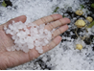 | 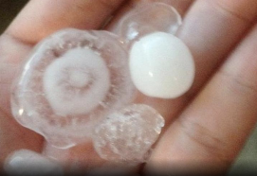 | 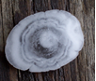
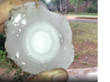 | 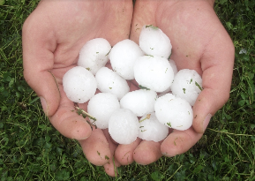 | 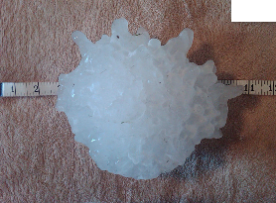
Observations | Questions about Hailstones  and How They Form

- What patterns do you see in the hailstones?

- What new ideas do you have about how hailstones are formed?

ANALYZING HAILSTROM MAP DATA
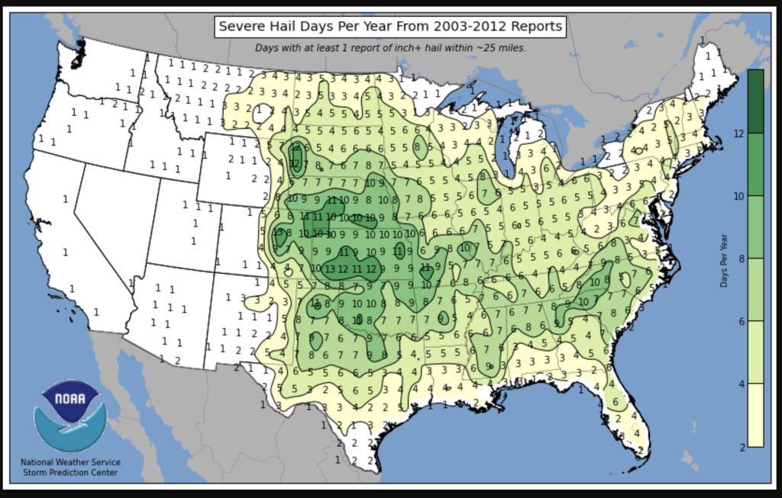
Annotate what you notice and record the questions you have on the Hail Frequency Map. If you are having trouble seeing the map, use colored map on the screen as a reference. Then, answer the prompts below.

- What are some patterns you noticed as you examined the hail map?

- What new questions do you have about hailstorms?

GALLERY WALK
Record the agreements and disagreements you observe during the Gallery Walk.
Agreement(s) | Disagreement(s)

RELATED PHENOMENA
Answer the prompts below and be prepared to share with others.
- Describe one event you (or someone you know) experienced when a lot of precipitation (in amount or size) fell in a relatively short amount of time.
____________________________________________________________________________________________________________________________________________________________________________________________________________________________________________________________________________________________________________________________________________________________________________________________________________________________________________________________________________________________________________________________________________________________________________________________________________

- Describe one event you (or someone you know) experienced when a lot of precipitation fell continuously over a much longer period of time.
____________________________________________________________________________________________________________________________________________________________________________________________________________________________________________________________________________________________________________________________________________________________________________________________________________________________________________________________________________________________________________________________________________________________________________________________________________

THINKING ABOUT RELATED PHENOMENA
- Do you think the causes of hail might also cause other types of brief precipitation events to occur? What similarities may these events have?
________________________________________________________________________________________________________________________________________________________________________________________________________________________________________________________________________________________________________________________________________________________________________________________________________

- What might be similar and what might be different about what causes a longer precipitation event to occur?
________________________________________________________________________________________________________________________________________________________________________________________________________________________________________________________________________________________________________________________________________________________________________________________________________

- How might figuring out how and why hail occurs help us to explain other short-term precipitation events?
________________________________________________________________________________________________________________________________________________________________________________________________________________________________________________________________________________________________________________________________________________________________________________________________________

- How might figuring out how and why hail occurs help us to explain long-term precipitation events?
________________________________________________________________________________________________________________________________________________________________________________________________________________________________________________________________________________________________________________________________________________________________________________________________________
CONSENSUS MODEL
Draw the class consensus model below:

