Name: __________________________________________ Date: _______________ Hour: _____
Observations and Inferences
Part A: Examine the picture. Then, complete the table below.
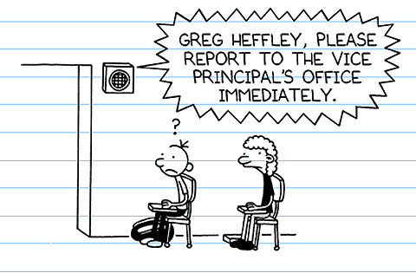

Observations (I saw/read…) | Inferences (I thought…)
Example: There are zig-zags around the text. | Example: The speaker is loud.
1. | 1.
2. | 2.
3. | 3.

Part B: Write your OWN definitions for the terms below.
Observation: __________________________________________________________________________
_____________________________________________________________________________________
Inference: ____________________________________________________________________________
_____________________________________________________________________________________
Part C: To show accuracy in the sentence below, circle either ‘observation’ or ‘inference.’
Scientists rely on observations/inferences to begin their investigations.

