MATTER AND CHEMISTRY
BATH BOMBS LESSON 5
INVESTIGATION QUESTION _____________________________________________________________________________________
__________________________________________________________________________________________________________________________________________________________________________

REVIEW
Question
Is the gas formed from citric acid, sodium bicarbonate, and water a new substance?

CLAIM:

EVIDENCE:

REASONING:

Gas-Related Phenomenon
List any experiences you’ve had with different types of gas. For each example explain the gas’s role in the system.

Properties of Gases Observations
Notice | Wonder/Question
Record the observations you notice about the common gas properties on the page, and record what you wonder or question.

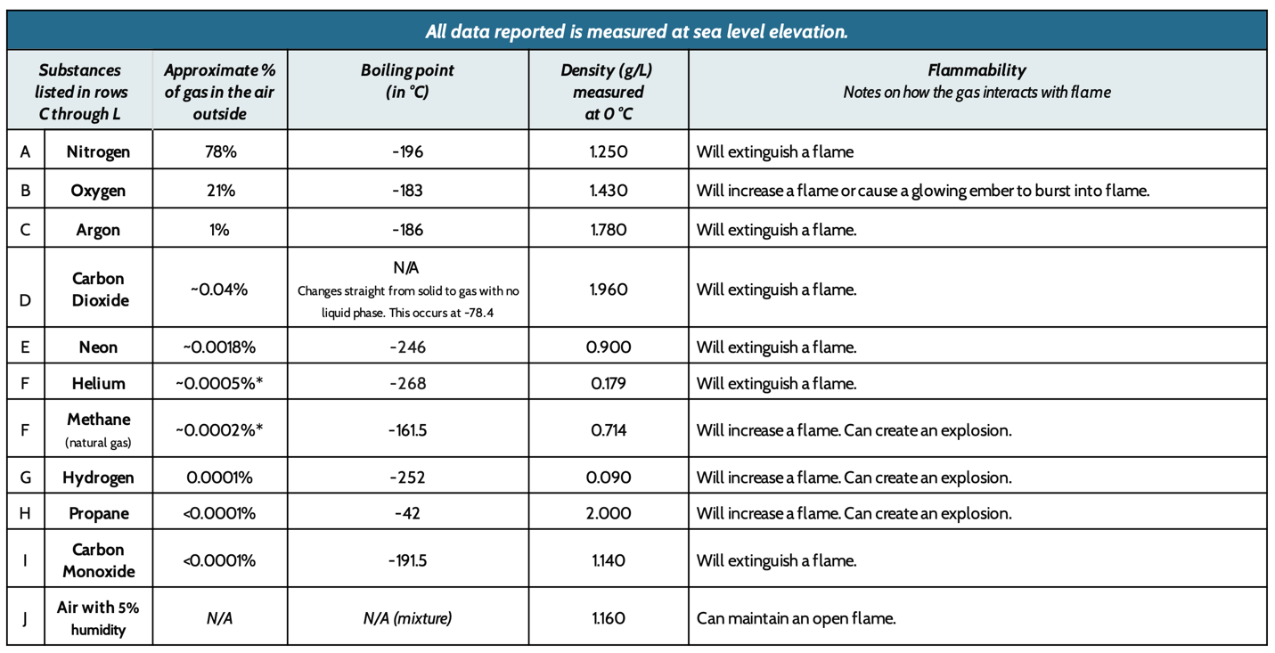
Properties of Common Gases
PLANNING AN INVESTIGATION #1
Record your ideas below about the following. Feel free to make a list, draw a picture, and/or write out your ideas.
- How can we test the gas produced by the bath bomb for the properties on the previous page?
- How could we trap the gas to do so?

Materials:

Samples of known gases
Bath bomb samples
Water
Flasks
Matches
Rubber stoppers

Identify the following for this investigation:
Independent variable: _______________________________ Control group: __ Air___
Dependent variable:__________________________________________________
Constants:_________________________________________________________________________________________________________________________________________________________________
Develop a hypothesis to answer the question: What will happen when we test the flammability of the gas produced by the bath bomb?
_____________________________________________________________________________________
__________________________________________________________________________________________________________________________________________________________________________

Observations of Gases
Gas | Flammability
Helium
Air
Oxygen
Gas from Bath Bomb

Problem/Question
What are some possible gases produced by the bath bomb?
CLAIM:

EVIDENCE:
REASONING:
SUMMARY/CONCLUSION
PLANNING AN INVESTIGATION #2
Record your ideas below about the following. Feel free to make a list, draw a picture, and/or write out your ideas.
- How can we test the property of density for the gas produced by the bath bomb?

PREDICTIONS
Use the slide your teacher displays and Properties of Common Gases table on page 2 to help you complete the two statements below.
1. If the gas from the gas bomb puts out a flame above it, that means it is ______________ dense than the room air which has a known range of values between ________________.
I know this because ______________________________________________________________ __________________________________________________________________________________ __________________________________________________________________________________ .
If evidence supports this prediction, it tells me that the gas from a bath bomb could be _________________________________________________________________________________.
2.If the gas from the gas bomb puts out a flame below it, that means it is _____________ dense than the room air which has a known range of values between _______________.
I know this because ______________________________________________________________ __________________________________________________________________________________ __________________________________________________________________________________.
If evidence supports this prediction, it tells me that the gas from a bath bomb could be
____________________________________________________________________________.
Materials:

plastic soda bottle and cap water
8 mini-bath bombs
matches
candle
small aluminum bread pan

Procedure:
- Fill a bottle about 1/10 full with water. Add 8 mini bath bombs to it. Cap it.
- Light a match. Hold it 1 inch over the bottle as a partner removes the cap.
- Keep it there for 2 seconds. Make note of whether the match goes out or not.
- Extinguish the match and cap the bottle. Discard the match in a cup of water.
- Light a candle in an aluminum bread pan.
- Lean the edge of the bottle against the pan and remove the cap.
- Gently squeeze the bottle to push the gas out of it. Make note of whether the candle in the pan goes out or not.

Observations of Gases to Test Density
Gas | Observations
Helium
Air
Oxygen
Gas from Bath Bomb

Problem/Question
What is the gas produced by the bath bomb?
CLAIM:

EVIDENCE:
REASONING:
SUMMARY/CONCLUSION

