MATTER AND CHEMISTRY
BATH BOMBS LESSONS 3 & 4
INVESTIGATION QUESTION _____________________________________________________________________________________________
__________________________________________________________________________________________________________________________________________________________________________________________
OBSERVATIONS
Homemade Bath Bomb Recipes
Recipe A | Recipe B | Recipe C | Recipe D
1/3 c. sodium bicarbonate  1/6 c. lemonade mix  1/6 c. Epsom salt  1 T. cornstarch  1 t. olive oil  1/3 t. water | 1/6 c Epsom salts  1/3 c. sodium bicarbonate  1/6 c. citric acid  1 t. olive oil  1/3 t. water | ½ c. sodium bicarbonate  ¼ c. citric acid  1/8 c. coconut oil  1 t Epsom salt  1 t sugar | 1/6 c lemonade mix  1/6 c. Epsom salts  1/3 c. sodium bicarbonate  1/3 t water  1 t olive oil

Store-bought Bath Bomb Ingredients
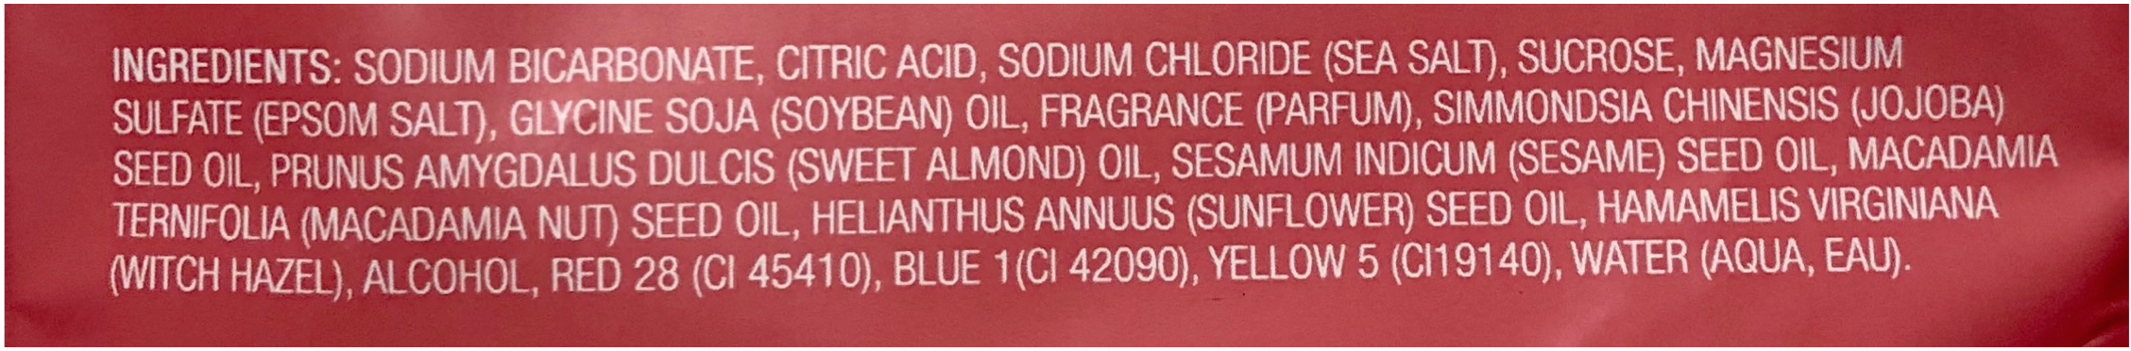
Record the observations you notice about the bath bomb ingredients, and record what you wonder or question.
Bath Bomb Ingredients Observations
Notice | Wonder/Question

Bath Bomb Ingredient Property Data
Observe and record physical properties of the ingredients that will help us tell the ingredients apart.
Properties of Bath Bomb Ingredients
Ingredient | Scientific Name | Melting Point (° C) | State of Matter @ room temp. | Color | Viscosity | Odor | Texture | Luster
Water | Dihydrogen monoxide | 0
Sugar | Sucrose | 160
Citric Acid | Citric Acid | 153
Epsom Salt | Magnesium sulfate | 1124
Table Salt | Sodium chloride | 801
Sodium bicarbonate | Sodium hydrogen carbonate | 50
Corn Starch | Amylum | 257
Olive Oil | Monounsaturated fat (Oleic acid) | -6
Coconut Oil | Fully saturated fat (Lauric acid) | 25
Lemonade Mix | This is a mixture | Not Applicable

PLANNING AN INVESTIGATION #1
Record your ideas below about the following. Feel free to make a list, draw a picture, and/or write out your ideas.
- How can we use the ingredients to help us figure out why the bath bomb makes gas bubbles?
- Do you see any patterns across the ingredients in the store-bought vs homemade bath bombs?
- What/how could we investigate?

Materials:

Samples of ingredients
Water
Pipette
Scoop
Toothpicks

Identify the following for this investigation:
Independent variable: _______________________________ Control group: __water with no ingredients___
Dependent variable:__________________________________________________
Constants:______________________________________________________________________________________________________________________________________________________________________________________________________________________________________________________________________________

Create a data table to record your observations of the ingredients in the template below. Use a ruler.
Observations of Bath Bomb Ingredients

SUMMARY/CONCLUSION OF INVESTIGATION #1
Problem/Question
Do any of the individual ingredients have the chemical property of reacting with water?

CLAIM:

EVIDENCE:

REASONING:
NEXT STEPS:

INVESTIGATION #2
Question: Which combinations of the substances in a bath bomb produce a gas?

Independent variable: _______________________________ Control group: __water with no ingredients___
Dependent variable:__________________________________________________
Constants:______________________________________________________________________________________________________________________________________________________________________________________________________________________________________________________________________________

Ice Cube Tray
Combinations of Bath Bomb Ingredients with Water
Ingredients |  | A | B | C | D | E | F | G | H | Assigned group
 |  | Coconut oil | Olive oil | Sodium bicarbonate | Epsom salts | Lemonade mix | Citric Acid | Sugar | Cornstarch
A | Coconut oil | X |  |  |  |  |  |  |  | 1
B | Olive oil |  | X |  |  |  |  |  |  | 2
C | Sodium bicarbonate |  |  | X |  |  |  |  |  | 3
D | Epsom salts |  |  |  | X |  |  |  |  | 4
E | Lemonade mix |  |  |  |  | X |  |  |  | 5
F | Citric Acid |  |  |  |  |  | X |  |  | 6
G | Sugar |  |  |  |  |  |  | X |  | 7
H | Cornstarch |  |  |  |  |  |  |  | X | 8

CONCLUSION/SUMMARY
- What combination(s) of ingredients created gas bubbles when added to water?

- The lemonade mix is a mixture of many ingredients. What patterns do you notice between the substances listed in the ingredients of the lemonade mix and the substances that resulted in bubbles appearing in question 1 above?
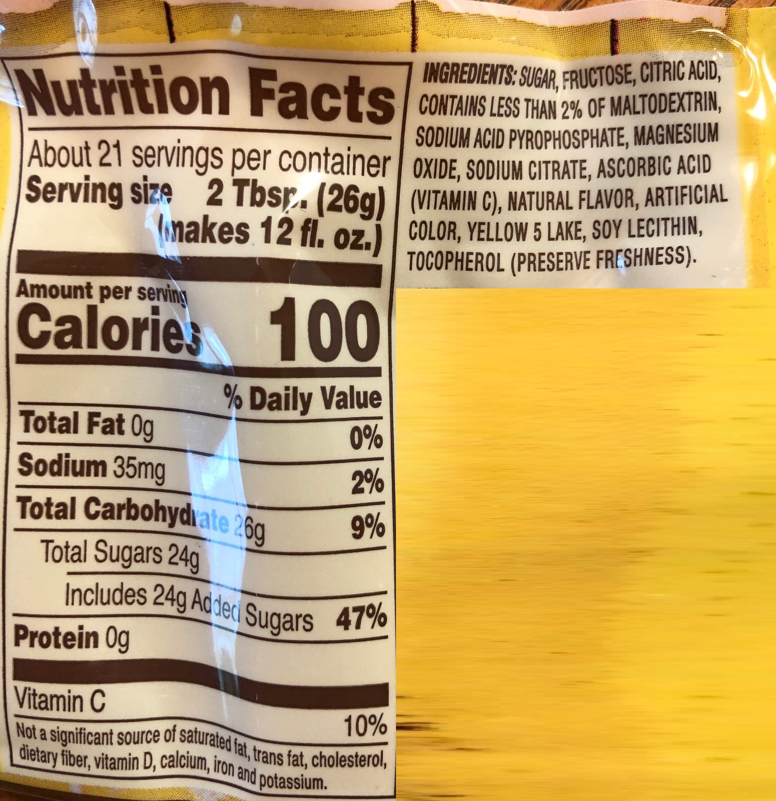

Problem/Question
Which combinations of the substances in a bath bomb produce a gas?
CLAIM:

EVIDENCE:

REASONING:
NEXT STEPS:

