- Dissolve- when a solid dissolves in a liquid, the solid breaks apart into particles too small to see and it completely mixes with the liquid

- Solubility- the ability of a substance to dissolve in another substance
- Soluble- when a substance can dissolve
- Insoluble- when a substance cannot dissolve
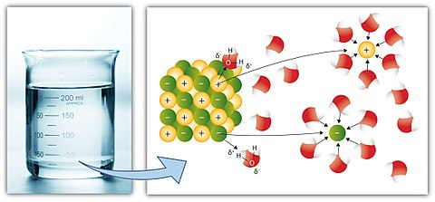

- Solution- solute + solvent
- Solute- substance being dissolved
- Solvent-substance that does the dissolving (larger amount)
