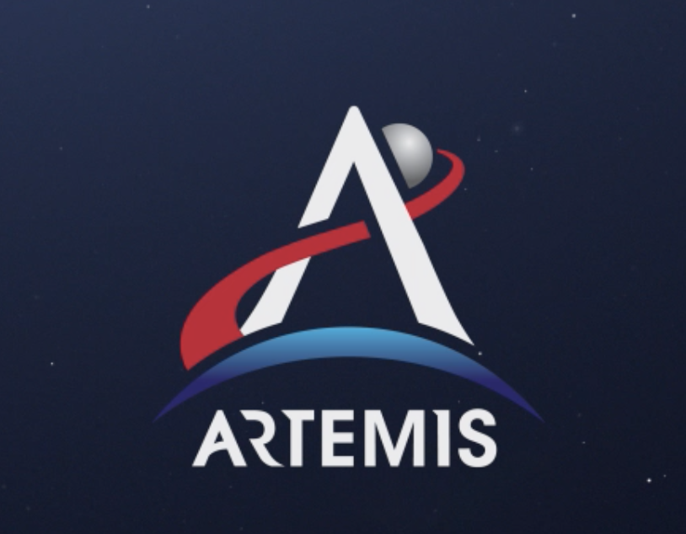
Mission to Mars: Space Launch System Design Challenge

PART 4: CREATE & TEST PROTOTYPE

Prototype Constraints
- SLS (rocket + engine) can only be made from provided materials
  - No more than six sheets of paper
  - No more than 100 cm of tape
- SLS cannot exceed 50 grams of mass, including engine
- Only 1 RS-25 engine (film canister) may be used
- Engine must be located on the bottom of the rocket
- Fuel used must match the fuel designed by chemical engineers during Part 3
  - No more than 20 mL of a fuel liquid can be used to power the engine
  - No more than 10 g of fuel solid can be used to power the engine
- All launches must be completed on the launch pad (bucket)
Testing Data
Trial | Approximate Height of Launch (cm)* | Observations & Improvements Made
1
2
3
Directions: As a team of mechanical and chemical engineers, construct your SLS prototype while taking into consideration the constraints listed below. After you have built your prototype and determined the best method to “ignite” the engine, conduct a minimum of three tests, making improvements in between each test.

*use a ruler or meter stick; official measurement should be made looking at the height the bottom of the rocket can reach

