Mission to Mars: Space Launch System Design Challenge

PART 5: FINAL COMMUNICATION

PHASE 1 – LAUNCH DATA

Directions: Record your group data in the table below.

Group Number ______ | Y/N | Approximate Height of Launch (cm)
Constraints Met
- SLS (rocket + engine) can only be made from provided materials
- SLS cannot exceed 50 grams of mass, including engine
- Rocket made of no more than six sheets of paper
- Rocket made of no more than 100 cm of tape
- Only 1 RS-25 engine (film canister) may be used
- Engine must be located on the bottom of the rocket
- Fuel made of no more than 20 mL of liquid(s)
- Fuel made of no more than 10 g of solid(s)

Directions: Meet with at least 4 other groups. Record their group number. Rate their ability to meet the project constraints, then record the approximate height of their launch. Using the data recorded, give the group an overall prototype rating. If you give a 5, the group was able to reach the highest possible height (based on the data you recorded) and meet 100% of the constraints listed above.

Group  Number | Meeting the Constraints  0 = did not meet, 1= partially met, 2 = met | Approximate Height of Launch (cm) | Overall Rating  1 = Not Effective → 5 = Very Effective
 | 0 1 2 |  | 1 2 3 4 5
 | 0 1 2 |  | 1 2 3 4 5
 | 0 1 2 |  | 1 2 3 4 5
 | 0 1 2 |  | 1 2 3 4 5

PHASE 2 – LAUNCH ANALYSIS & CONCLUSIONS

- How do the results of your group compare to the results of other groups?

- What changes would you make if given an opportunity to redesign your SLS?

- Here is a common chemical equation for the reactants used in the SLS engines (baking soda + vinegar).
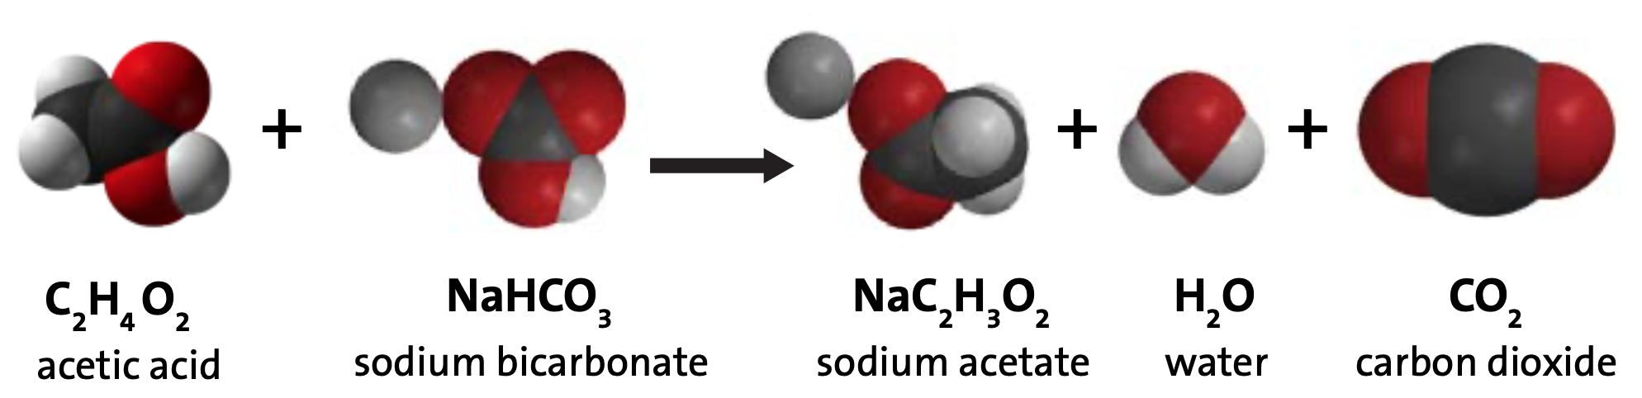
(vinegar) (baking soda)

- Is this an example of a chemical reaction? Make a claim, give evidence, and a reasoning.
Claim | Evidence | Reasoning

- Circle the product in the equation above that propels the Space Launch Systems to the highest height.

- What do you notice about the number of atoms in the reactants vs the products? Make a claim, give evidence, and a reasoning for what you observe in the chemical equation.
Claim | Evidence | Reasoning

- If you were able to take the mass of the your system before and after the launch in a closed system, how would the masses compare and why?

- Of the data you have collected, which group’s SLS would you recommend for continued testing? Support your claim with evidence and reasoning.
______________________________________________________________________________________________________________________________________________________________________________________________________________________________________________________________________________________________________________________________________________________________________________________________________________________________________________________________________________________________________________________________________________________________________________________________________________________________________________________________________________________________________________________________________________________________________________________________________________________________________________________________________________________________________________________________________________________________________________________________________________________________________________________________________________________________________________________________________________________________________________________________________________________________________________________________________________________________________________________________________________________

