Scientific Method Assessment

- Scientific Method
- Observation
- Inference
- Qualitative
- Quantitative
- Hypothesis

- Experiment
- Variable
- Independent variable
- Dependent variable
- Procedure
- Trials

- Constants
- Control group
- Data
- Data table
- Graph
- Conclusion
Part A: Vocabulary
Match the above words to one of the statements below. (Write the letter of your answer next to the statement it matches.) NOT ALL WORDS ARE USED!

- ________ Factors that are always the same in each trial of an experiment

- ________ A factor that changes in an experiment

- ________ A variable that you change in your experiment; usually follows ‘if’ in a hypothesis

- ________ A variable that responds to what is done in the experiment; usually follows ‘then’ in a
hypothesis

- ________ This is the end of an investigation where you write your results for the lab and make inferences
as to why something happened.

- ________ A type of observation that is measured in numbers (ex. The pencil is 8-cm long)

- ________ A type of observation that is expressed by the five senses; you can see, touch, hear, smell,
or taste it (ex. The shirt is black)

- ________ This is the recorded data from an experiment. It can be numbers or observations.
We usually record it in a table during the lab.
- ________ A visual display of quantitative data (pie chart is an example)

- ________ The step-by-step directions of what to do during an experiment

- ________ An opinion/guess based on an observation that isn’t necessarily a fact

- ________ An “If…then…” statement that attempts to answer the question/problem; a testable inference

- ________ The “normal” group used for comparison

- ________ Gathering information using your senses and/or measurements

Part B: Multiple Choice
Circle the letter of the best choice
- A scientist testing the effects of a chemical on apple yield sprays an orchard with the chemical. A second orchard does not receive the chemical. In the fall, the number of apples harvested from each forest is counted. Which of the following is the independent (manipulated) variable in the experiment?
- the first orchard
- the second orchard
- the chemical
- the number of apples
- In order for the apple tree experiment to be valid scientifically, both orchards must: receive the same amount of sunlight, receive the same amount of water have the same species of apple tree, etc. These factors that are kept the same are called __________.
  - observations
  - constants
  - controls
  - variables
- How many variables should you change in an experiment?
a. one
b. two
c. three
d. four

- When doing an experiment, Doug thought, “If I add mentos to diet and regular Coke, then the diet Coke will react more.” This is the part of the scientific method called the _________.
a. conclusion
b. purpose
c. hypothesis
d. observation

- _____ data is usually based on observations using the 5 senses.
- Descriptive
- Quantitative
- Qualitative
- Scientific

- An experimenter can make sure an experiment is repeatable by having more
- Hypotheses
- Variables
- Observations
- Trials

Part C: Making Observations
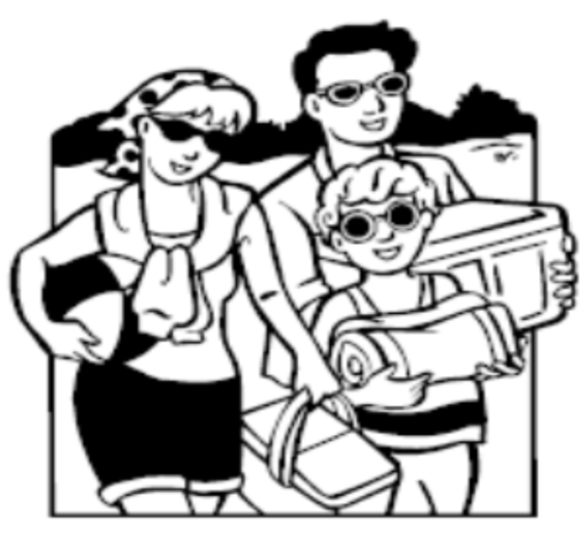
- Look at the picture and write two observations and one inference about it.
Observations:

Inference:

Part D: Differentiating Between Two Types of Data
Write QN if the data is quantitative. Write QL if it is qualitative.

- The lemon was 17 cm around : ________
- The lemon was yellow:_________

- The lemon was lumpy:_________

- The lemon had 2 spots: _____________

Part E: Writing a Hypothesis
Write a hypothesis for the following question. In the question underline the independent variable and circle the dependent variable.

- Question: How does amount of sunlight (full sun, partial sun, and no sun) affect plant growth?

Hypothesis:

Part F: Doing an Experiment
Identify the following based on the experiment below.
Squidward loves playing his clarinet and believes it attracts more jellyfish than any other instrument he has played. In order to test his hypothesis, Squidward played a song on his clarinet for a total of 5 minutes and counted the number of jellyfish he saw in his front yard. He played the song a total of 3 times on his clarinet and repeated the experiment using a flute and a guitar. He also recorded the number of jellyfish he observed when he was not playing an instrument.

- What is the independent variable?

- What is the dependent variable?

- What is a possible hypothesis?

30. What are the constants?

31. What is the control group?

Part G: Collecting and Analyzing Data

32. Do the following: 1) Identify the variables and control group (1 pt each) , 2) make a data table (4 pts) and 3) graph the averages (4 pts) for the following investigation.

Jose wanted to see how the amount of compost used on his garden would affect the height (cm) of his tomato plants. He set up 3 garden beds with 3 tomato plants in each. In the first bed he added no compost, in the second he added 900 g and in the third bed be added 300 g. Below is his data.

No compost: 10, 9, 11, avg: 10 Independent variable: __________________________
900 g compost: 17, 15, 16, avg: 16
300 g compost: 15, 14, 13, avg: 14 Dependent variable: ___________________________

2) Data Table:

3) Graph:
20

18

16

14

12

10

8

6

4

2

0

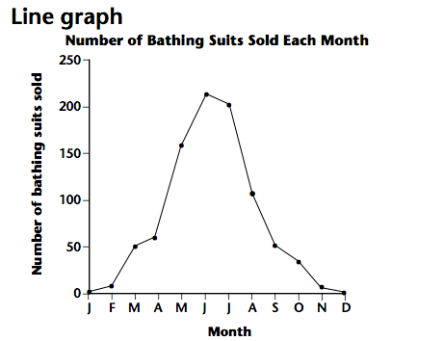
33) For the graph below, what is the independent variable? What is the dependent variable? What can you conclude from the graph?

Independent variable:

Dependent variable:

Conclusion:

