Science Safety Introduction
Mission: Using the picture below and your tour of the classroom from the previous class, come up with some safety procedures/rules that are important to a science classroom
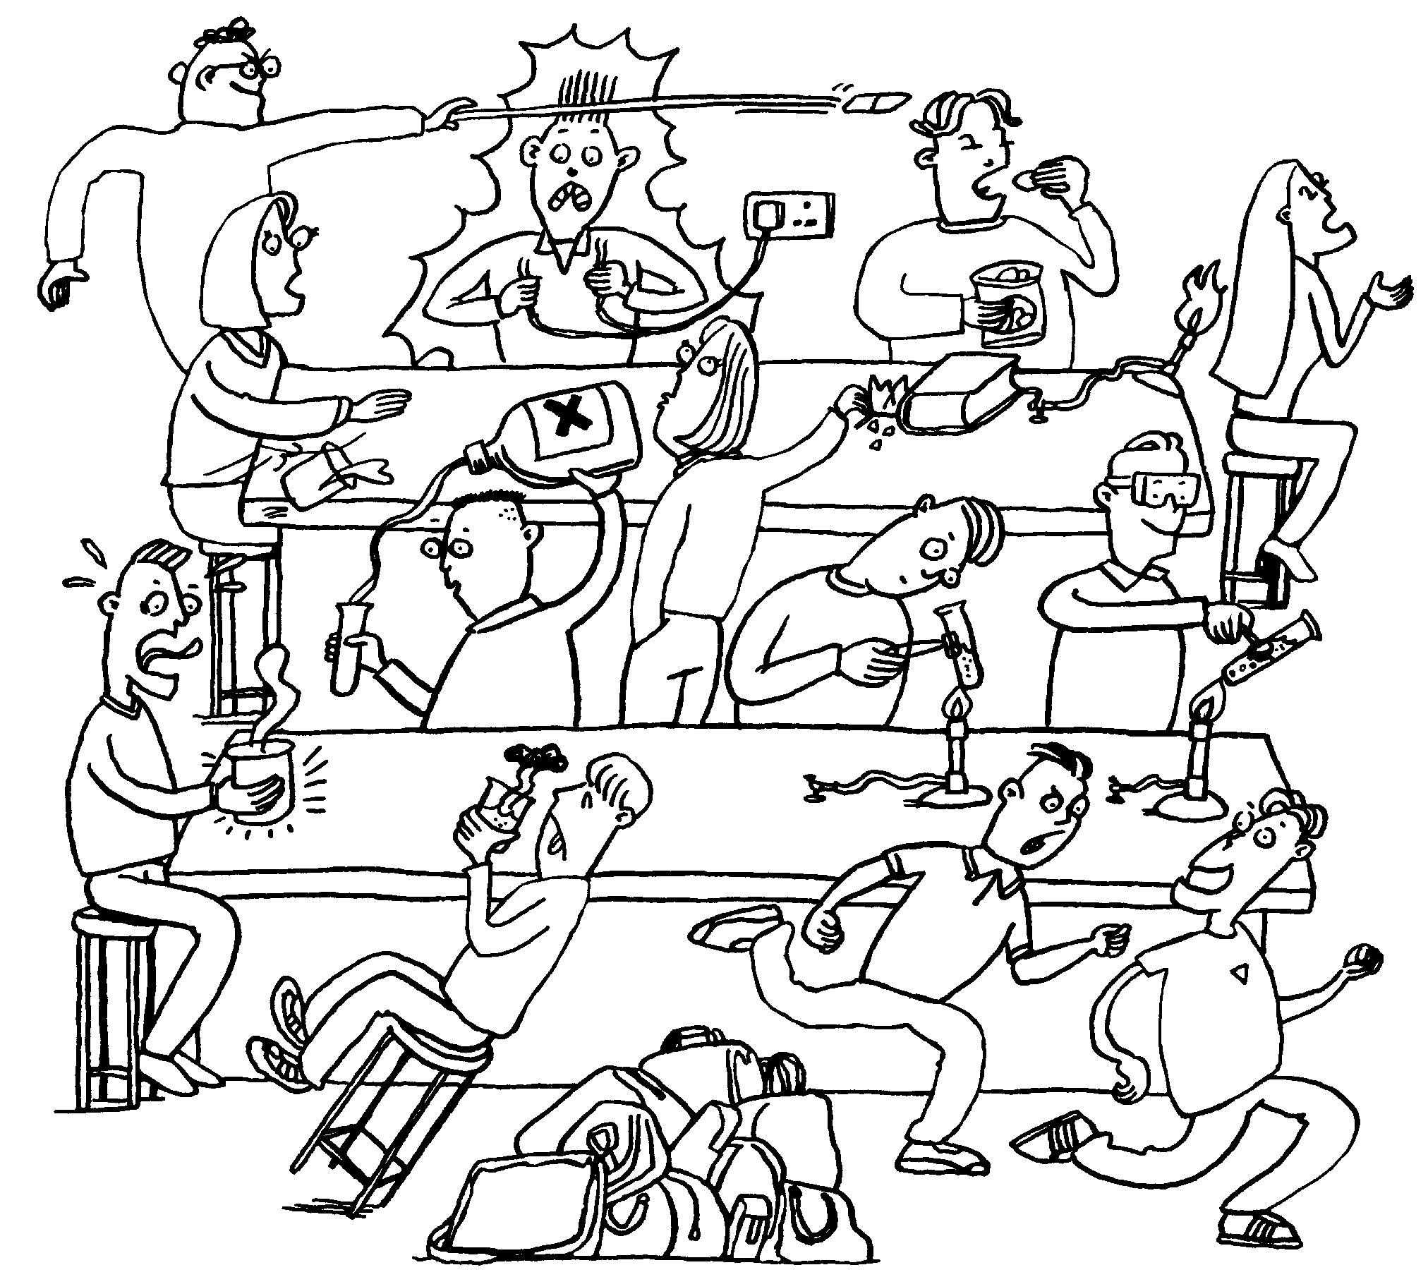
Part 1- In the picture below, circle things that seem unsafe for a science classroom.

Part 2- On your own, create some science safety procedures/rules that would prevent the problems seen in the picture.

Part 3- Share your ideas with others at your table. Write down any procedures/rules shared that you agree with.

