MISSION TO MARS: SLS DESIGN CHALLENGE
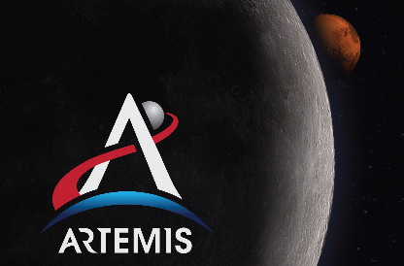
PROJECT RUBRIC – MECHANICAL ENGINEERS
CRITERIA | POINTS
PARTS 1 & 2 – RESEARCH THE ENGINEERING PROBLEM | /15
- All sections of research 100% complete
PART 3 – IMAGINE POSSIBLE SOLUTIONS | /30
- Phase 1 structures listed relate to research conducted and are most relevant to the goal of the project
- At least 1 Phase 2 prototype digitally modeled on Tinkercad
- Digital prototype shows relevant structures
- 3 prototype ideas were evaluated (advantages & disadvantages)
- Conclusion contains at least one claim supported by evidence & reasoning
PART 4 – CREATE & TEST PROTOTYPE | /15
- Prototype meets constraints
- Testing data 100% complete & accurate
PART 5 – FINAL COMMUNICATION | /30
- Individual group launch data 100% complete & accurate (Table 1)
- Comparison group launch data table 100% complete (Table 2)
- Conclusion contains at least one claim supported by evidence and reasoning
ENGANGED IN LEARNING
- Effort | 0 1 2
- Teamwork | 0 1 2
- Helpful | 0 1 2
- Prepared | 0 1 2
- Calm | 0 1 2

