Property- characteristic of substances; any pure substance has characteristic properties that can be used to identify it.
Physical property- can be observed or measured without changing the identity of the matter
Ex. Color; state of matter
Chemical property- can only be observed or measured with changing the identity of the matter
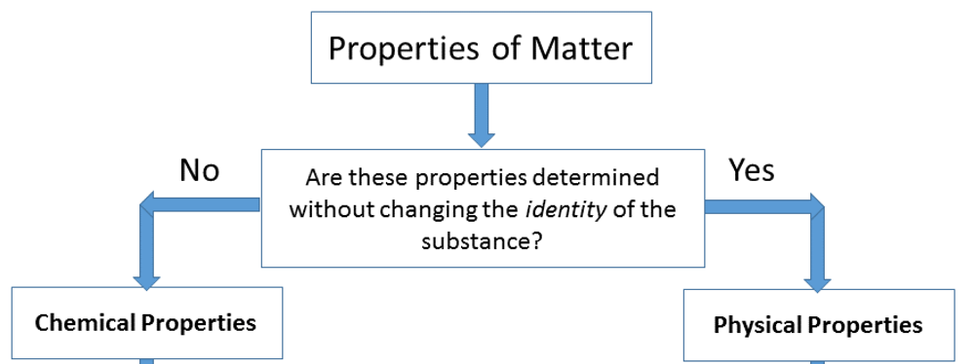
Ex. Flammability

