Popping Boba-Making a Synthetic Substance
Lesson 3
INVESTIGATION QUESTION
_______________________________________________________________________________________________________________________
_______________________________________________________________________________________________________________________
POPPING BOBA BACKGROUND INFORMATION
In science a "synthetic" material is one in which the starting substances are changed chemically to produce a material with different characteristics. A common example is plastic. To make it, petroleum , a natural resource, is processed and chemically changed to eventually become plastic. The series of chemical reactions that are used to change natural resources into synthetic products is called chemical synthesis. (see video).
Beginning in the year 2000, gel foods and bubble teas began to increase in popularity within the food industry. Popping boba, for example, is a popular gel ball used in bubble teas across the United States. Popping boba is unique in that it is synthetically made from the interaction between sodium alginate and calcium chloride, both made from natural sources (see table below). Oftentimes, water, sugar, and fruit juices are added to the sodium alginate to enhance its flavor.
Table 1. Natural Resources Used to Make Popping Boba
 | Sodium Alginate | Calcium Chloride
Natural Resource | A brown seaweed called kelp | Calcium chloride is made from limestone which is a common rock that is mined
Process Used | The seaweed is cut up, mixed with water and filtered. The water evaporates off and the sodium alginate powder is left | The limestone, calcium carbonate, is reacted with hydrochloric acid or sodium chloride to make calcium chloride
PURPOSE
- Analyze and interpret data and use molecular models to thoroughly explain whether a chemical reaction took place.
- Obtain, evaluate, and communicate information to describe how the properties of the natural and synthetic substances differ.
Materials:
- Safety goggles (required) | - Lab apron (optional) | - Container of sodium alginate + juice | - Labeled container for calcium chloride
- Spoon | - Cup | - pipette | - Petri dish  - Stopwatch
Procedure:
- Always wear safety goggles.
- Measure approximately 20-mL of calcium chloride into the provided cup . Record observations in data Table 2.
- Get container of sodium alginate. Record observations in data Table 2.
- Squeeze approximately 10 large drops of sodium alginate into the cup of calcium chloride, using the provided pipette. Pause after each squeeze.
- After 1 minute, use the spoon to transfer one or two of the alginate gel beads from the beaker to the petri dish. Leave the rest of the beads in the cup for later.
- Quickly rinse the beads in the petri dish with distilled water. Then, record observations in data Table 2. You may touch the beads.
- Repeat steps 5 and 6 after 2 minutes have passed, and then after 3 minutes have passed. Record observations.
- Clean up by: Returning sodium alginate beaker. Eating or throwing away the beads and rinsing petri dish with water. Emptying cup of calcium chloride and rinsing it clean with water. Returning all materials, including safety equipment.
Table 2. Observations
REACTANTS- Before |  | PRODUCTS- After
Calcium Chloride (aq) | Sodium Alginate (aq) | Calcium Alginate (s)
 |  | After 1 minute:
 |  | After 2 minutes:
 |  | After 3 minutes:
Analysis and Conclusions:
- a. Complete data Table 3 below by identifying the missing reactant name and product chemical formula and by drawing your version of the missing molecular models, by determining the type and number of each atom in each molecule.
Table 3. Interpreting the Reaction
 | Before |  | After
 | Calcium Chloride (aq) |  | Calcium Alginate (s) | Sodium Chloride (aq)
Chemical Formula | CaCl₂ | 2NaC₆H₇O₆ | CaC₁₂H₁₄O₁₂
Molecular Model |  | 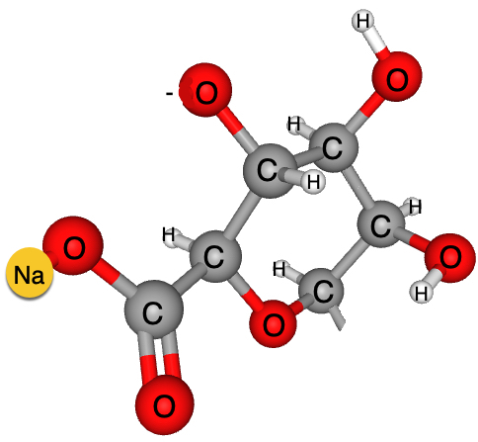 | 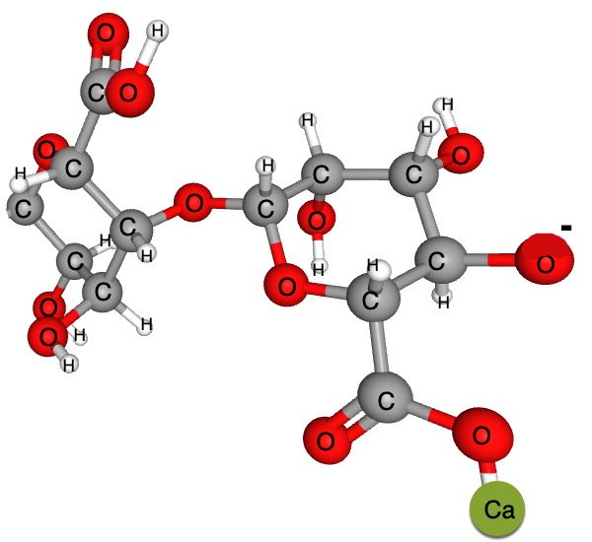
Counting Atoms |  |  | Ca- 1 C-12  H-14 O-12
2NaC6H7O6 + CaCl2 2NaCl + CaC12H14O12
b. What do you notice about the number and type of atoms when you compare the reactants and products? What is the scientific reasoning behind this?

Table 4. Analyzing the Reaction
 | Reactant | Product
 | Sodium Alginate (aq) | Calcium Alginate (s)
Model of Polymer | 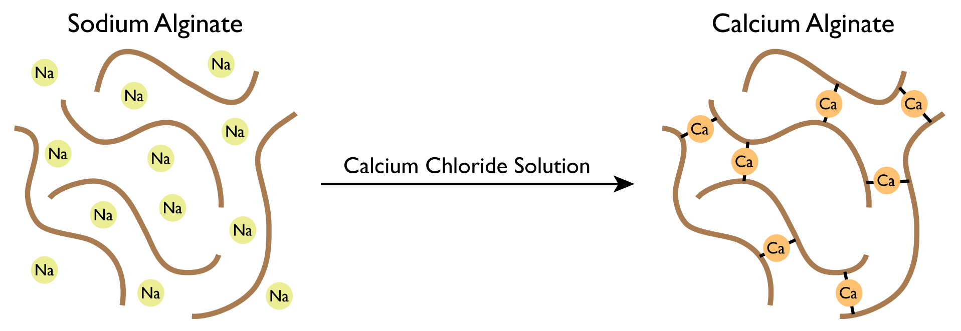
Observations | CaCl_{2(aq)}
- Make observations of the models found in Data Table 4. Record your observations in the provided space.

- Using Data Table 4, describe what the calcium ions from the calcium chloride do to help make the sodium alginate polymer become a gel. How is this similar to vulcanization of rubber?

- Did you observe a chemical reaction during this lab?
Claim | Evidence | Reasoning

- Sodium alginate and calcium alginate are both polymers. Annotate the text below to define and describe the term polymer.

Passage 2. Polymers
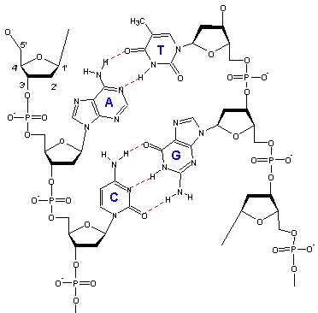
The word polymer is derived from two Greek words, polys (many) and meros (part). Polymers are large, chain-like molecules that contain many copies of one or two “repeating units,” called monomers, which have been joined together by a chemical reaction. It is not unusual to have thousands of monomer units in a single polymer molecule. Because of the enormous size of polymer molecules and the flexibility of polymer chains, many polymers have unique and useful properties. Polymers can be formed into fibers, drawn out into thin films, or molded into a variety of solid objects. Many polymers will swell up in contact with water to give gels, with properties that appear to be intermediate between those of a solid and a liquid. The properties of a polymer depend on the chemical nature of the monomer, the length of the polymer chain, and how the monomers are joined together. Many biological molecules and materials, such as DNA, proteins, starch, cellulose, and wood, are examples of natural polymers. Sodium alginate is a natural polymer obtained from kelp and seaweed
Image 1. Sequence of DNA
FLINN Scientific Inc. Sodium Alginate-Food Additives. . Retrieved January 12, 2020, from https://www.flinnsci.com/api/library/Download/3a0c348137584c589ac2f6d5b43148d9

Table 5. Connections to Natural Resources
 | Main Ingredient(s) | Natural Resources Used to Make Ingredient | Process to Make Ingredient | Renewable?  Why or why not?
Popping Boba  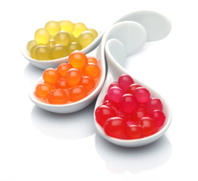 | Sodium Alginate | A brown seaweed called kelp | Kelp is cut up, mixed with water and filtered. The water evaporates and the sodium alginate powder is left.
 | Calcium Chloride | Made from limestone  (a common rock that is mined) | Limestone is reacted with hydrochloric acid or sodium chloride to make calcium chloride.
Watermelon Slices | Watermelon | Watermelon plant, water, sun | Photosynthesis
Watermelon is a common flavor of Popping Boba. Complete the table below in order to determine what are the impacts to society of making and using the synthetic product, compared to making a more natural product with a similar function.
- Sodium alginate and calcium chloride are chemicals derived from natural resources. Explain, using evidence from Table 5, why this statement is true or false.

- Which ingredient in Table 5 undergoes greater chemical changes in order to be used in the Popping Boba reaction? How do you know?

Table 6. Impacts to Society and the Environment
 | Popping Boba | Fresh Watermelon Slices
Impact of harvesting, mining, or collecting natural resources | Kelp is harvested from the ocean and is food and shelter for many sea creatures. This could affect the entire ecosystem. Processing seaweed into sodium alginate takes energy and produces waste.  Limestone must be mined. This takes equipment, which uses energy and pollutes. Processing limestone to make calcium chloride produces waste, which has to be controlled. | Prepare the land using large equipment, which uses energy and adds to pollution.  Fertilize and water the plants. Some fertilizes can be pollutants it they get into lakes and rivers. In some areas, water may be less available than in others. Use of pesticides can be a possible pollutant.  Harvesting by hand is not polluting, but harvesting by machine uses energy and adds to pollution.
Processing the natural resource to make the final product | Mass production of the gummi treat in a factory takes equipment and uses energy. | Cutting up the fruit into snack-size pieces would probably be done by a machine, which uses energy and adds to pollution.
Usefulness of the product | People (kids mostly) like eating them. | People like eating sliced fruit. Fresh fruit contains vitamins and nutrients essential for good health.

- If Popping Boba were made and sold on a large scale as a synthetic snack item for kids, what are some of the impacts to society of producing and using them compared to producing and using fresh fruit slices? Use Table 6 to answer the question.

- Why might society continue to use and manufacture synthetic materials such as calcium alginate in order to make products like Popping Boba? What advantages are there to synthetic vs. natural?

