Popping a Balloon with an Orange-A Chemical Reaction?
Lesson 4
INVESTIGATION QUESTION
______________________________________________________________________________________________________________________________________________________________________________
Procedure:
- Obtain a balloon and fill it as full as possible with carbon dioxide.
- Record your observations in Table 1, paying close attention to the substances and materials present during set up.
- Using one drop of oil from the pipette, squirt the balloon, paying close attention to any evidence of a chemical reaction.
- After the pop, record your observations, paying close attention to substances and materials present.
- Find a small piece of the balloon and rub it into a small drop of oil. Record observations in the During/After Pop column of Table 1.
Table 1. Observations
Before Pop | During/After Pop
(Think about: What substances are present during set-up? How do you know?) | (Think about: What substances are present during and after the reaction? How do you know?)
Summary: Make a claim about whether a chemical reaction took place and support it with evidence and reasoning.
Table 2. Did a chemical reaction take place?
Claim | Evidence | Reasoning
Prediction:

INVESTIGATION QUESTION #2
_______________________________________________________________________________________
_______________________________________________________________________________________
BACKGROUND
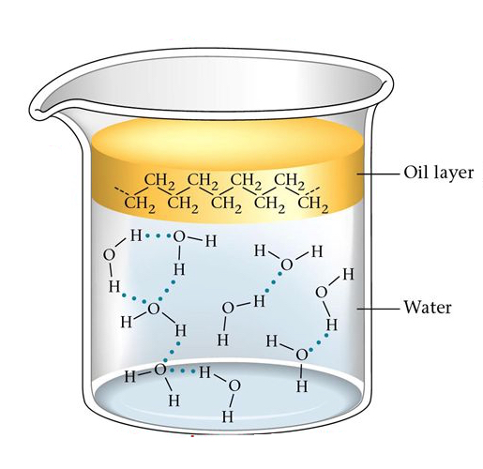
There is a saying in chemistry that states, “Like dissolves like”. In its simplest terms, it means that similar molecules can dissolve in each other, whereas, unlike molecules cannot (see example of oil and water below).
“Like Dissolves Like”
Polar substances tend to dissolve in polar solvents
Nonpolar substances tend to dissolve in nonpolar solvents

Water is polar and oil is nonpolar, therefore they do not mix (dissolve)

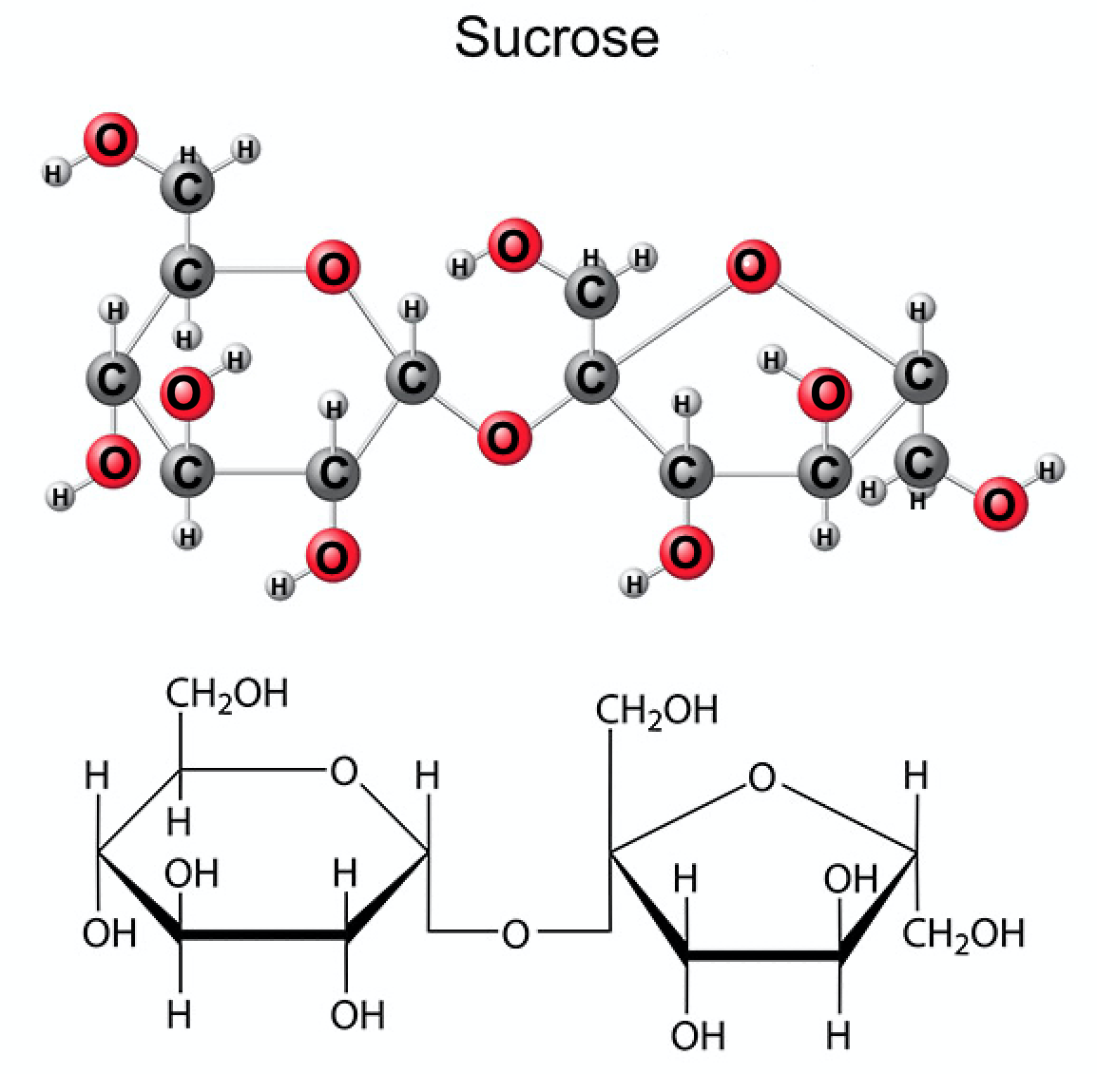
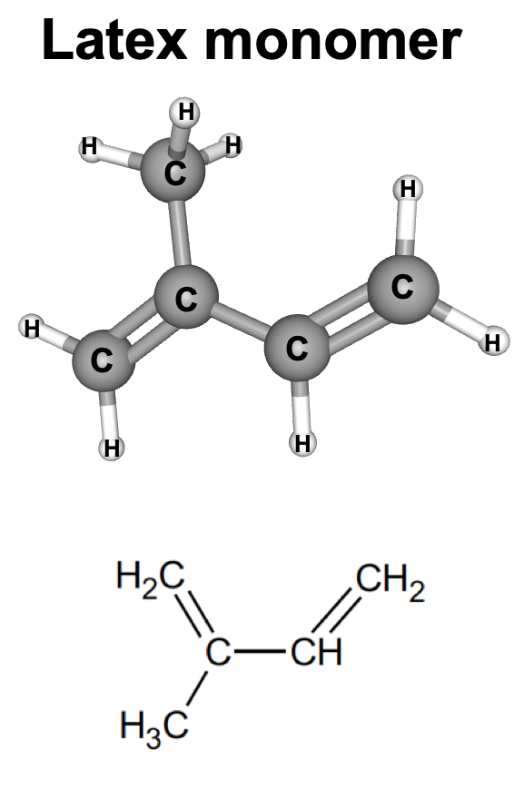
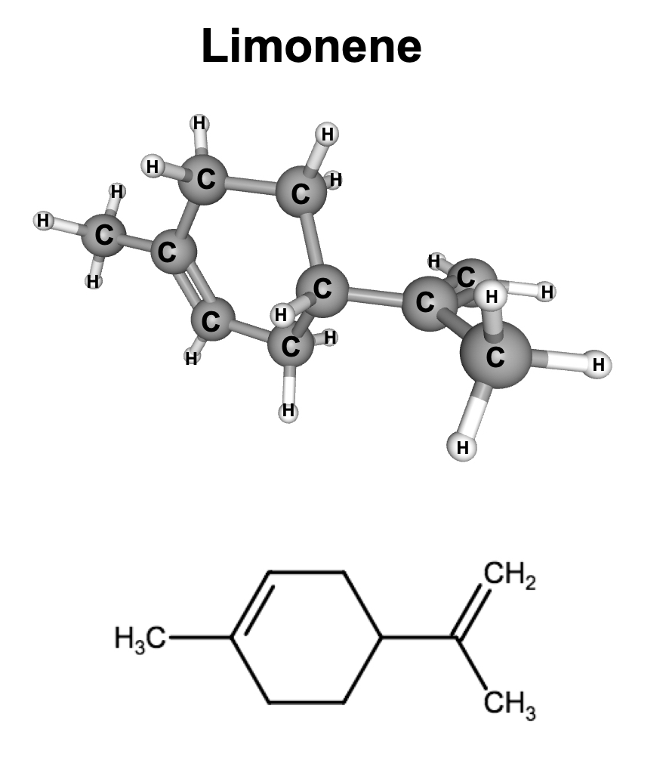
- Using the pictures below, explain which molecule, limonene or sucrose, could dissolve latex. (HINT look at the atoms that make up each molecule).

Table 3. What molecule could dissolve latex?
Claim | Evidence

- Based on the information above and what you discovered in the first part of this investigation, what do you believed happened to the molecules present in the balloon to cause it to pop when limonene oil was added?

