Matter And Chemistry
Scientific Principles Continued
Density
Density is the measure of the amount of matter in a volume or a comparison of how much matter there is in a certain amount of space.
Density determines whether something will sink or float:
When an object is ________________ than the surrounding gas or liquid it sinks downward.
When an object is ________________ than the surrounding gas or liquid it floats upward.

Atoms
Atoms are the smallest possible unit into which matter can be divided, while still maintaining its properties (ex. gold bar and a gold atoms have the same properties)

Made of a ____________________ (center of the atom) that contains _____________________ (+) and ____________________(0); _____________________(-) surround the nucleus in the _______________________

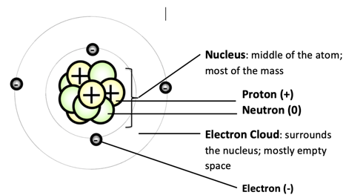

Elements and the Periodic Table
- Elements are specific types of atoms with characteristic physical and chemical properties use to identify them and can be found on the periodic table; defined by their subatomic particles (protons, neutrons, and electrons)
- The periodic table organizes elements with similar chemical properties in columns called families (ex. alkali metals, alkaline earth metals, transition metals, halogens, noble gases)

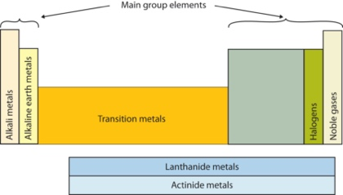
Elements arranged by _____________________ (# of protons)
Families:
- Hydrogen: ______ electron; highly __________________
- Alkali metals: __________ electron; highly reactive (especially with water)
- Alkaline Earth metals: ____________ electrons; reactive
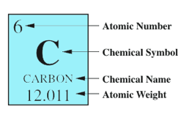
- Halogens: ___________ or ____________ electron; highly reactive
- Noble gases: do not ________________ electrons; non-reactive; colorless
Classification of Matter
- Compounds are made from different types of atoms bonded together, which combine with one another in various ways.
- Molecules are made of atoms. Atoms form molecules that range in size from two to thousands of atoms bonded together and all the substances in our world are made of very few types of atoms.
- The number, type, and arrangement of atoms in the molecules of a substance determine its properties.
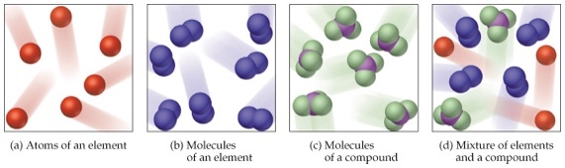
Element: _____________ of atom
Molecule: _____________________ atoms bonded together
Compound: _______________________________ atoms bonded together
Mixture: ________________________ of _________________________________,
that can be taken apart _______________________

Chemical Reactions
- In a chemical reaction, the atoms that make up the original substance(s) are regrouped and these new substances have different properties from the original substance(s).
- The total number of each type of atom is conserved in the reaction, and thus the mass does not change.
Chemical Reaction: Process in which matter _____________________________, causing __________________________ to form
  - Atomic ___________ are __________________________________ during a chemical reaction

Chemical Equations: used to show ______________________________ and how much of each ___________________ and __________________ are needed
Law of Conservation of Matter:
- The mass of the reactants is ___________________________ to the mass of the products in a chemical reaction
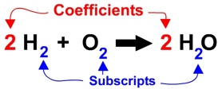
- _________________________________ on both sides of the equation
Evidence of Chemical Reactions
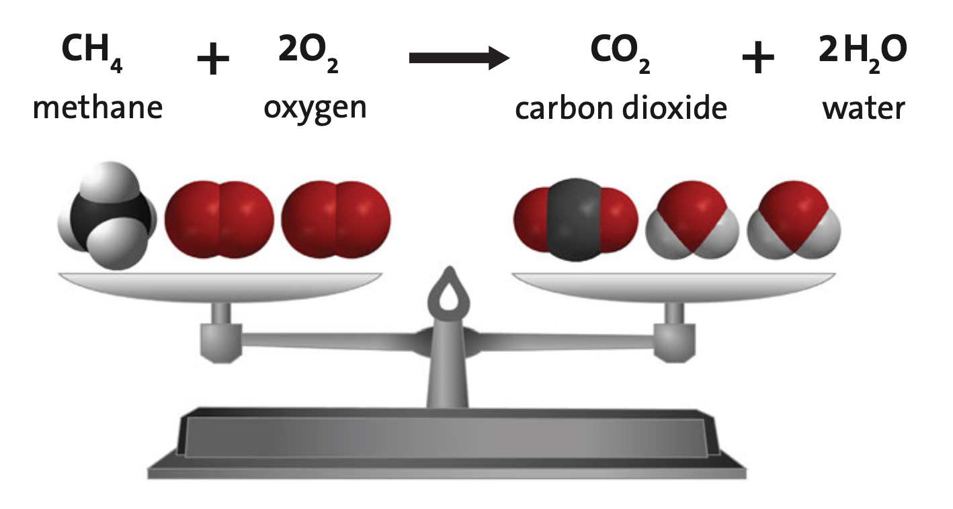
  - F_________________ (formation of a gas)
  - A_________________ (strong change in smell)
  - R____________________ (atoms rearrange)
  - T____________________ (really cold or really hot)
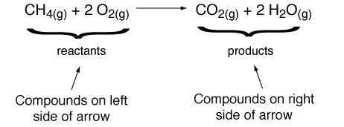
  - new S_________________(products are different than reactants)

  - and Fireworks (Production of _______________________ and/or _____________________; _____________________ changes)

