atom
- The smallest possible unit into which matter can be divided, while still maintaining its properties (ex. gold bar and a gold atoms have the same properties)
- Made of a nucleus that contains protons (+) and neutrons (0); electrons (-) surround the nucleus in the electron cloud
- Elements are specific types of atoms with different properties and can be found on the periodic table; defined by their subatomic particles (protons, neutrons, and electrons)
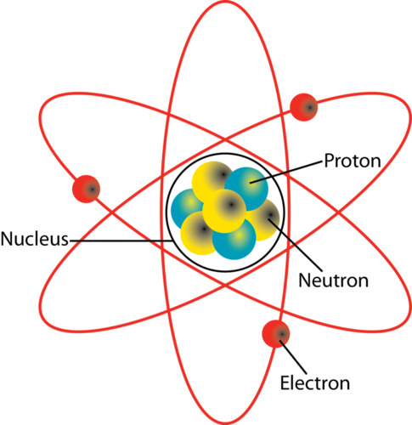
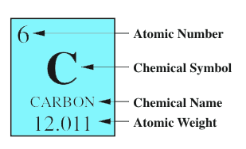
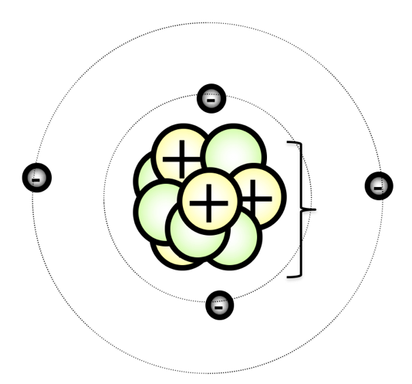
Atomic number (# p⁺)
Chemical symbol
Element name
Atomic mass (p⁺ + n⁰)
Nucleus: middle of the atom; most of the mass
Proton (+)
Neutron (0)
Electron Cloud: surrounds the nucleus; mostly empty space
Electron (-)

