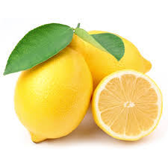
.Find Your Lemon
A Lesson on Observations
Part 1: With your partner, choose a lemon from the bowl. Study your lemon. Make as many OBSERVATIONS of your lemon as you can ( ex. its measurements, its smell, its shape…).
Make a list of your observations below. Be as detailed as possible.

1.)_____________________________ 2.) _____________________________
3.) _____________________________ 4.) _____________________________
5.) _____________________________ 6.) _____________________________
7.) _____________________________ 8.) _____________________________
9.) _____________________________ 10.) ____________________________
Part 2: Make a colored sketch of your lemon.
Sketch:

Part 3: How could you take all your observations and divide them in two separate groups? What would be the characteristic that helps to define the two groups?
Part 4:
Make an inference…After you were asked to find your lemon when it was placed back in the bowl, were you successful? Why or why not (Use your observations to explain your inference)?

Part 5:
On your observations list, put a QN next to quantitative observations and QL next to qualitative observations.

