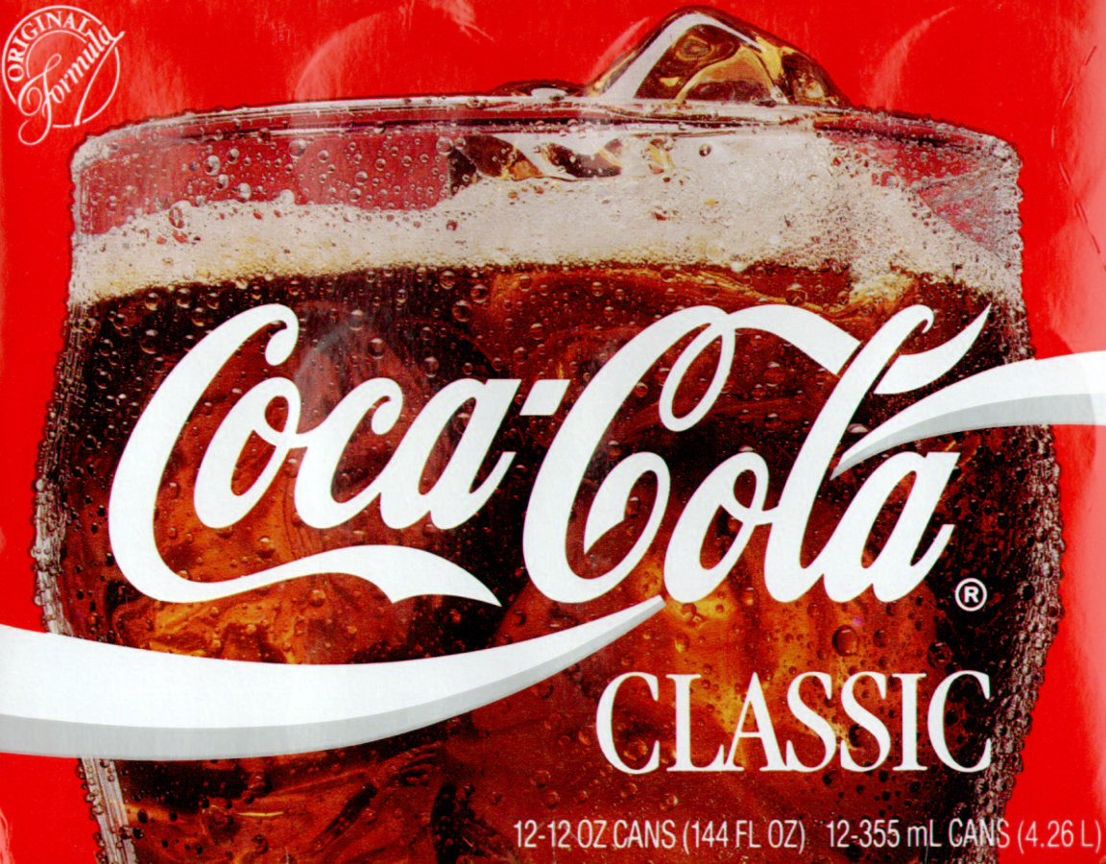
Coke® and Mentos® Demo
Initial Observation: After school one day you are drinking a Coke, when a friend offers you a Mentos. Without much thought, you take the Mentos and immediately take a swig from your Coke. All of a sudden, there is a small explosion in your mouth and you are forced to spit your Mentos and Coke out onto the floor.
Problem: You wonder if both diet and regular Coke both have the same effect with Mentos.
Hypothesis: _____________________________________________________________________________
_______________________________________________________________________________________
How can we tell which one will react more? _____________________________________________
_________________________________________________________________________________
Define the following and give examples of each for this demo:
Qualitative: _____________________________________________________________________________
ex.
Quantitative:_____________________________________________________________________________
ex.
What is a variable?
Tell what each of the following is in this demo:
Independent variable:
Dependent variable:
Constants:
Control Group:
Conclusion:

