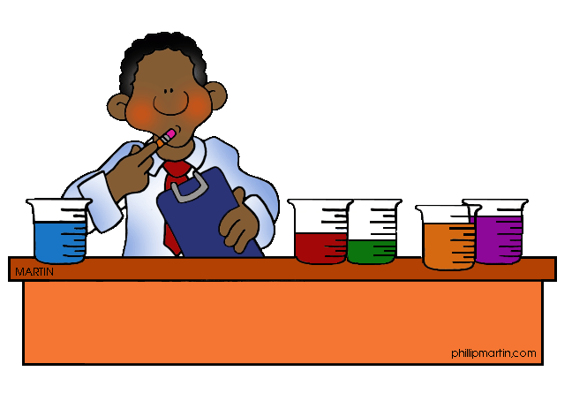
Scientific Inquiry
- Scientific Method
  - The _________________ scientists use to _______________ a problem, question, and/or ____________________
- Scientific Method: Making Observations
  - Observation: when you use your _________________ to obtain _______________________________
  - Types of observations:
    - ________________________: Observations that involve _________________________
    - ________________________: Observations using your ___________________________
  - Inference: Making a __________________________________ based on __________________; cannot be directly ________________________; not a __________________
- Scientific Method: Making a Hypothesis
  - Hypothesis: an ____________________ guess (____________________) that tries to explain a scientific ____________________, ____________________, or __________________ and must be _____________________; a testable inference
  - Written as an _____ …________ statement
- Scientific Method: Designing an Experiment
  - Variable: Factor that _____________________ in an experiment
    - ______________________ variable: factor that the experimenter changes; If you are the experimenter you say it’s the variable “I” changed
    - ______________________ variable: factor that changes in response to the independent variable; the experimenter makes observations of this variable
  - Experimental group(s): Groups in which the ___________________ variable is changed
  - Control group: The “_______________________” or “__________________________” group; used to compare to experimental groups
  - Controlled experiment: an experiment that contains only _______ independent variable
  - Constants: Factors that ______________________________________ in an experiment
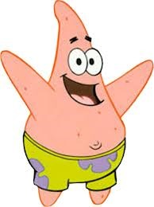
PRACTICE: Patrick believes that fish that eat food exposed to microwaves will become smarter and would be able to swim through a maze faster. He decides to perform an experiment by placing fish food in a microwave for 20 seconds. He has the fish swim through a maze and records the time it takes for each one to make it to the end. He feeds the special food to 10 fish and gives regular food to 10 others. After 1 week, he has the fish swim through the maze again and records the times for each.
What was Patrick’s hypothesis?
What is the independent variable? Dependent variable?
Control group?

  - Procedure: ______________________________________________________________
________________________________________________________________________
    - Experiments require many ____________________ to improve accuracy of the data collected.
      - Trials: Repetition of testing during experiment
- Scientific Method: Collecting and Analyzing Data
  - Data: ________________________________________________ made during an experiment
  - Data Table: a __________________________ of data using _________ and ________________
Size of Bread Loaf (cm³)
Trials
Ex. How Does Sugar Affect Bread Loaf Size

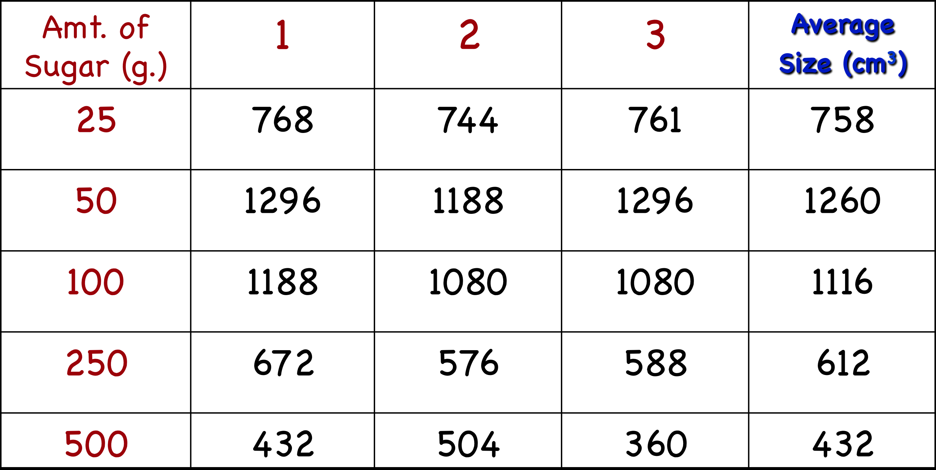

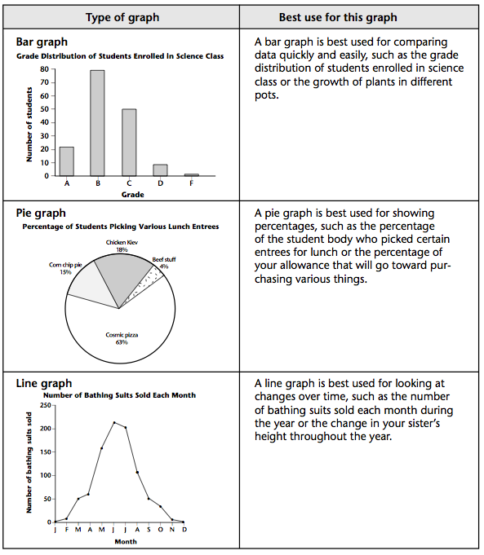
  - Graph: _____________ display of ___________________ data; _____ major parts to a graph

    - Types of Graphs:
      - Bar graph
      - Line graph
      - Pie chart
- Scientific Method: Writing a Conclusion

  - What was the question/problem you were investigating?
  - What was your hypothesis?
  - Is your hypothesis supported or unsupported by your data?
  - What is the explanation for what happened in the experiment? (This could be an inference)
  - What improvements would you make next time?

