Elements and the Periodic Table
- Elements
  - Made of ________________________________________________________
  - Found on the ____________________________________________________
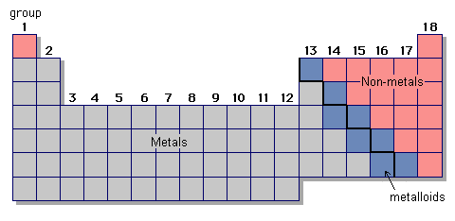
- Classes of Elements on the Periodic Table
  - Metals
    - Physical Properties
      - ____________________ of heat and electricity
      - Shiny
      - ____________________ and ______________________
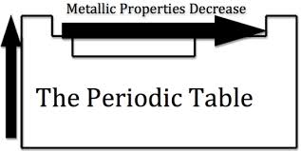
      - Most metals are ________________ at room temperature
    - Chemical Properties
      - Water causes ____________________________
      - Tend to _____________ electrons
    - Found on the ___________________ side of the periodic table
    - Examples:

  - Non-metals
    - Physical Properties
      - ____________________________ of heat and electricity
      - Solids are _________________________ and ______________
      - Many are __________________
    - Chemical Properties
      - Tend to _________ electrons
    - Found on the ___________________ side of the periodic table
    - Examples:

  - Metalloids
    - Physical Properties
      - Properties of both _______________________ and _____________________________
      - ____________________________________: Conduct heat and electricity better than non-metals, but not as well as metals
      - ____________________ and ______________________
    - Chemical Properties
      - Can ______________, ________________, or ___________________ electrons
    - Found along the _________________________________ of the periodic table
    - Examples:
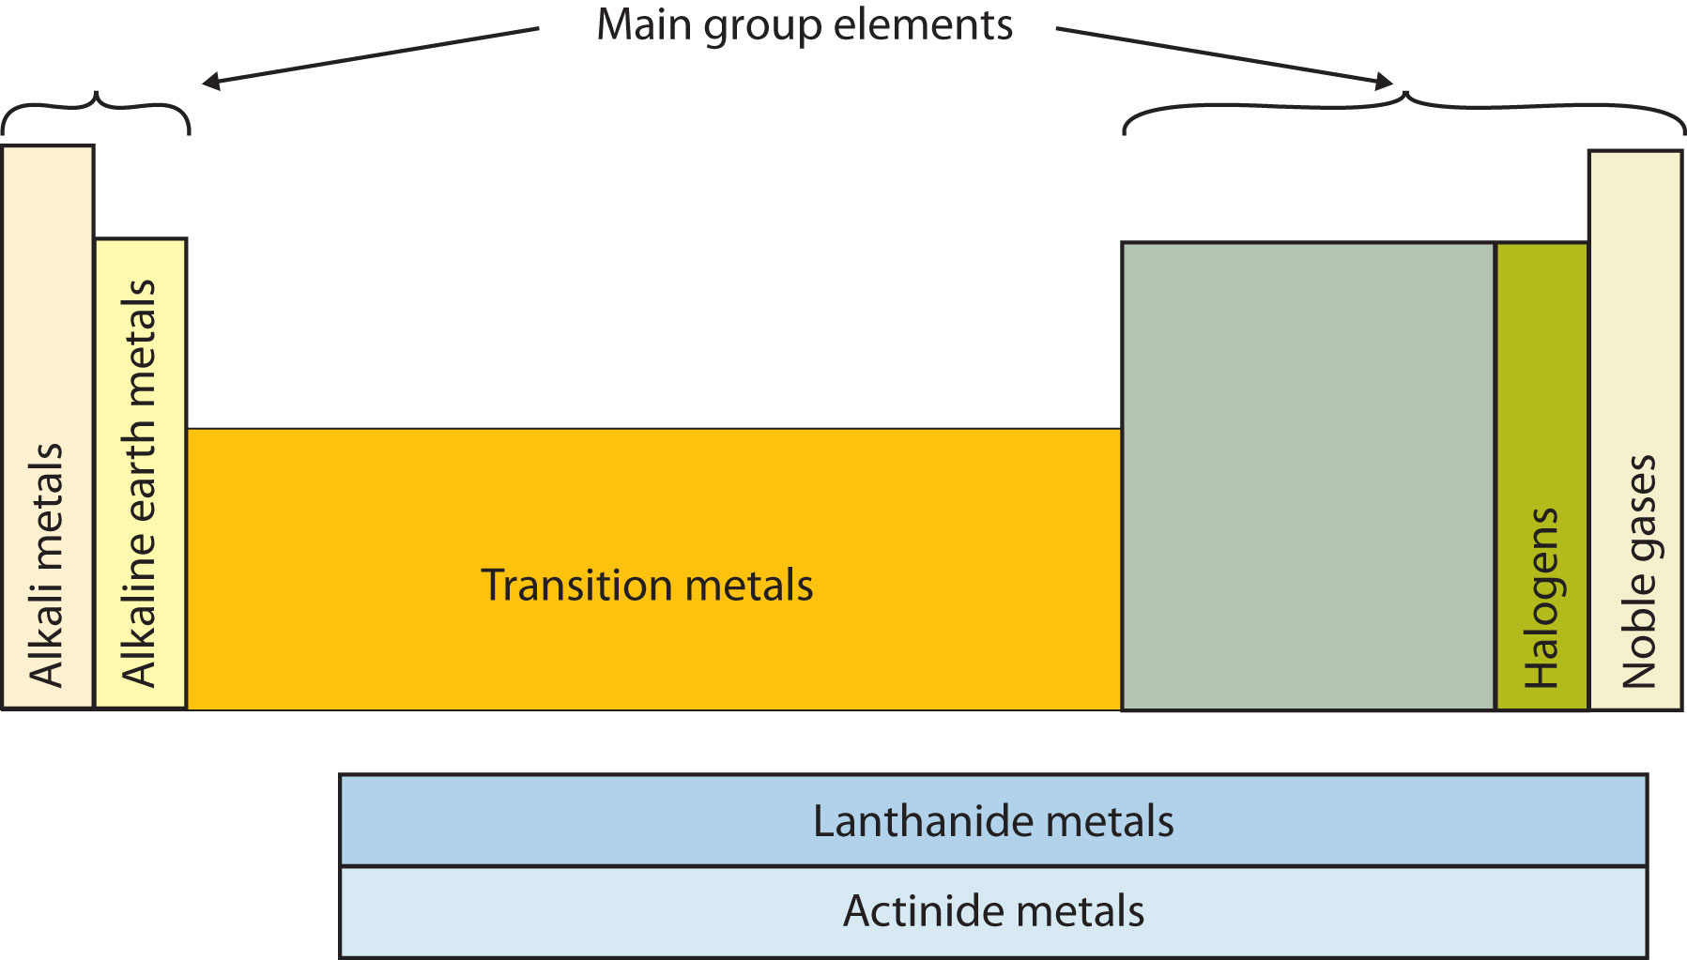
- Groups/Families (* = know this group/family)
      - __________________________________
        - Has ____ electron
        - Very ______________________ gas
      - Group 1: _________________________________*
        - _____________, _________________ metals
        - ____________________ electron
        - Very reactive with _________________________
      - Group 2: _________________________________*
- __________________- _______________ metals
- ____________________ electrons
- ____________________
      - Group 3-12: _________________________________*
        - ______________________ of heat and electricity
        - _____________________ and ___________________
        - Electrons vary
      - Group 13: ___________________ Family
        - _________________ electrons
      - Group 14: ___________________ Family
        - _________________ electrons
      - Group 15: ___________________ Family
        - _________________ electrons
      - Group 16: ___________________ Family
        - _________________ electrons
      - Group 17: _________________________________*
        - Most are _________________________
        - __________________ electron or _____________
        - Very _______________________
        - React with _____________________________________ to form ___________________
      - Group 18: _________________________________*
        - _______________________ (inert)
        - Does not _____________ or ___________ electrons
        - ________________________ gas
      - _________________________________*
        - At the _____________________ of the Periodic Table
        - Composed of ______________________

