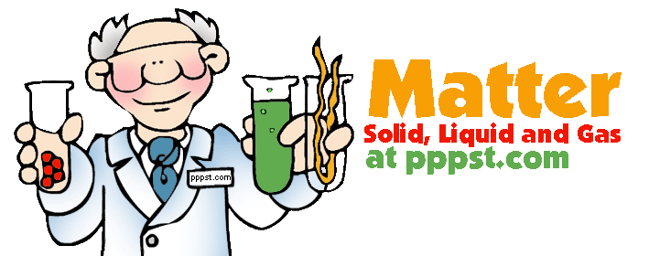
Introduction to Chemistry and Matter

- Chemistry
  - Chemistry is the study of
    - the ____________________________________________________ of matter
    - the _______________________that matter undergoes.
- Defining Matter
  - Matter is
    - Anything that has ___________________ and __________________________________
    - Made of small particles called __________________________
    - 3 main states of matter: ________________, _________________, and _____________
- Measuring Matter
  - Matter is measured in two ways:
    - _____________________________
    - _____________________________
Mass | Unit(s) | Instrument(s)
The ______________ of “_______________” (living and non-living material) an object contains

Volume | Unit(s) | Instrument(s)
The ___________________________________ an object takes up

- Examples and Non-Examples of Matter
  - Using the table below, categorize the words as an example or non-example of matter
Example | Non-example

- The Language of Chemistry:
- ______________________________: pure substances that cannot be broken down by ordinary means to other substances
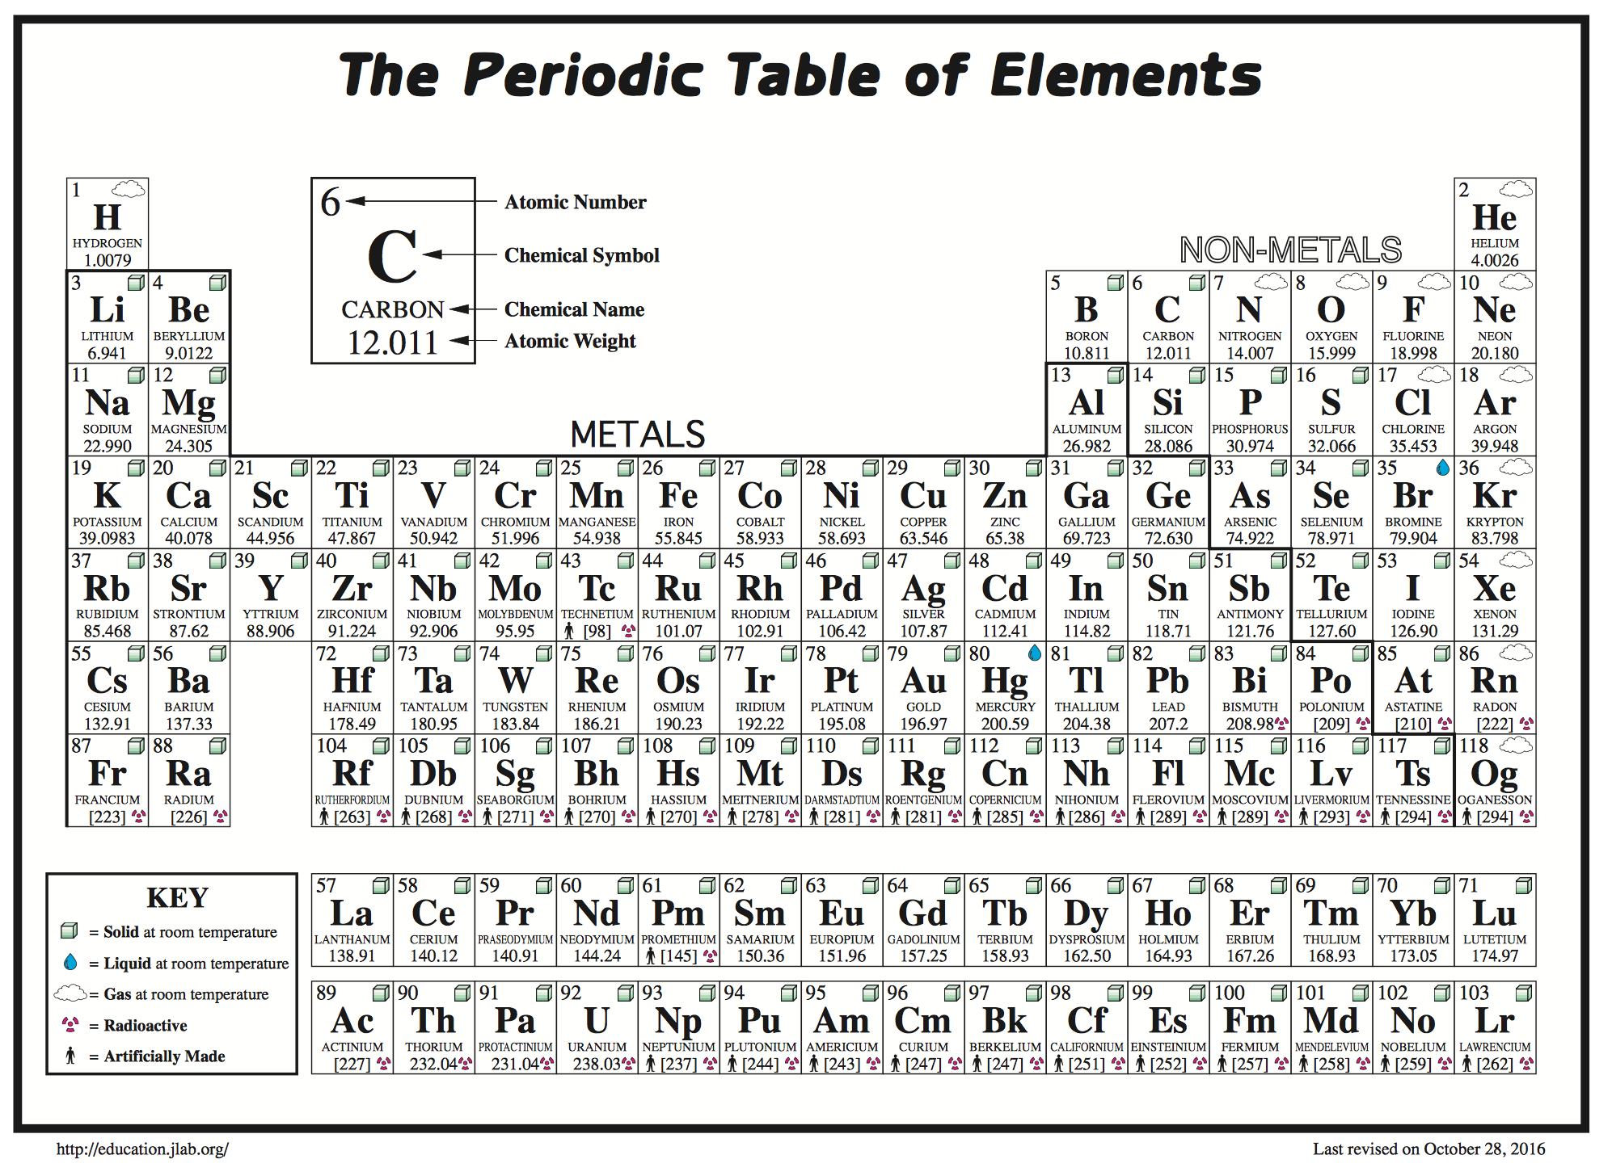
- The elements, their names, and symbols are given on the _______________________________

Periodic Table Word Fun!
Since the periodic table is like the alphabet and we use the “letters” (atoms) to form words (“molecules”) let’s start with some practice. Make some words out of the symbols from the periodic table below or on a separate piece of paper.

