Engineering Design Process
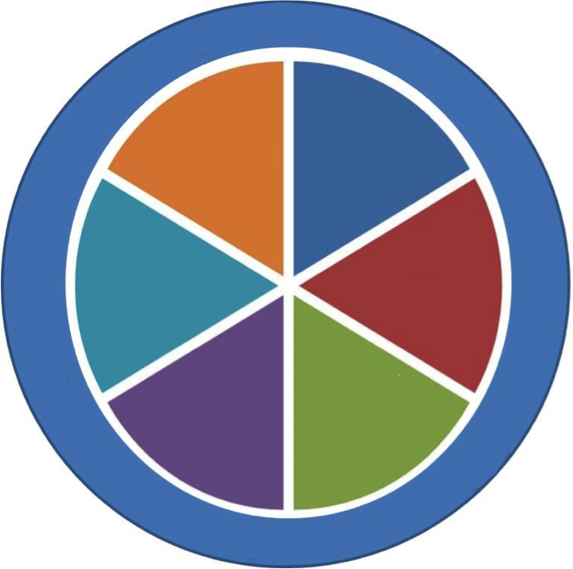
Engineering Design Process: A series of steps that _______________________ use to
guide their steps in _____________________________________________________
It is __________________________ and can begin at any step, or move back and forth
between steps

Engineer: A person trained and skilled in ______________________________________
_______________________________________________________________________
Prototype: an ________________________________________________ of a solution, often
made with different materials (________________________and _______________________to work with)
Iterate: to _________________________________________________ to incorporate new
information

