Classification of Matter
- Matter
  - Matter: anything that has _______________________ and takes up ______________________ (has _____________________________)
  - Matter is made of small particles called _____________________________________________
- Elements
  - Made of ________________________________________________________
  - Found on the ____________________________________________________
  - Examples:
- Compounds and Molecules
  - Compounds: Molecules with ___________________________________________ chemically ______________________ together
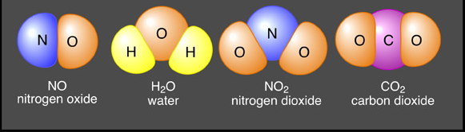
    - Have _____________________________________
    - Examples:

  - Molecules: _________________________________ chemically __________________ together
    - All compounds are molecules, but not all molecules are compounds
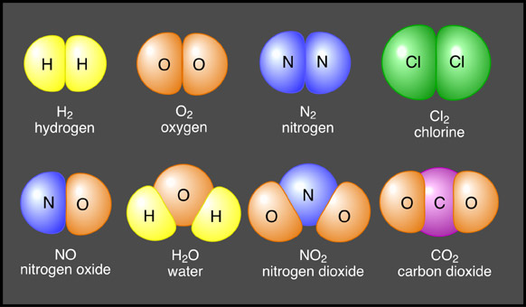
    - Have ______________________________________
    - Examples:

- How Compounds/Molecules are Made and Broken
  - Chemical Reaction: Process in which matter ________________________________, causing ____________________________ to form
  - Atomic ___________ are __________________________________ during a chemical reaction
- Evidence of Chemical Reaction:
F_________________ (formation of a gas)
A_________________ (strong change in smell)
R____________________ (atoms rearrange)
T____________________ (really cold or really hot)
new S_________________(products are different than reactants)
and Fireworks
      - _______________________
      - _______________________
      - ______________________
- Chemical Equations
  - Chemical Equations: used to show ______________________________ and how much of each ___________________ and __________________ are needed
    - Reactants: substance(s) at the _________________of the reaction (__________ side of arrow)
    - Products: substance(s) at the __________of the reaction (____________side of arrow)
  - Law of Conservation of Matter:
    - The mass of the reactants is ___________________________ to the mass of the products in a chemical reaction
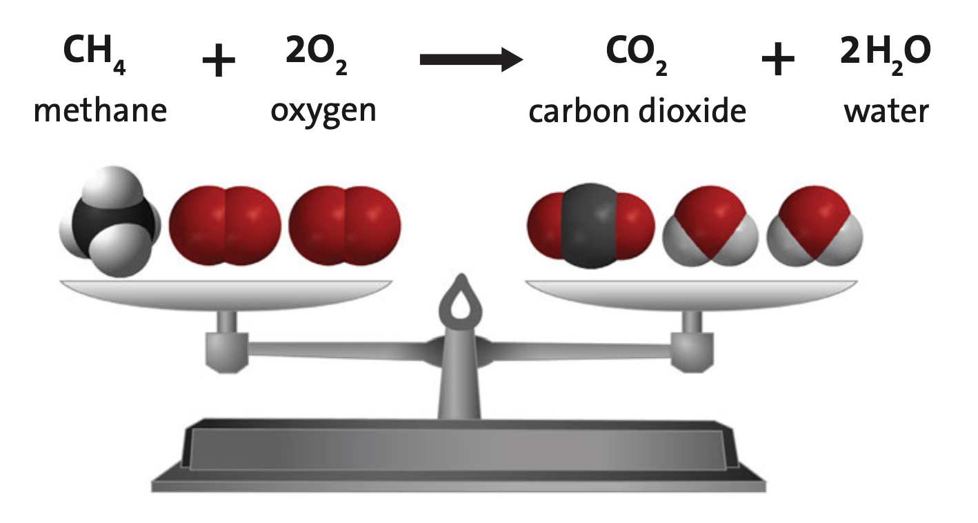
    - _________________________________ on both sides of the equation

  - Coefficients and Subscripts
    - Coefficients: numbers _____________________ of the reactants and products that tell how many are needed for the reaction
    - Subscripts: numbers written _____________________ and ______________ the elements that tell _________________________________ there are
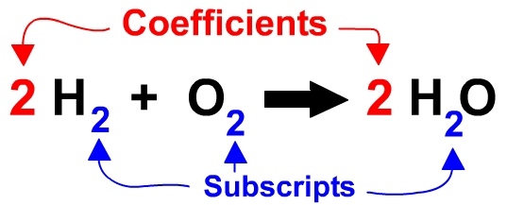
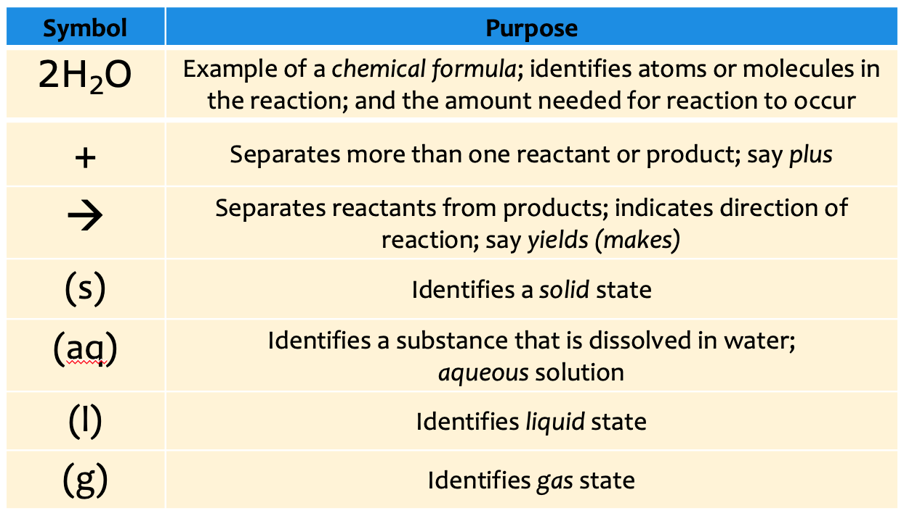

- Mixtures:
  - Made up of a combination of _____________________________________ and/or __________________________ that can be taken apart ________________________________
  - Examples:

