**Macintosh HD:Users:maranda:Desktop:images-1.jpeg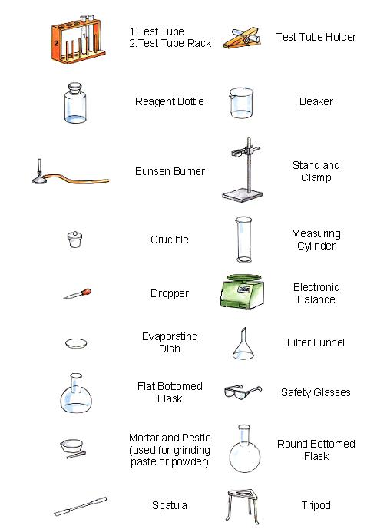 CLASS NOTES—KEEP VERY SAFE**

Test Tube Holder

Round Bottom Flask

Safety glasses/goggles

Funnel

Graduated Cylinder

Electronic Balance

Mortar and Pestle

Beaker

Bunsen Burner

Reagent Bottle

1.) Test tube

2.) Test Tube Rack

Syringe

Erlenmeyer Flask



Evaporation dish

Eye dropper

Crucible and Lid

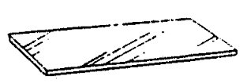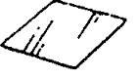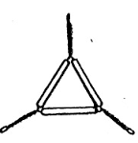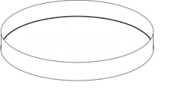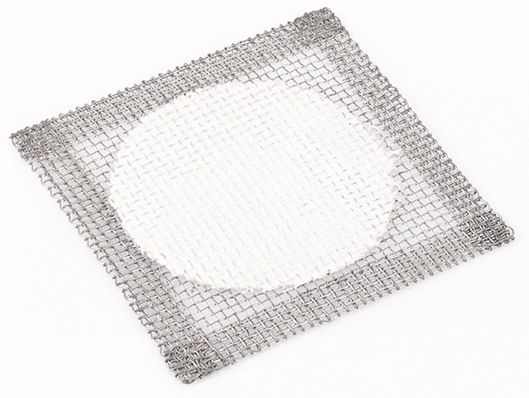**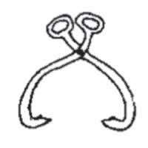 Lab Equipment List**

Microscope Slide and coverslip

Ring Stand, clamp, and clay triangle

Petri dish

Gauze

Tongs