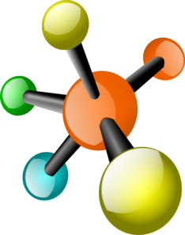
Candy Compounds Activity
Objective: Illustrate the structure of molecules/compounds using models or drawings
Materials: Gumdrops or Jellybeans or marshmallows, toothpicks, colored pencils or crayons
Procedure:
- You will be working in pairs to assemble and draw models of compounds out of toothpicks and candies.
- Fill in the following Candy Key based on the numbers of different colored candies you received in your bag. Count the number of candies you have for each color and match the key. Use a colored pencil or crayon to color each candy in the key. Match the colors to the numbers!
Sodium (Na)- 1 | Chlorine (Cl)- 1 | Hydrogen (H)- 2 | Oxygen (O)- 3 | Carbon (C)- 1
3. Using the key you created above, related to your bag of candy, complete the following models and corresponding worksheet. For each compound you will need to:
- List the atoms and numbers of each
- Tell whether the models are representing a molecule, compound, or both.
- Make the candy model and color the candy model picture below.
- Give the proper name of the compound
Information | # of atoms | Molecule, Compound, or Both? | Candy model | Name of Compound
NaCl | Na=  Cl= |  | 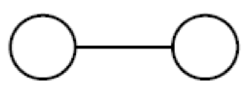
H₂O | H=  O= |  | 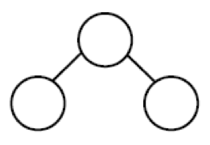
CO₂ | C=  O= |  | 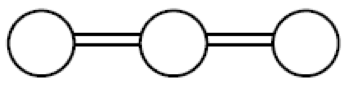

Post Lab Questions:
- What small particle makes up all substances?

2. How is a compound different from a molecule?

3. Are all molecules, compounds? Explain.

4. Draw a Bohr model of an oxygen atom in first box and a hydrogen atom in the second.

5. Looking at the models above, explain why are two hydrogen atoms bonded to an oxygen atom to make a stable water molecule? (Hint: Look at the valence electrons)

6. One of the properties of a pure substance it that they always exist in fixed proportions.
How many hydrogen atoms are needed to form 5 water molecules? _________
How many oxygen atoms are needed to form 5 water molecules? _________

7. How do compounds and molecules form?

