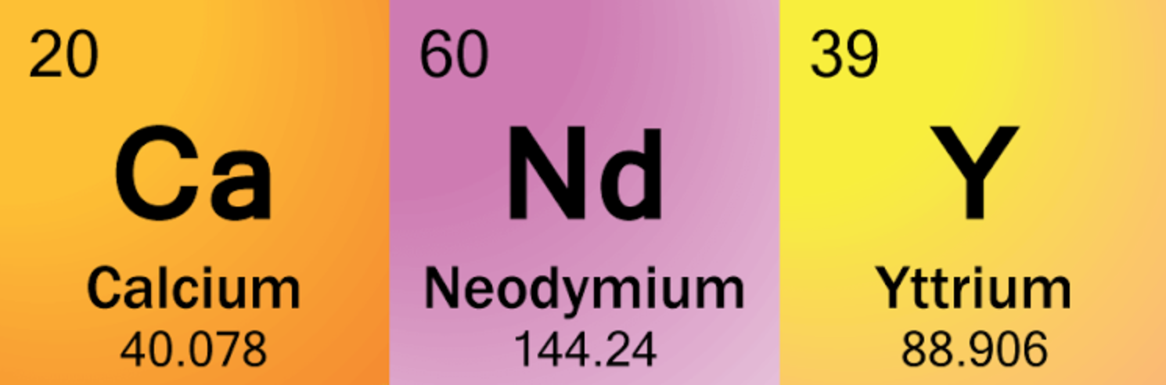
Candy Chemistry
Review for Bath Bombs
Ingredients: Sugar (2 parts), Powdered Drink mix (1 part), baking soda (1 part), citric acid (1 part)
Part A: Sample the candy as instructed.
- Record your observations on the properties of substances before and after eating the candy in Table 1.
Table 1. Observations
Before Eating | During/After Eating
Part B: Analyze the popping candy reaction by answering the questions below. Refer to the provided chemical equation when necessary:
C₆H₈O_{7(aq)} + 3NaHCO_{3(aq)} → Na₃C₆H₅O_{7(aq)} + 3CO_{2(g)} + 3H₂O_{(l)}
citric acid baking soda sodium citrate carbon dioxide water
- Complete Table 2 by drawing the missing molecular models.
Table 2. Models
 | REACTANTS |  | PRODUCTS
Chemical Formula | C₆H₈O₇ | 3NaHCO₃ | Na₃C₆H₅O₇ | 3CO₂ | 3H₂O
Molecular Model | 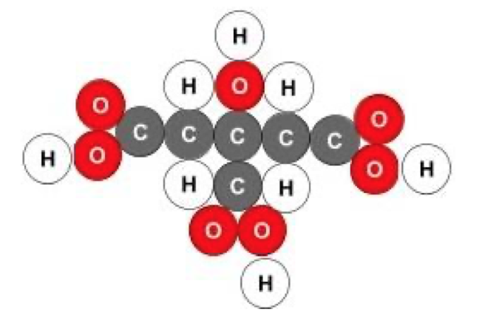 | 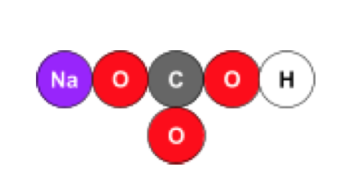 | 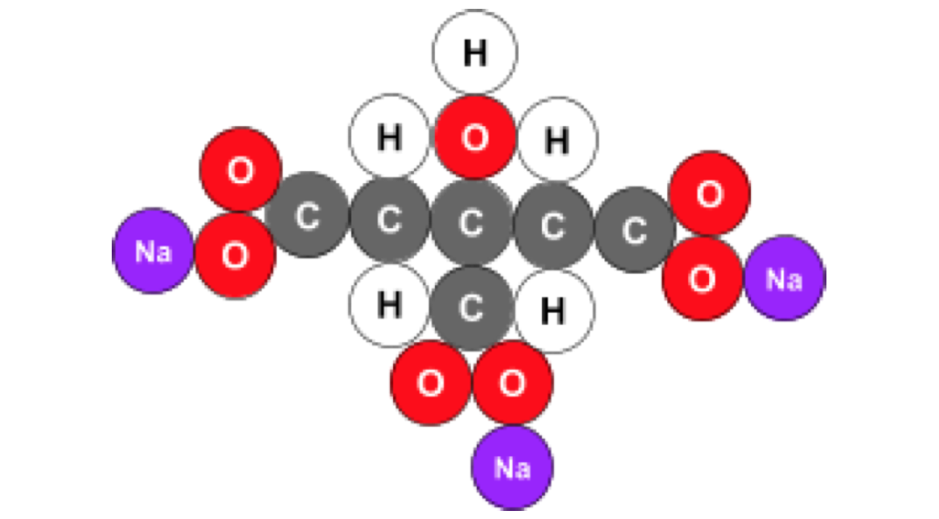 | Model: | Model:
- Which atom is present in every compound of the reaction? What is a chemical property of this element?
- Examine the evidence and make a claim about what happened to the individual atoms present during this reaction. Give a reasoning by stating the scientific principle that helps to explain the evidence.
Claim | Evidence | Reasoning
#Atoms in reactants | # of Atoms in products
C = 9  H = 11  O = 16  Na = 3 | C = 9  H = 11  O = 16  Na = 3

- Did a chemical reaction take place after you ate the mixture? Circle one of the claims. Support your claims with evidence and reasoning.
Did a chemical reaction take place?
Claim | Evidence | Reasoning
YES, a chemical reaction took place.

NO, a chemical reaction did not took place.

- Analyzing the chemical equation: C₆H₈O_{7(aq)} + 3NaHCO_{3(aq)} Na₃C₆H₅O_{7(aq)} + 3CO_{2(g)} + 3H₂O_{(l)}
citric acid baking soda sodium citrate carbon dioxide water
  - What part of the chemical equation represents the saliva added? ___________
  - What is the chemical formula for the gas that is formed as a result of this reaction? _______________________
  - What classification of matter: elements, molecules, or compounds are the reactants and products?

