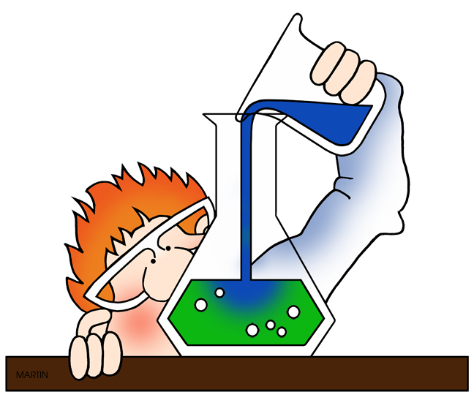
Brr! It’s Cold in Here!

Introduction and Purpose: Today, you will be working in a group to conduct and analyze the results of a mini-experiment. You will be assessed on your ability to work in a group, to follow a procedure, and to draw conclusions based on data. Do not worry about right and wrong when conducting this experiment; simply do your personal best while working in a group.

Question: How can you make new things from old?

Initial Ideas: ______________________________________________________________
______________________________________________________________________________________________________________________________________________________
Materials:
- 2 grams (g) citric acid  - 2.5 grams (g) baking soda  - 20 milliliters (mL) water | - 1 small beaker  - 1 plastic bag  - 1 graduated cylinder | - Safety goggles (required)  - Lab apron (optional)

Procedure:
- Write your name, today’s date, and class hour on the top of this document.
- Retrieve safety goggles (required) and lab apron (optional). Put on safety equipment.
- Measure and then mix 2 g citric acid and 2.5 g baking soda in the plastic bag.
- Make observations of the contents of the bag. Record your observations on the data table on the back of this paper. Touch the bottom of the bag and record the general temperature of the mixture (cold, warm, hot).
- Measure 20 mL of water and pour it into the small beaker. CAUTION: The beaker is made of glass. Keep it away from table edges and carry with two hands.
- Place the beaker upright in the plastic bag. DO NOT LET THE WATER COME IN CONTACT WITH THE POWDER MIXTURE.
- Close the plastic bag. Remove as much air as possible before sealing the bag.
- Once the bag is closed, wiggle the bag so that the beaker falls over.
- Use the data table to record observations of what is happening inside the bag. Touch the bottom of the bag after the reaction and record the general temperature of the mixture (cold, warm, hot).
- Remove the beaker from the bag, pour the contents of the bag down the sink, rinse the beaker with water from the faucet, and then return the materials to the table (except the plastic bag…you may throw that away).
- Return safety equipment, wash your hands, and answer analysis questions.

Data Table:

Observations
Before Reaction | During and After Reaction

Analysis:

- Which observations do you consider to be most significant?

- What questions do you have about the observations you made?

- Do your observations support your initial ideas? How do you know?

4. Examine the data below and answer the following: What conclusion can be drawn when baking soda and vinegar react?

Baking Soda and Vinegar Reaction
Closed System | Open System
Starting mass:  ____147.6 g_____  Ending mass:  ____148.3 g______ | Starting mass:  ____145.6 g_____  Ending mass:  ____93.7 g______

5. In the space below, draw a model that shows the changes that happened to the substances during the reaction. You may use pictures, symbols, and/or words to support your explanation.

6. To clarify what you have modeled above, write an explanation that describes what happened to the substances in the reaction.

____________________________________________________________________________________________________________________________________________________________________________________________________________________________________________________________________________________________________________
______________________________________________________________________________________________________________________________________________________
______________________________________________________________________________________________________________________________________________________
______________________________________________________________________________________________________________________________________________________

