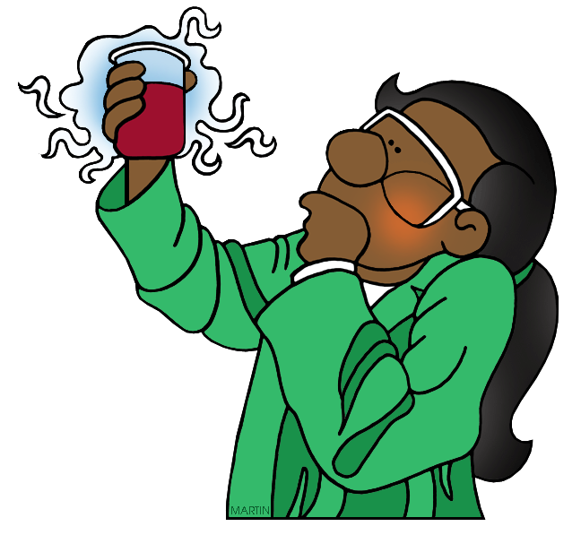
Brr It’s Cold In Here Reflection
Science Skills
What science related skills do you have questions about based on the experiment? Rank how comfortable/skillful you are with the following skills. (5= very comfortable, knowledgeable; 3= I remember doing this before, but need a refresher; 1= I’ve never done this or don’t remember anything about it or I’m not comfortable at all with this)
- Knowing where materials/equipment can be found 5 4 3 2 1
- Knowing how to use the equipment to make observations 5 4 3 2 1
- Using a graduated cylinder 5 4 3 2 1
- Using a balance 5 4 3 2 1
- Knowing how to safely conduct an experiment 5 4 3 2 1
- How to measure using the metric system? (mL, g, etc.) 5 4 3 2 1
- Knowing how to read and follow a scientific procedure 5 4 3 2 1
- How to make observations during an investigation 5 4 3 2 1
Working in a Group
Now that you have worked together to conduct and analyze an experiment, please answer the questions below.
- What did you personally do to support your group during the experiment?

- What did your group members do to support each other during the experiment?

- What did your group members do well during the experiment?

- In what areas did you group members struggle with? (Be specific!)

5. Think about one or more positive learning experiences you have had either at school or outside of school. What were some of the behaviors shown by you and others that helped you to participate as a learner? Write them in the space provided below. Be prepared to share an idea with a partner and the whole class.
Example: My mom taught me to sew with a sewing machine. She helped me to find YouTube videos to help me better understand the sewing machine. Then, she watched me practice and helped me to understand what I did right. She was very patient and kind as she helped me to learn. I listened very well and was also patient. When I got frustrated, she said kind things and encouraged me to try again.

Is | Does
A Great Group Member

Says | Is Not

