Whitmer tours bridge inspection, hammers importance of more money to fix roads
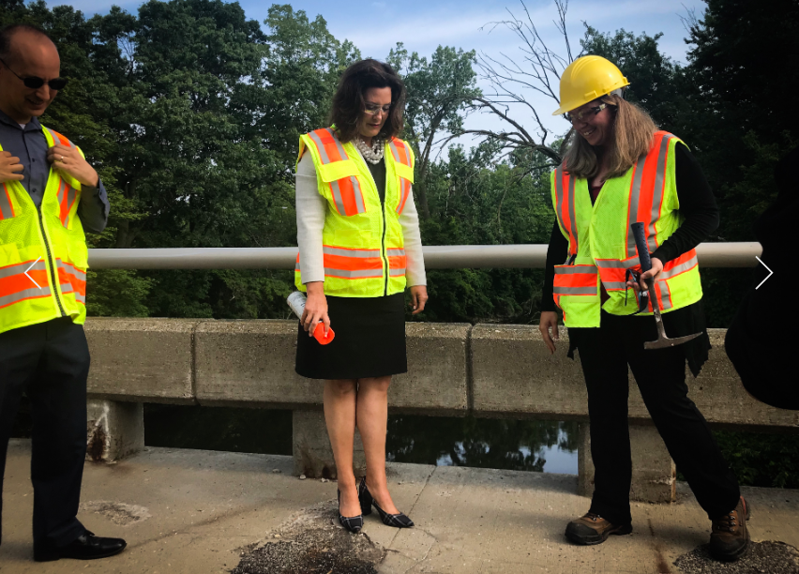
by Mikenzie Frost | Sinclair Broadcast Group
Monday, August 12th 2019
https://wwmt.com/news/state/whitmer-continues-to-hammer-importance-of-more-funds-to-fix-roads

LANSING, Mich. — A bridge in Lansing was inspected by a special guest Monday in the latest push by the Whitmer administration to pressure the state Legislature and highlight the need for an increase in funding for infrastructure.
Gov. Gretchen Whitmer, along with Rebecca Curtis, deputy bridge engineer with the Michigan Department of Transportation, inspected a bridge in Lansing’s REO Town district on Elm Street. The crumbling state of the bridge was visible with wires hanging below the structure and asphalt patches holding together the cracks on top.
The legal load limit for bridges in Michigan is 77 tons, according to Curtis, and the Elm Street bridge has a decreased capacity requirement due to its deteriorating condition.
Curtis said MDOT distributes about $48 million annually for local bridge repairs. However, MDOT gets between $250 million and $300 million in requests for local bridge repairs. Of that $48 million, about $14 million comes from federal assistance, Curtis said.
Whitmer said the number of requests that MDOT receives annually highlights the need and importance of allocating more money to improve infrastructure.
“There are $44 million in projects to be done here and only $8 million available. This bridge alone is a $3 million fix,” Whitmer said. “That’s why it’s important the Legislature gets serious about really coming up with a solution around infrastructure.”
In March, Whitmer unveiled her budget proposal that called for a 45-cent gas-tax increase that would be phased in over three increments. In total, it would raise about $2 billion annually — enough to fix Michigan’s crumbling roads, she said.
Whitmer’s gas-tax increase proposal has garnered fierce opposition and critiques from the Republican-controlled Legislature. Both the House and Senate have rolled out their own road funding plan since March. Speaker Lee Chatfield, R-Levering, even going as far as saying the 45-cent gas-tax increase is a ‘non-starter’. The House's road funding plan includes shifting sales tax revenue captured at the pumps to improve the roads. The Senate's plan calls for speeding up the implementation of the 2015-approved gas tax increase plan, but it doesn't generate the $2 billion Whitmer said is necessary.
So, with several months in the rear-view mirror and no compromise on the horizon, the idea of a government shutdown looms over Lansing. Lawmakers are due back in the Capital City by the end of the month after a few months off.
After hammering her infrastructure point, Whitmer said Monday that both sides — meaning herself and Republican leadership — are desperately trying to avoid a government shutdown. The deadline to get a new budget negotiated and signed on the dotted line is Oct. 1.
Whitmer said she would support a continuation of the current budget to avoid a shutdown, “only if good-faith negotiations” are taking place. Right now, she said, those good-faith negotiations are not happening.
“They are going to need Democratic votes in the House and Senate and my signature to have a budget and that’s why we’ve got to get serious about negotiating,” Whitmer said.
Questions:
- Based on what you have read, what needs to be accomplished, and why?

- What is needed to find a solution to the problem?

- Are there any limitations in reaching the goal?

- Who benefits from a solution?
ANALYSIS
DEFINE THE ENGINEERING PROBLEM
__________________________________________________________________________________________________________________________________________________________________________
_____________________________________________________________________________________
_____________________________________________________________________________________
__________________________________________________________________________________________________________________________________________________________________________
IMAGINE POSSIBLE SOLUTIONS
Idea #1 | Idea #2
Reasoning: | Reasoning:

