Bill Nye - Atoms

- The middle of the atom is called the _________________________.

- The two particles in the nucleus are _____________________ and __________________.

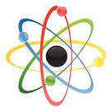
- The heaviest part of the atom is the ____________________________.

- The particles which have a positive charge are ______________________.

- The particles which have no charge are ______________________.

- The particles which have a negative charge are ___________________.

- Atoms are mostly ________________ ________________.

- The basic building blocks of all matter are ________________.

- Atoms combine to form __________________________.

- Water can be broken down by passing an electric current through it. What two gasses are produced by the break down of water?

- What makes one atom different from another atom?

- What does the atomic number tell you?

- What is the chemical formula for a) water? _____________ and b) salt? ______________

- Atoms are too small to see. How do scientist study atoms and the particles which make up atoms?

- What two things make up everything in the universe?

- Give three examples of energy.

- What is so special about the element carbon?

- What is Organic Chemistry?
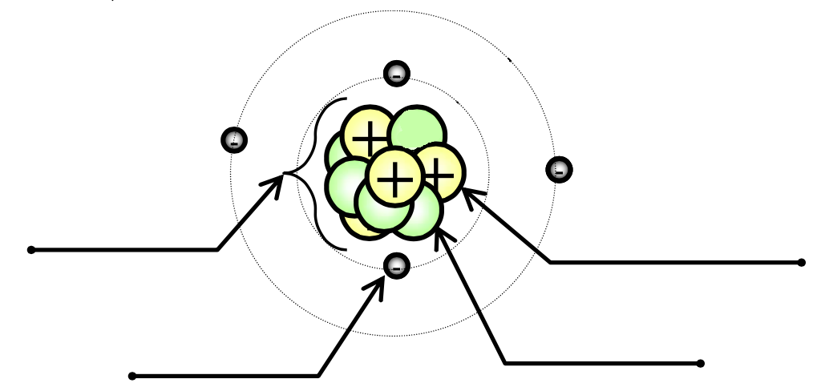
Parts of an Atom
Part 1: Label the atom

Part 2: Answer the following using your periodic table as a guide
- _______________What part of the atom has no charge?
- _______________What part of the atom has a positive charge?
- _______________What part of the atom has a negative charge?
- _______________There are the same number of these two particles in an atom.
- _______________The atomic number is the same as the number of these particles.
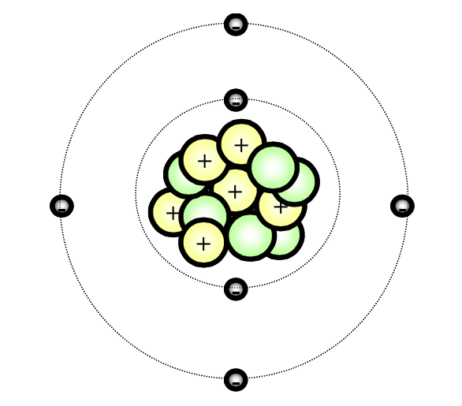
- _______________The mass number is determined by which particles?
Part 3: Using the diagram to the right, answer the questions that follow
(Use your periodic table to help you)
- _______________How many neutrons does the atom have?
- _______________How many protons does the atom have?
- _______________How many electrons does the atom have?
- _______________What is the atomic number of the atom?
- _______________What is the mass number (atomic weight) of the atom?
- _______________ What atom is this?

