Matter and Chemistry
Bath Bomb Study Guide
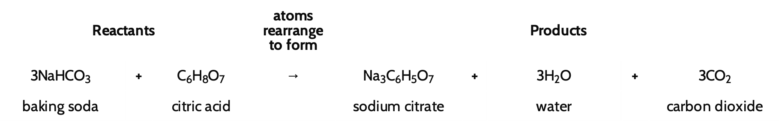

Driving Questions:
How is it possible that a new substance (the gas) was produced and the total mass of the closed system didn’t change?

Objectives:
- Develop a model showing what is happening at a scale smaller than we can see to help explain what happened to the matter in the solid bath bombs and what caused the gas bubbles to appear.
  - Determine reactants and products of the bath bomb reaction
  - Be able to count atoms given a chemical equation
  - Draw molecular models of reactants and products of the bath bomb reaction
- Explain what is happening to the atoms of the substances in the system to cause this reaction.
  - Model and explain how the solids in the bath bomb must dissolve in water prior to the reaction.
  - Explain what a chemical reaction is and how atoms rearrange to form new substances.
- Develop a scientific explanation to explain why or why not a chemical reaction is occurring when the solid bath bomb is placed in water.
  - Make a claim to answer whether a chemical reaction is occurring.
  - Use evidence from the bath bomb investigations to back up your claim.
  - Give a reasoning for how your evidence backs your claim using scientific principles.
- Use a model to develop a scientific explanation for how the total number of atoms in the reactants rearrange to form the same number/type of atoms in the products during the chemical reaction when the bath bomb produces gas bubbles, thus mass is conserved.
- Analyze and interpret data to predict the possible products in a chemical reaction, explain how it is possible for other new substances to come from the starting substances in the bath bomb.

