All About Me Mind Map

Introduction: Teamwork makes science better and has been recognized as a key to success! Working with others allows each individual in a team to learn more, to do more, and to have more fun! Teams are best when they cooperate with one another, pay attention to one another, and communicate their strengths with one another. Our science class will learn to work together as a team by reaching these goals.

Purpose: To communicate your strengths with your class.

Requirements and Constraints:
- Highlight who you are and what makes you unique. Advertise what makes you YOU.
- Draft your All About Me Mind Map on the back of this page. Use the graphic below to help you.
- Show lots of creativity.
- Use the piece of provided paper to make a final copy of your mind map. You may not exceed the size of this paper.

Mind Map Tips:
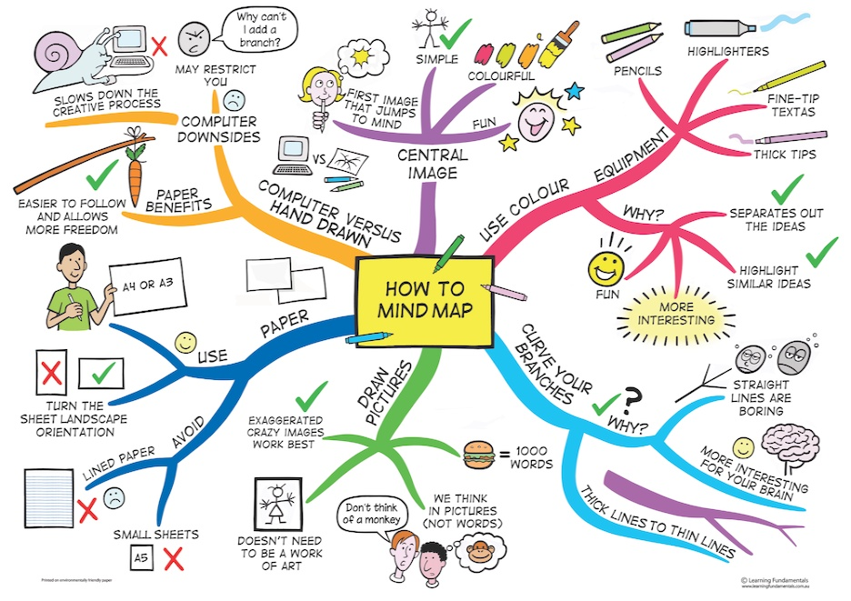

All About Me Mind Map Draft:

